AMMAR YASEEN MANSOUR
Neural Conduction in Synapses,
"Innovated View"
Permanently, at rest as well as in action, the vesicles inject their burdens of the neurotransmitter into the synaptic cleft. In such a way, the neurotransmitter moistens the synaptic cleft, and makes it apt to conduct the electrical neural current whenever it is time. Therefore, the electrical neural current could promptly pass to another side of the synapses.; more details on the following link:
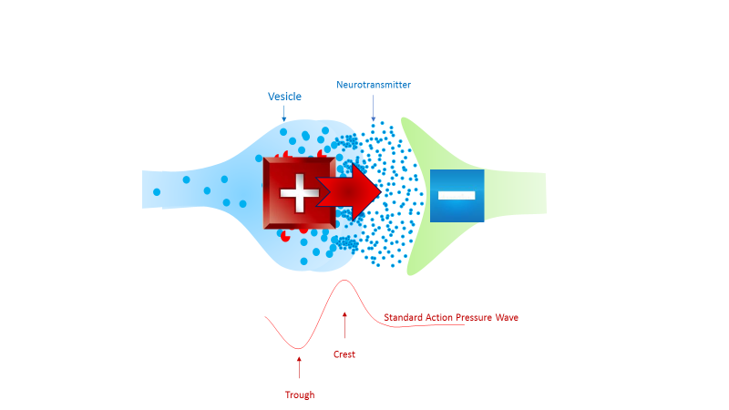


In another context, one can read:
- | Neural Conduction, Personal View vs. International View (Innovated)
 | Neural Conduction, Action Pressure Waves (Innovated)
 | Neural Conduction, Action Potentials (Innovated)
 | Neural Conduction, Action Electrical Currents (Innovated)
 | The Function of Action Potentials (Innovated)
 | The Three Phases of Neural Conduction
 | Neural Conduction in the Synapse (Innovated)
 | Sensory Receptors
- | Nodes of Ranvier, the Equalizers (Innovated)
 | Nodes of Ranvier, the Functions (Innovated)
 | Nodes of Ranvier, Function N1 (Innovated)
 | Nodes of Ranvier, Function N2 (Innovated)
 | Nodes of Ranvier, Function N3 (Innovated)
- | The Philosophy of Pain, Pain Comes First! (Innovated)
- | The Philosophy of Form (Innovated)
- | Spinal Injury, pathology of Spinal Shock, Pathology of Hyperreflexia
 | Spinal Shock (Innovated)
 | The Clonus (Innovated)
 | Hyperactivity Hyperreflexia (Innovated)
 | Hyperreflexia, Extended Sector of Reflex
 | Hyperreflexia, Bilateral Responses
 | Hyperreflexia, Multiple Responses
- | Nerve Conduction Study, Wrong Hypothesis is the Origin of Misinterpretation (Innovated)
 | Wallerian Degeneration (Innovated)
 | Neural Regeneration (Innovated)
- | Wallerian Degeneration Attacks Motor Axons, While Avoids Sensory Axons
 | Barr Body, the Whole Story (Innovated)
 | Boy or Girl, Mother Decides!
 | Adam's Rib and Adam's Apple, Two Faces of one Sin
 | The Black Hole is a (the) Falling Star?
 | Adam's Rib, could be the Original Sin?

22/10/2019

