Dr. Ammar Yaseen Mansour

The Spinal Reflex: The Traditional Physiology

To watch a brief video explaining the classic physiology of the spinal reflex,
click this link:
Conventionally, each spinal reflex is said to possess:
- An afferent sensory pathway
- An efferent motor pathway
Typically, the first pathway terminates where the second begins—within the same spinal segment. Occasionally, both pathways interface across adjacent spinal segments (rostral or caudal).
- Sensory Afferent Pathway:
Converges at sensory neurons within the spinal ganglion of the posterior root (dorsal root) of the spinal nerve.
- Motor Efferent Pathway:
Originates from motor neurons in the anterior horn of the spinal cord.
So far, I agree with traditional physiology regarding the occurrence of the spinal reflex. Beyond this, my perspectives diverge irrevocably.
The Traditional Model Asserts:
Interposed between sensory neurons (SN) and lower motor neurons are intermediate neurons (interneurons). These interneurons relay the afferent impulse directly from sensory to motor neurons, thereby completing a functional circuit:
- The Lower Motor Neuron (LMN) Circuit
- Equivalently, the Spinal Reflex Circuit
Thus, according to this model (see Figure below), the spinal reflex comprises:
- The sensory neuron (SN)
- The lower motor neuron (LMN) (within the same or adjacent segment)
- Interneurons bridging them...or so they claim.

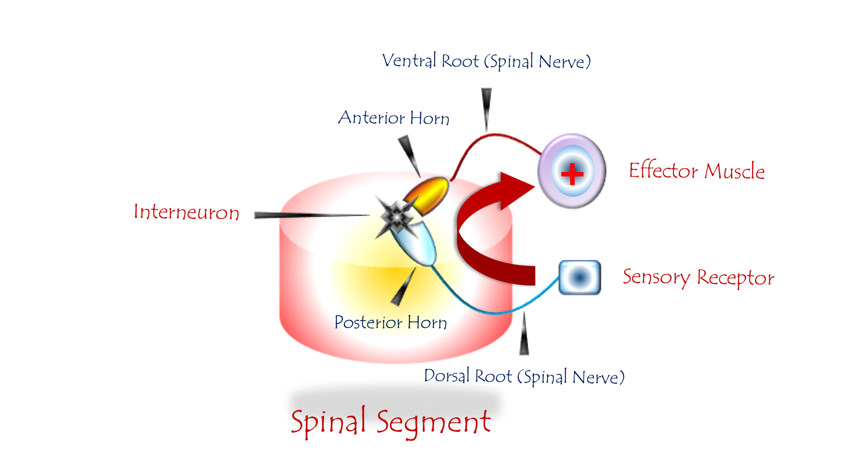
The Spinal Reflex (Traditional Conception)
To watch a brief video explaining the classic physiology of the spinal reflex, click this link:
The spinal reflex circuit comprises three elements:
- Sensory Neuron (SN)
- Interneuron (Intermediate Neuron)
- Lower Motor Neuron (LMN)
Neuroanatomical Localization:
Component | Location
Sensory Neuron (SN) | Spinal ganglion of the dorsal root
Interneuron | Posterior horn of the spinal cord
Lower Motor Neuron (LMN) | Anterior horn of the spinal cord
All neural elements reside within one or two adjacent spinal segments.

Physiological Sequence (Traditional View):
- Sensory input arrives at the sensory neuron (SN).
- Excitation is relayed via an interneuron to the lower motor neuron (LMN).
- The sensory input carries a binding motor command that mandates execution.
- LMNs promptly issue motor orders to effector targets.

Role of the Upper Motor Neuron (UMN):
The UMN remains detached from the decision site. It merely:
- Monitors reflex activity
- Evaluates reflex performance...without direct engagement in the reflex execution.

…………………………………………………………………………………………………
In other contexts, you can also read the following articles:
The Spinal Reflex, New Hypothesis of Physiology
The Hyperreflexia, Innovated Pathophysiology
The Spinal Shock
The Spinal Injury, the Pathophysiology of the Spinal Shock, the Pathophysiology of the Hyperreflexia
Upper Motor Neuron Lesions, the Pathophysiology of the Symptomatology
The Hyperreflexia (1), the Pathophysiology of Hyperactivity
The Hyperreflexia (2), the Pathophysiology of Bilateral Responses
The Hyperreflexia (3), the Pathophysiology of Extended Hyperreflex
The Hyperreflexia (4), the Pathophysiology of Multi-Response Hyperreflex
The Clonus, 1st Hypothesis of Pathophysiology
The Clonus, 2nd Hypothesis of Pathophysiology
The Clonus, Two Hypotheses of Pathophysiology
The Nerve Transmission through Neural Fiber, Personal View vs. International View
The Nerve Transmission through Neural Fiber (1), The Action Pressure Waves
The Nerve Transmission through Neural Fiber (2), The Action Potentials
The Nerve Transmission through Neural Fiber (3), The Action Electrical Currents
The Function of Standard Action Potentials & Currents
The Three Phases of Nerve transmission
Neural Conduction in the Synapse (Innovated)
Nodes of Ranvier, the Equalizers
Nodes of Ranvier, the Functions
Nodes of Ranvier, First Function
Nodes of Ranvier, Second Function
Nodes of Ranvier, Third Function
Node of Ranvier, The Anatomy
The Wallerian Degeneration
The Neural Regeneration
The Wallerian Degeneration Attacks Motor Axons, While Avoids Sensory Axons
The Sensory Receptors
Nerve Conduction Study, Wrong Hypothesis is the Origin of the Misinterpretation (Innovated)
Piriformis Muscle Injection_ Personal Approach
The Philosophy of Pain, Pain Comes First! (Innovated)
The Philosophy of the Form (Innovated)
Pronator Teres Syndrome, Struthers-Like Ligament (Innovated)
Ulnar Nerve, Congenital Bilateral Dislocation
Posterior Interosseous Nerve Syndrome
The Multiple Sclerosis: The Causative Relationship Between
The Galvanic Current & Multiple Sclerosis?
Cauda Equina Injury, New Surgical Approach
Carpal Tunnel Syndrome Complicated by Complete Rupture of Median Nerve
Biceps Femoris' Long Head Syndrome (BFLHS)
Barr Body, The Whole Story (Innovated)
Adam's Rib and Adam's Apple, Two Faces of one Sin
Adam's Rib, could be the Original Sin?
Barr Body, the Second Look
Who Decides the Sex of Coming Baby?
Boy or Girl, Mother Decides!
Oocytogenesis
Spermatogenesis
This Woman Can Only Give Birth to Female Children
This Woman Can Only Give Birth to Male Children
This Woman Can Give Birth to Female Children More Than to Male Children
This Woman Can Give Birth to Male Children More Than to Female Children
This Woman Can Equally Give Birth to Male Children & to Female Children
Eve Saved Human Identity; Adam Ensured Human Adaptation
Coronavirus (Covid-19): After Humiliation, Is Targeting Our Genes
Coronavirus (Covid-19): After Humiliation, Is Targeting Our Genes
The Black Hole is a (the) Falling Star?
Mitosis in Animal Cell
Meiosis
Universe Creation, Hypothesis of Continuous Cosmic Nebula
Circulating Sweepers
Pneumatic Petrous, Bilateral Temporal Hyperpneumatization
Congenital Bilateral Thenar Hypoplasia
Ulnar Dimelia, Mirror hand Deformity
Surgical Restoration of a Smile by Grafting a Segment of the Gracilis Muscle to the Face
Mandible Reconstruction Using Free Fibula Flap
Presacral Schwannoma
Liver Hemangioma: Urgent Surgery of Giant Liver Hemangioma
Due to Intra-Tumor Bleeding
Free Para Scapular Flap (FPSF) for Skin Reconstruction
Claw Hand Deformity (Brand Operation)
Algodystrophy Syndrome Complicated by Constricting Ring at the Proximal Border of the Edema
Non- Traumatic Non- Embolic Acute Thrombosis of Radial Artery
(Buerger’s Disease)
Isolated Axillary Tuberculosis Lymphadenitis
The Iliopsoas Tendonitis... The Snapping Hip
To read the article in Arabic, click on
The New Frankenstein Monster
The Lone Wolf
The Delirium of Night and Day
The Delirium of the Economy
Ovaries in a Secure Corner… Testicles in a Humble Sac:
An Inquiry into the Function of Form
Eve Preserves Humanity’s Blueprint; Adam Drives Its Evolution

1/6/2020

