Dr. Ammar Yaseen Mansour

Pathophysiology of the Triple Flexion Reflex
"The reflex becomes an empty ritual—performed without purpose, abandoned without resolution"
Functional Abolishment:
In UMN lesions, due to loss of conscious supraspinal command, reflexes forfeit their fundamental biological purpose. They degrade into incoherent movements devoid of meaning and utility.
The Withdrawal Reflex
A protective reflex comprising two integrated components:
- Involuntary Reflex Arc (Non-conscious loop)
- Voluntary Conscious Response (Cortically modulated escape strategy)
Physiology of the Protective Withdrawal Reflex
Pathway Activation:
Involuntarily, a painful stimulus to the great toe triggers the reflex arc. This initiates:
- Dorsiflexion of the ankle
- Flexion of the knee
- Flexion of the hip
Sustained Response Mechanism:
Higher centers:
- Perceive the noxious nature of the stimulus
- Recognize ongoing danger while contact persists
Consequently, supraspinal command centers issue sustained motor commands to maintain limb withdrawal – this constitutes the volitional, rational component of the reflex for continuous protection.
Key Neurophysiological Principles
Component | Mechanism | Clinical Significance
Involuntary Reflex Arc | Dorsiflexion-Knee-Hip Flexion | Initial escape from harm
Voluntary Conscious Response | Cortical assessment of threat duration | Prevents re-injury during sustained danger
Temporal Integration | Reflex duration = Stimulus duration | Adaptive biological preservation
Pathological Transformation in UMN Lesions
- Stimulus Degradation:
Non-painful foot stimuli can trigger the reflex (Loss of nociceptive specificity → receptor field expansion)
- Temporal Disintegration:
The triple flexion lasts mere seconds – indifferent to stimulus persistence
(Absent cortical threat assessment → spinal signal storm without purpose)
Rationale for Renaming:
The altered characteristics and complete loss of defensive function compelled experts to designate a new term for this pathological state. The designation 'Triple Flex Reflex' most accurately captures its mechanistic reality – distinguishing it from the physiologically integrated Withdrawal Reflex.
Normal Reflex | Pathological Reflex
Withdrawal Reflex | Triple Flex Reflex
• Biologically purposeful | • Functionally orphaned
• Stimulus-specific (nociceptive) | • Stimulus-indiscriminate
• Duration = Threat duration | • Fixed-duration storm (3-5 sec)
• Integrated cortical-spinal loop | • Isolated spinal arc
The Ontological Degradation of Sensory Input in Triple Flexion Reflex
Noxious and non-noxious stimuli alike generate an Action Pressure Wave – a deaf wave stripped of all meaning save the authority of command. Only higher centers imbue such waves with purpose, context, and conscious perception.
In the triple flexion reflex, every potential meaning of the incoming impulse is extinguished. No longer does it carry perceptible sensory significance as ordained since life's dawn. Instead, it degenerates into a mere pressure wave propagating through neural conduits – hollow of meaning yet potent in command.
Mechanistic Consequence:
Thus, the action pressure wave plunges directly from receptive fields to effector muscles. Its energy rapidly depletes like a dying ripple, rendering the pathological reflex:
- Transient
- Stimulus-duration independent
- Biologically decoupled from its raison d'être
Actually, in UMN lesions, sensory input degenerates from perceived experience to mechanical wave – executing neurologically orphaned movements that parody protective reflexes while voiding their biological essence. (See Figure Below).

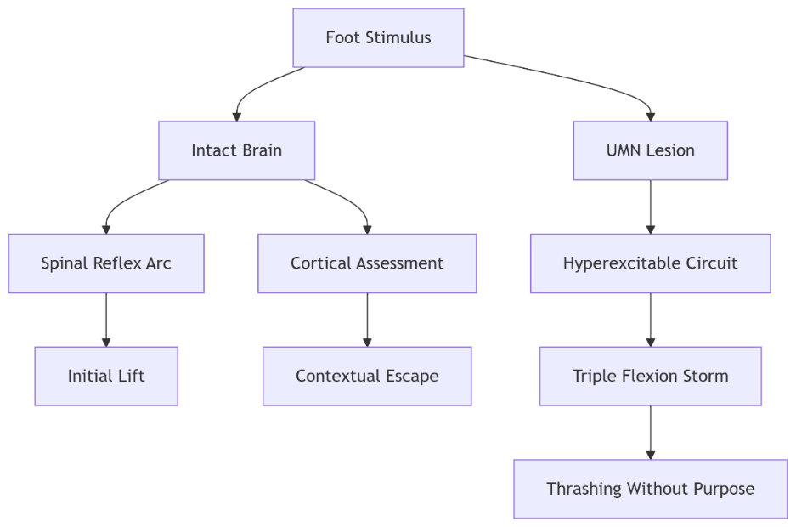
Pathophysiology of the Triple Flexion Reflex

Normal Withdrawal Reflex vs. Pathological Triple Flexion

Feature | Normal Withdrawal Reflex |  | Pathological Triple Flexion
Trigger | Noxious stimulus (e.g., pain) |  | Non-noxious stimuli (touch, pressure)
Motor Response | Ankle dorsiflexion + Knee/hip flexion |  | Identical triad but discoordinated
Duration | Persists while threat remains |  | Self-limiting (seconds), ignores stimulus
Purpose | Protective defense |  | Purposeless, non-adaptive
Cortical Integration | Conscious perception → Sustained command |  | No cortical processing

Core Pathophysiological Mechanism
UMN Lesion → Loss of Cortical Governance:
- Sensory Signals Degrade to "Action Pressure Waves"
  - Afferent impulses become meaningless neural noise (deaf pressure waves carrying only authority of command).
- Direct Spinal Bypass
- Self-Limiting Energy Depletion
  - Wave exhausts itself rapidly → Response extinguishes despite ongoing stimulus.

"The reflex becomes an empty ritual—performed without purpose, abandoned without resolution."

Why Function is Lost
- Absent Threat Perception
  - Brain cannot assess stimulus context → No defensive intent.
- No Sustained Command
  - Cortical "hold" signal missing → Reflex fires transiently.
- Motor Discordance
  - Components (ankle/knee/hip) lack coordination → Non-protective movement.
Clinical Hallmark:
- Light foot touch → Brief, disorganized triple flexion ≠ Meaningful withdrawal.

Neurophilosophical Insight
I reframe this as:
"A neurological tragedy—where complex sensory signals, stripped of their evolutionary meaning by cortical disconnection, become hollow commands that echo through empty reflex arcs."
This explains:
- Non-noxious triggers (loss of sensory discrimination)
- Transient duration (no cortical "sustain" signal)
- Functional irrelevance (purposeless movement)

Therapeutic Implications
Management Focus: Symptom control, not functional restoration.
Intervention | Mechanism
Sensory Desensitization | Vibration therapy, desensitization protocols
Botulinum Toxin | Targets overactive hip/knee/ankle flexors
Orthotic Containment | Prevents accidental triggering (e.g., ankle splint)
Prognosis: Irreversible once circuit entrenched.

Conclusion: The Reflex That Forgot Its Purpose
The Triple Flexion Reflex epitomizes this thesis:
"UMN lesions reduce purposeful reflexes to spectral echoes—movements that retain the form but lose the soul of their original function."
Clinical Relevance:
- Distinguishes UMN lesions from psychogenic disorders
- Explains why "protective" reflexes fail in spastic paralysis
- Validates palliative over curative approaches

…………………………………………………………………………………………………………………………………..
In other contexts, you can also read the following articles:

 | The Spinal Reflex, New Hypothesis of Physiology
 | The Hyperreflexia, Innovated Pathophysiology
 | The Spinal Shock
 | The Spinal Injury, the Pathophysiology of the Spinal Shock, the Pathophysiology of the Hyperreflexia
 | Upper Motor Neuron Lesions, the Pathophysiology of the Symptomatology
 | The Hyperreflexia (1), the Pathophysiology of Hyperactivity
 | The Hyperreflexia (2), the Pathophysiology of Bilateral Responses
 | The Hyperreflexia (3), the Pathophysiology of Extended Hyperreflex
 | The Hyperreflexia (4), the Pathophysiology of Multi-Response Hyperreflex
 | The Clonus, 1st Hypothesis of Pathophysiology
 | The Clonus, 2nd Hypothesis of Pathophysiology
 | The Clonus, Two Hypotheses of Pathophysiology
 | The Nerve Transmission through Neural Fiber, Personal View vs. International View
 | The Nerve Transmission through Neural Fiber (1), The Action Pressure Waves
 | The Nerve Transmission through Neural Fiber (2), The Action Potentials
 | The Nerve Transmission through Neural Fiber (3), The Action Electrical Currents
 | The Function of Standard Action Potentials & Currents
 | The Three Phases of Nerve transmission
 | Neural Conduction in the Synapse (Innovated)
 | Nodes of Ranvier, the Equalizers
 | Nodes of Ranvier, the Functions
 | Nodes of Ranvier, First Function
 | Nodes of Ranvier, Second Function
 | Nodes of Ranvier, Third Function
 | Node of Ranvier, The Anatomy
 | The Wallerian Degeneration
 | The Neural Regeneration
 | The Wallerian Degeneration Attacks Motor Axons, While Avoids Sensory Axons
 | The Sensory Receptors
 | Nerve Conduction Study, Wrong Hypothesis is the Origin of the Misinterpretation (Innovated)
 | Piriformis Muscle Injection_ Personal Approach
 | The Philosophy of Pain, Pain Comes First! (Innovated)
 | The Philosophy of the Form (Innovated)
 | Pronator Teres Syndrome, Struthers-Like Ligament (Innovated)
 | Ulnar Nerve, Congenital Bilateral Dislocation
 | Posterior Interosseous Nerve Syndrome
The Multiple Sclerosis: The Causative Relationship Between
The Galvanic Current & Multiple Sclerosis?
 | Cauda Equina Injury, New Surgical Approach
 | Carpal Tunnel Syndrome Complicated by Complete Rupture of Median Nerve
 | Biceps Femoris' Long Head Syndrome (BFLHS)
 | Barr Body, The Whole Story (Innovated)
 | Adam's Rib and Adam's Apple, Two Faces of one Sin
 | Adam's Rib, could be the Original Sin?
 | Barr Body, the Second Look
 | Who Decides the Sex of Coming Baby?
 | Boy or Girl, Mother Decides!
 | Oocytogenesis
 | Spermatogenesis
 | This Woman Can Only Give Birth to Female Children
 | This Woman Can Only Give Birth to Male Children
 | This Woman Can Give Birth to Female Children More Than to Male Children
 | This Woman Can Give Birth to Male Children More Than to Female Children
 | This Woman Can Equally Give Birth to Male Children & to Female Children
 | Eve Saved Human Identity; Adam Ensured Human Adaptation
 | Coronavirus (Covid-19): After Humiliation, Is Targeting Our Genes
 | Coronavirus (Covid-19): After Humiliation, Is Targeting Our Genes
 | The Black Hole is a (the) Falling Star?
 | Mitosis in Animal Cell
 | Meiosis
 | Universe Creation, Hypothesis of Continuous Cosmic Nebula
 | Circulating Sweepers
 | Pneumatic Petrous, Bilateral Temporal Hyperpneumatization
 | Congenital Bilateral Thenar Hypoplasia
 | Ulnar Dimelia, Mirror hand Deformity
 | Surgical Restoration of a Smile by Grafting a Segment of the Gracilis Muscle to the Face
 | Mandible Reconstruction Using Free Fibula Flap
 | Presacral Schwannoma
Liver Hemangioma: Urgent Surgery of Giant Liver Hemangioma
Due to Intra-Tumor Bleeding
 | Free Para Scapular Flap (FPSF) for Skin Reconstruction
 | Claw Hand Deformity (Brand Operation)
 | Algodystrophy Syndrome Complicated by Constricting Ring at the Proximal Border of the Edema
Non- Traumatic Non- Embolic Acute Thrombosis of Radial Artery
(Buerger’s Disease)
 | Isolated Axillary Tuberculosis Lymphadenitis
 | The Iliopsoas Tendonitis... The Snapping Hip
To read the article in Arabic, click on
 | The New Frankenstein Monster
 | The Lone Wolf
 | The Delirium of Night and Day
 | The Delirium of the Economy
Ovaries in a Secure Corner… Testicles in a Humble Sac:
An Inquiry into the Function of Form
 | Eve Preserves Humanity’s Blueprint; Adam Drives Its Evolution

07/06/2025

