Dr. Ammar Yaseen Mansour

Spinal Hyperreflexia: Pathophysiology
(The Lower Motor Neuron Circuit)
"This circuit isn't just damaged—it's rebelliously autonomous."

To watch a brief video explaining the pathophysiology of the spinal hyperreflexia,
click this link:

Core Concept: The Pathological LMN Circuit
Definition: A self-sustaining vicious circuit formed after upper motor neuron (UMN) lesion, where lower motor neurons (LMNs), by means of a group of interneurons, bypass brain control and directly interpret sensory input as motor commands.

Mechanism of Formation
Stage | Process
1. UMN Disconnection | Interruption of corticospinal pathways severs brain-spinal communication.
2. Aberrant Rewiring | LMNs, by means of a group of interneurons, form new synapses with sensory neurons (same/adjacent segments).
3. Signal Misinterpretation | LMNs treat all sensory impulses as "binding motor commands" requiring immediate execution.
4. Circuit Entrenchment | The LMN circuit becomes functionally "impenetrable," resisting cortical reintegration attempts.
"Neural currents carry no identity—to the LMN, every signal is an order to act."

Key Pathological Features
- Self-Perpetuating Vicious Cycle:
  - Reinforces synaptic connections, becoming resistant to top-down modulation.
- Functional "Fortress" Effect:
  - Blocks descending motor commands even if neural repair occurs ("newly formed cortical pathways struggle against entrenched LMN circuits").
- Prognostic Weight:
  - Primary reason for poor recovery in chronic UMN lesions.

Clinical Manifestations
Hyperreflexia manifests as:
- Involuntary Movements:
  - Coarse, uncoordinated motor outputs (e.g., spastic synergy patterns).
- Loss of Modulation:
  - Responses lack intensity control (non-graded), spatial specificity (non-localized), or contextual relevance (non-adaptive).
- Signature of UMN Lesions:
  - Babinski sign, clonus, spasticity reflect this pathological circuit.
"These are not reflexes but distorted motor echoes—brainless, purposeless, chaotic."

Contrast: Normal vs. Pathological Reflex
Aspect | Normal Spinal Reflex | Pathological Hyperreflexia
Control | Brain-supervised | Autonomous LMN circuit
Input | Filtered sensory data | Raw sensory bombardment
Output | Precise, adaptive | Stereotyped, explosive
Purpose | Protective/adaptive | None (maladaptive)

Therapeutic Implications
- Early Intervention Critical:
Prevents circuit entrenchment ("once solidified, disconnection is near-impossible").
- Target LMN Circuit Directly:
  - Botulinum toxin: Blocks aberrant neuromuscular transmission.
  - Intrathecal baclofen: Suppresses sensory-motor synaptic hyperactivity.
- Neuromodulation Failure:
Cortical retraining fails if the "LMN fortress" blocks descending signals.

Conclusion: The Autonomy of Chaos
This model reframes hyperreflexia as a self-organized pathological entity—not merely "released" reflexes but:
- A hijacked motor pathway (LMNs commanding themselves).
- A prognostic black hole worsening UMN lesion outcomes.
- The neurobiological basis for treatment-resistant spasticity.
"In UMN lesions, the spinal cord becomes a rebel province—issuing orders without a king."

Visual Summary: See Figure below for the LMN circuit’s aberrant sensory-motor wiring.

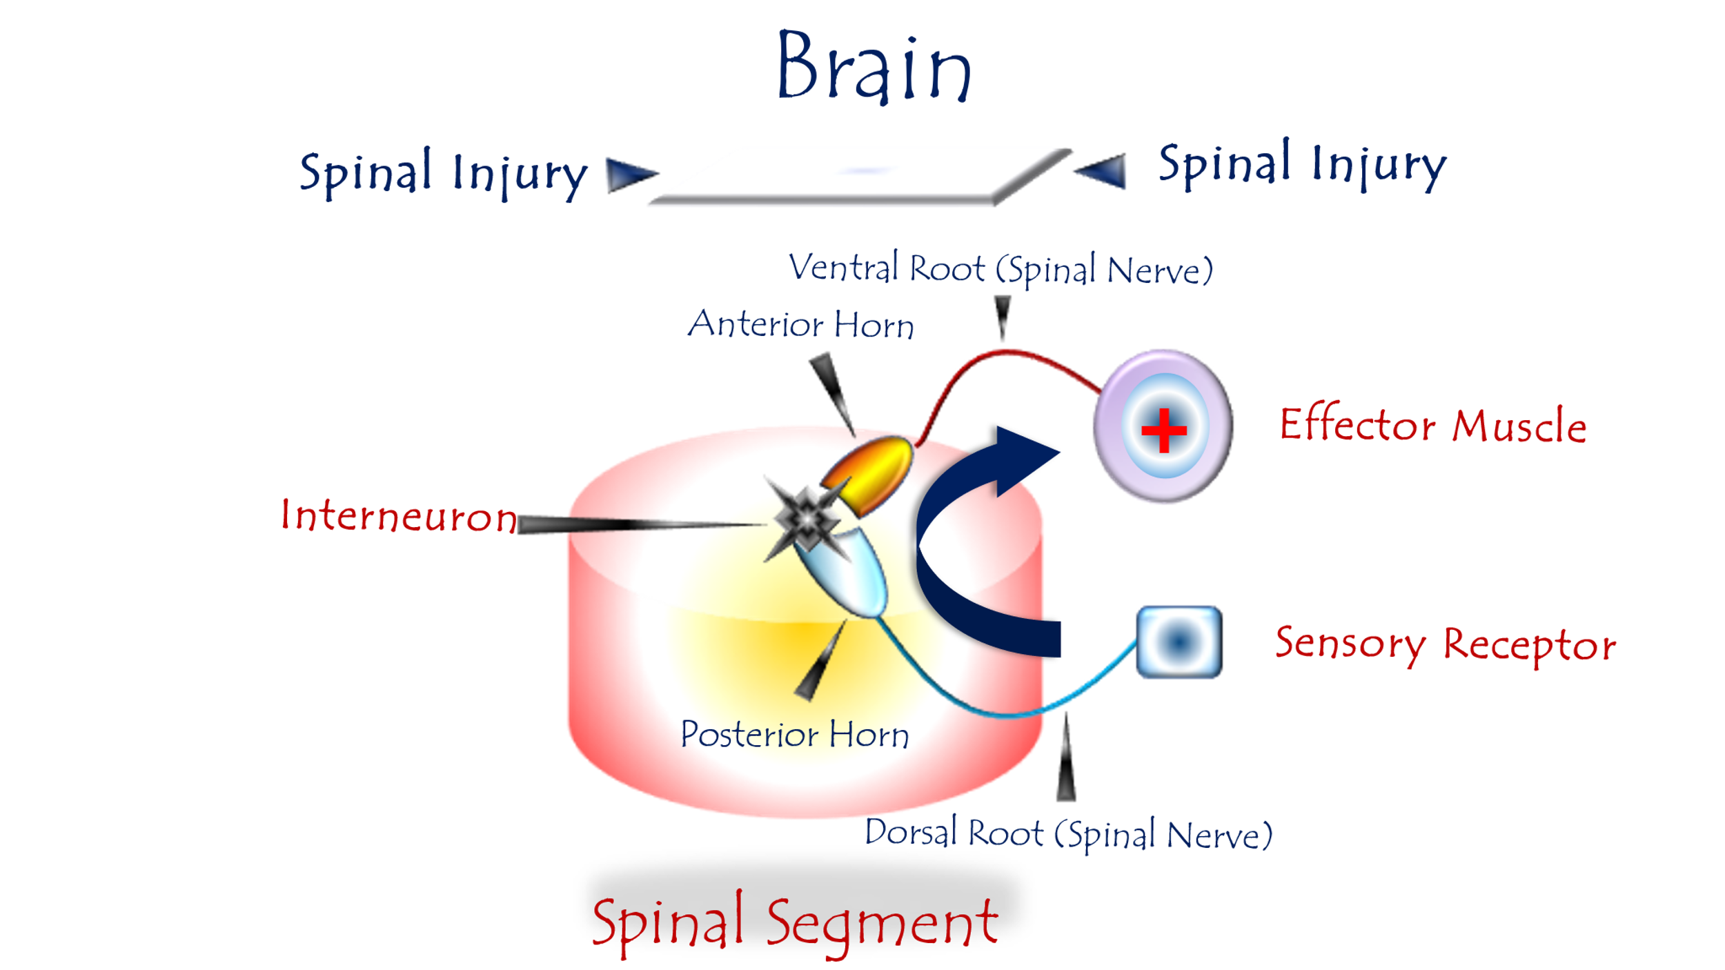
Pathophysiology of Spinal Hyperreflexia
(The Lower Motor Neuron Circuit)
For video explanation, click:

Core Mechanism: Pathological Rewiring Post-UMN Lesion
Trigger: Disconnection between upper motor neurons (brain) and lower motor neurons (spinal cord).
Response: Spinal elements form an aberrant self-sustaining circuit through:
- Novel Neural Bridges
  - LMNs, sensory neurons, and interneurons forge new synaptic connections (same/adjacent segments).
- Sensory-Motor Hijacking
  - Sensory neurons dump raw, unprocessed input directly onto LMNs.
- Signal Misinterpretation
  - LMNs treat all sensory signals as "mandatory motor commands.
"The LMN circuit becomes a dictator—issuing orders without context or restraint."

Pathological Characteristics
Feature | Consequence
Unfiltered Input | Sensory impulses bypass brain modulation → Sensory bombardment
Non-Selective Execution | LMNs execute all signals → Non-graded, explosive movements
Functional Incompetence | Responses mismatch stimulus intensity/purpose → Maladaptive outputs
Circuit Entrenchment | Becomes a "functional fortress" resisting cortical reintegration
Clinical Manifestations:
- Spasticity, clonus, Babinski sign
- Coarse involuntary movements
- Loss of fine motor control

Why This Circuit Dooms Recovery
- Blocks Cortical Reconnection
  - Even if UMN pathways heal, the entrenched LMN circuit intercepts descending commands.
- Self-Reinforcing Vicious Cycle
  - Synaptic strengthening makes disruption progressively harder.
- Worsens Prognosis
  - Primary reason for treatment-resistant spasticity in chronic UMN lesions.

"This circuit isn't just damaged—it's rebelliously autonomous."

Contrast: Normal vs. Pathological LMN
Function | Healthy LMN | Pathological LMN Circuit
Input Processing | Receives filtered brain orders | Interprets raw sensory noise
Output Control | Precision movements | Explosive, uncoordinated actions
Hierarchy | Subordinate to brain | Self-governing "dictatorship"
Adaptability | Context-appropriate responses | Stereotyped, non-adaptive reactions

Therapeutic Implications
Intervention Goals:
- Prevent Circuit Formation
  - Early neuromodulation.
- Disrupt Existing Circuit
  - Intrathecal baclofen: Suppresses synaptic hyperactivity.
  - Botulinum toxin: Chemically denervates overactive LMNs.
- Cortical Bypass Strategies
  - Brain-computer interfaces to reroute motor commands.

Prognostic Reality:
- Once solidified, the circuit becomes a permanent pathological entity.
- Explains why chronic spasticity rarely fully resolves.

Conclusion: The Autonomy of Dysfunction
This model reframes hyperreflexia as:
"A self-organized neural insurgency—where spinal elements seize control, executing chaos without purpose or permission."
This circuit embodies the tragic paradox of neuroplasticity: The same adaptability that enables recovery also forges chains of permanent dysfunction.
……………………………………………………………………………………………………..

In other contexts, you can also read the following articles:
The Spinal Reflex, New Hypothesis of Physiology
The Hyperreflexia, Innovated Pathophysiology
The Spinal Shock
The Spinal Injury, the Pathophysiology of the Spinal Shock, the Pathophysiology of the Hyperreflexia
Upper Motor Neuron Lesions, the Pathophysiology of the Symptomatology
The Hyperreflexia (1), the Pathophysiology of Hyperactivity
The Hyperreflexia (2), the Pathophysiology of Bilateral Responses
The Hyperreflexia (3), the Pathophysiology of Extended Hyperreflex
The Hyperreflexia (4), the Pathophysiology of Multi-Response Hyperreflex
The Clonus, 1st Hypothesis of Pathophysiology
The Clonus, 2nd Hypothesis of Pathophysiology
The Clonus, Two Hypotheses of Pathophysiology
The Nerve Transmission through Neural Fiber, Personal View vs. International View
The Nerve Transmission through Neural Fiber (1), The Action Pressure Waves
The Nerve Transmission through Neural Fiber (2), The Action Potentials
The Nerve Transmission through Neural Fiber (3), The Action Electrical Currents
The Function of Standard Action Potentials & Currents
The Three Phases of Nerve transmission
Neural Conduction in the Synapse (Innovated)
Nodes of Ranvier, the Equalizers
Nodes of Ranvier, the Functions
Nodes of Ranvier, First Function
Nodes of Ranvier, Second Function
Nodes of Ranvier, Third Function
Node of Ranvier, The Anatomy
The Wallerian Degeneration
The Neural Regeneration
The Wallerian Degeneration Attacks Motor Axons, While Avoids Sensory Axons
The Sensory Receptors
Nerve Conduction Study, Wrong Hypothesis is the Origin of the Misinterpretation (Innovated)
Piriformis Muscle Injection_ Personal Approach
The Philosophy of Pain, Pain Comes First! (Innovated)
The Philosophy of the Form (Innovated)
Pronator Teres Syndrome, Struthers-Like Ligament (Innovated)
Ulnar Nerve, Congenital Bilateral Dislocation
Posterior Interosseous Nerve Syndrome
The Multiple Sclerosis: The Causative Relationship Between
The Galvanic Current & Multiple Sclerosis?
Cauda Equina Injury, New Surgical Approach
Carpal Tunnel Syndrome Complicated by Complete Rupture of Median Nerve
Biceps Femoris' Long Head Syndrome (BFLHS)
Barr Body, The Whole Story (Innovated)
Adam's Rib and Adam's Apple, Two Faces of one Sin
Adam's Rib, could be the Original Sin?
Barr Body, the Second Look
Who Decides the Sex of Coming Baby?
Boy or Girl, Mother Decides!
Oocytogenesis
Spermatogenesis
This Woman Can Only Give Birth to Female Children
This Woman Can Only Give Birth to Male Children
This Woman Can Give Birth to Female Children More Than to Male Children
This Woman Can Give Birth to Male Children More Than to Female Children
This Woman Can Equally Give Birth to Male Children & to Female Children
Eve Saved Human Identity; Adam Ensured Human Adaptation
Coronavirus (Covid-19): After Humiliation, Is Targeting Our Genes
Coronavirus (Covid-19): After Humiliation, Is Targeting Our Genes
The Black Hole is a (the) Falling Star?
Mitosis in Animal Cell
Meiosis
Universe Creation, Hypothesis of Continuous Cosmic Nebula
Circulating Sweepers
Pneumatic Petrous, Bilateral Temporal Hyperpneumatization
Congenital Bilateral Thenar Hypoplasia
Ulnar Dimelia, Mirror hand Deformity
Surgical Restoration of a Smile by Grafting a Segment of the Gracilis Muscle to the Face
Mandible Reconstruction Using Free Fibula Flap
Presacral Schwannoma
Liver Hemangioma: Urgent Surgery of Giant Liver Hemangioma
Due to Intra-Tumor Bleeding
Free Para Scapular Flap (FPSF) for Skin Reconstruction
Claw Hand Deformity (Brand Operation)
Algodystrophy Syndrome Complicated by Constricting Ring at the Proximal Border of the Edema
Non- Traumatic Non- Embolic Acute Thrombosis of Radial Artery
(Buerger’s Disease)
Isolated Axillary Tuberculosis Lymphadenitis
The Iliopsoas Tendonitis... The Snapping Hip
To read the article in Arabic, click on
The New Frankenstein Monster
The Lone Wolf
The Delirium of Night and Day
The Delirium of the Economy
Ovaries in a Secure Corner… Testicles in a Humble Sac:
An Inquiry into the Function of Form
Eve Preserves Humanity’s Blueprint; Adam Drives Its Evolution

1/6/2020

