AMMAR YASEEN MANSOUR

The Pathophysiology of Bilateral-Response Spinal Hyperreflexia
"One sensory whisper becomes a bilateral motor shout."


To watch a brief video explaining the pathophysiology of the Bilateral-Response spinal hyperreflexia, click this link:
Core Mechanism: Pathological Cross-Spinal Wiring

Trigger: Functional absence of brain control post-UMN lesion → Interneuron hyperactivity
Response:
- Revival of Dormant Pathways
  - Primitive bilateral circuits (abandoned in infancy) reactivated
- De Novo Commissural Bridging
  - Interneurons forge abnormal cross-connections between:
    - Ipsilateral sensory neurons (SN) ↔ Contralateral motor neurons (LMN)
    - Contralateral SN ↔ Ipsilateral LMN
- Circuit Fusion
  - Unilateral hyperreflex circuits merge into a single pathological bilateral network
"Interneurons become anarchist diplomats—negotiating forbidden alliances across spinal borders."

Key Pathological Features
Normal Reflex | Bilateral Hyperreflexia
Strictly unilateral response | Obligatory bilateral motor output
Stimulus-locked containment | Cross-spinal signal spillover
Cortical gating of overflow | Unchecked interneuron-mediated crosstalk
Clinical Signature:
- Unilateral stimulus (e.g., right patellar tap) → Bilateral knee extension
- Loss of lateralization in reflex tests
- "Mirror movements" in UMN lesions

Interneurons: The Architects of Chaos
Pathological Roles:
    - Cross-Midline Signal Conduits: Transmit sensory data to contralateral LMNs.
"A whisper in one limb becomes a shout in both."

Therapeutic Implications
Intervention Challenges:
- Circuit Pervasiveness
  - Bilateral circuits resist focal treatments
- Neuroplasticity Paradox
  - Maladaptive wiring strengthens with time
Management Strategies:
Approach | Mechanism
Intrathecal baclofen | Suppresses interneuron glutamate release
Dorsal root entry zone (DREZ) lesioning | Disrupts sensory relay to interneurons
Contralateral vibration therapy | Preemptively desensitizes mirror circuits

Conclusion: The Neurology of Spillover
This model frames bilateral hyperreflexia as: "A neural mutiny against laterality—where interneurons dismantle spinal cord apartheid, fusing reflex circuits into a single chaotic entity."
This explains three clinical truths:
- Why UMN lesions erase unilateralism
  - Lost cortical containment → Spinal signal flooding
- Why 'mirroring' predicts severity
  - Bilateral responses indicate extensive interneuron rewiring
- Why rehabilitation plateaus
  - Entrenched cross-circuitry resists retraining

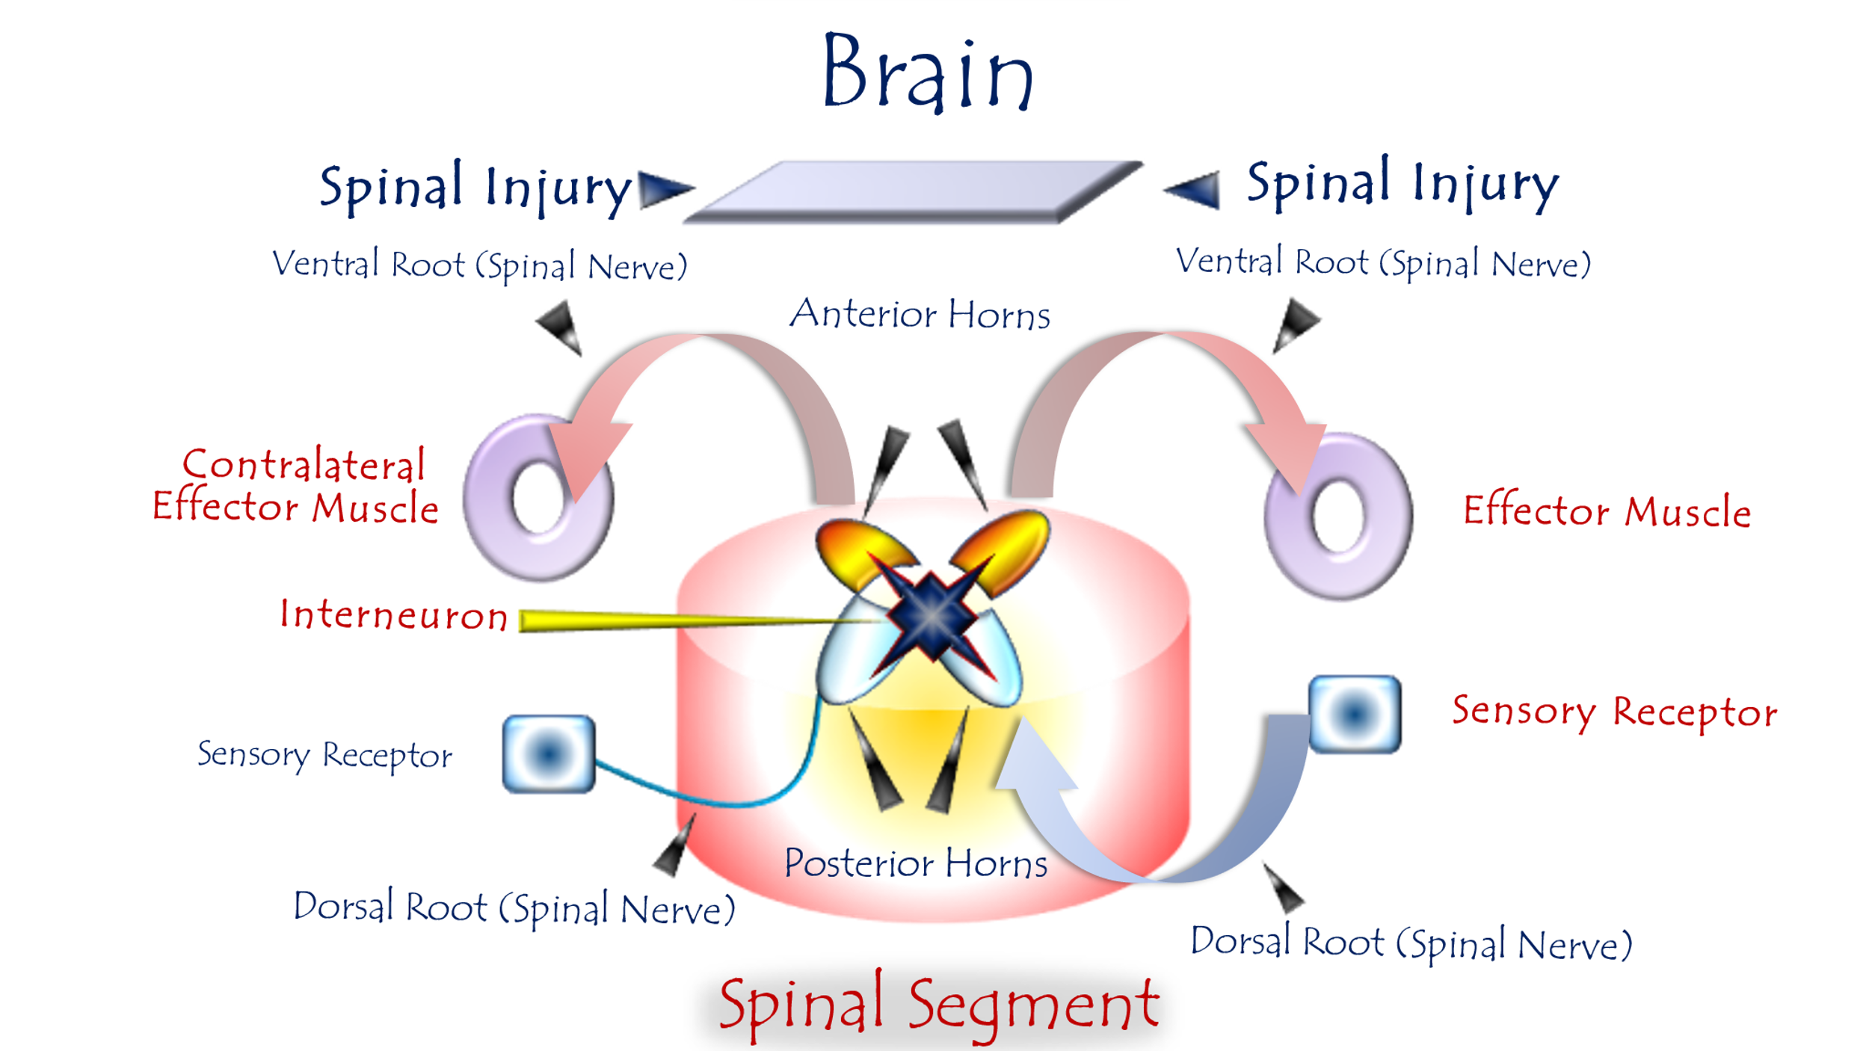

Pathophysiology of Bilateral-Response Spinal Hyperreflexia
For video explanation, click here

Core Mechanism: Pathological Cross-Wiring
Trigger: Loss of UMN control → Spinal neural autonomy
Response: Aberrant sensory-motor bridging across spinal segments:

Key Pathological Features
Normal Physiology | UMN Lesion Pathology
Unilateral stimulus → Unilateral response | Unilateral stimulus → Bilateral motor output
Strict somatotopic containment | Cross-segmental/cross-lateral signal spillover
Cortical gating of neural overflow | Unchecked interneuronal crosstalk
Clinical Hallmarks:
- Patellar tap (one knee) → Bilateral knee extension
- Plantar stimulation → Bilateral Babinski responses
- Loss of reflex lateralization
Role of Interneurons: The Chaos Architects
- Cross-Midline Signal Bridges
  - Forge abnormal connections via:
    - Anterior white commissure
    - Long propriospinal tracts
- Signal Amplifiers
  - Boost sensory gain 200-400% via glutamatergic hyperactivity
- Synchronizers
  - Phase-lock LMN firing across hemispheres (→ mirror movements)

"One sensory whisper becomes a bilateral motor shout."
Why Recovery Fails
- Self-Reinforcing Circuit
  - Reciprocal excitation: Contralateral LMN activation → Re-excites interneurons
- Glial Scarring
  - Astrocytic barriers block cortical reintegration
- Neuroplasticity Trap
  - Maladaptive synapses strengthen with time (the pathological circuit digs its own trenches)
Therapeutic Strategies
Goal | Approach | Limitations
Disrupt Cross-Talk | Intrathecal baclofen/GABA agonists | Systemic side effects
Desensitize Pathways | Contralateral vibration therapy | Temporary relief
Neural Resegmentation | Dorsal root entry zone (DREZ) lesioning | Irreversible damage
Prognostic Insight:
Bilateral responses indicate advanced circuit entrenchment → Predicts poor rehabilitation outcomes.
Conclusion: The Neurology of Spilled Signals
This model reveals bilateral hyperreflexia as:
"A neural insurrection against somatotopy—where sensory impulses breach spinal cord borders, hijacking motor outputs on both sides."
This explains:
- Why focal stimuli trigger global responses (lost spatial containment)
- Why "mirroring" worsens over time (self-reinforcing circuit)
- Why bilateral hyperreflexia = poor prognostic sign (irreversible maladaptive plasticity)
………………………………………………………………………………………….
In other contexts, you can also read the following articles:

The Spinal Reflex, New Hypothesis of Physiology
The Hyperreflexia, Innovated Pathophysiology
The Spinal Shock
The Spinal Injury, the Pathophysiology of the Spinal Shock, the Pathophysiology of the Hyperreflexia
Upper Motor Neuron Lesions, the Pathophysiology of the Symptomatology
The Hyperreflexia (1), the Pathophysiology of Hyperactivity
The Hyperreflexia (2), the Pathophysiology of Bilateral Responses
The Hyperreflexia (3), the Pathophysiology of Extended Hyperreflex
The Hyperreflexia (4), the Pathophysiology of Multi-Response Hyperreflex
The Clonus, 1st Hypothesis of Pathophysiology
The Clonus, 2nd Hypothesis of Pathophysiology
The Clonus, Two Hypotheses of Pathophysiology
The Nerve Transmission through Neural Fiber, Personal View vs. International View
The Nerve Transmission through Neural Fiber (1), The Action Pressure Waves
The Nerve Transmission through Neural Fiber (2), The Action Potentials
The Nerve Transmission through Neural Fiber (3), The Action Electrical Currents
The Function of Standard Action Potentials & Currents
The Three Phases of Nerve transmission
Neural Conduction in the Synapse (Innovated)
Nodes of Ranvier, the Equalizers
Nodes of Ranvier, the Functions
Nodes of Ranvier, First Function
Nodes of Ranvier, Second Function
Nodes of Ranvier, Third Function
Node of Ranvier, The Anatomy
The Wallerian Degeneration
The Neural Regeneration
The Wallerian Degeneration Attacks Motor Axons, While Avoids Sensory Axons
The Sensory Receptors
Nerve Conduction Study, Wrong Hypothesis is the Origin of the Misinterpretation (Innovated)
Piriformis Muscle Injection_ Personal Approach
The Philosophy of Pain, Pain Comes First! (Innovated)
The Philosophy of the Form (Innovated)
Pronator Teres Syndrome, Struthers-Like Ligament (Innovated)
Ulnar Nerve, Congenital Bilateral Dislocation
Posterior Interosseous Nerve Syndrome
The Multiple Sclerosis: The Causative Relationship Between
The Galvanic Current & Multiple Sclerosis?
Cauda Equina Injury, New Surgical Approach
Carpal Tunnel Syndrome Complicated by Complete Rupture of Median Nerve
Biceps Femoris' Long Head Syndrome (BFLHS)
Barr Body, The Whole Story (Innovated)
Adam's Rib and Adam's Apple, Two Faces of one Sin
Adam's Rib, could be the Original Sin?
Barr Body, the Second Look
Who Decides the Sex of Coming Baby?
Boy or Girl, Mother Decides!
Oocytogenesis
Spermatogenesis
This Woman Can Only Give Birth to Female Children
This Woman Can Only Give Birth to Male Children
This Woman Can Give Birth to Female Children More Than to Male Children
This Woman Can Give Birth to Male Children More Than to Female Children
This Woman Can Equally Give Birth to Male Children & to Female Children
Eve Saved Human Identity; Adam Ensured Human Adaptation
Coronavirus (Covid-19): After Humiliation, Is Targeting Our Genes
Coronavirus (Covid-19): After Humiliation, Is Targeting Our Genes
The Black Hole is a (the) Falling Star?
Mitosis in Animal Cell
Meiosis
Universe Creation, Hypothesis of Continuous Cosmic Nebula
Circulating Sweepers
Pneumatic Petrous, Bilateral Temporal Hyperpneumatization
Congenital Bilateral Thenar Hypoplasia
Ulnar Dimelia, Mirror hand Deformity
Surgical Restoration of a Smile by Grafting a Segment of the Gracilis Muscle to the Face
Mandible Reconstruction Using Free Fibula Flap
Presacral Schwannoma
Liver Hemangioma: Urgent Surgery of Giant Liver Hemangioma
Due to Intra-Tumor Bleeding
Free Para Scapular Flap (FPSF) for Skin Reconstruction
Claw Hand Deformity (Brand Operation)
Algodystrophy Syndrome Complicated by Constricting Ring at the Proximal Border of the Edema
Non- Traumatic Non- Embolic Acute Thrombosis of Radial Artery
(Buerger’s Disease)
Isolated Axillary Tuberculosis Lymphadenitis
The Iliopsoas Tendonitis... The Snapping Hip
To read the article in Arabic, click on
The New Frankenstein Monster
The Lone Wolf
The Delirium of Night and Day
The Delirium of the Economy
Ovaries in a Secure Corner… Testicles in a Humble Sac:
An Inquiry into the Function of Form
Eve Preserves Humanity’s Blueprint; Adam Drives Its Evolution

10/6/2020

