Dr. Ammar Yaseen Mansour
Pathophysiology of Clonus
Clonus manifests as involuntary, rhythmic oscillations – aberrant sequential cycles of joint flexion and extension. Pathological clonus requires >5 flexion-extension cycles. While similar movements may occur in healthy individuals, they never exceed 5 cycles. When accompanied by other signs of Upper Motor Neuron (UMN) lesions, even brief clonus (<5 cycles) warrants diagnostic consideration. Clinically, we primarily investigate clonus at the knee and ankle. Though possible elsewhere, such occurrences remain exceptional.

Clonus: 1st Pathophysiological Hypothesis
“Asynchronous Afferent Barrage”
"One stretch becomes a symphony of desynchronized commands - each afferent volley demanding its own motor encore"

To watch a detailed video explaining this hypothesis, click this link:

Within the operational field of every spinal reflex, specialized sensory receptors serve as the reflex's trigger points. Alongside them reside other sensory receptor types – all occupying the same territory where reflex-triggering stimuli occur.
Each receptor possesses its own dedicated neural axon. Since receptors differ functionally, their afferent axons exhibit distinct properties – particularly variable neural conduction velocities.
Neural transmission is maximally rapid in myelinated alpha-type axons, yet markedly slow in delta-type axons – among others. Similarly, transmission through demyelinated axons is severely delayed. Even within a single fiber type, conduction velocity varies significantly with axonal diameter.
This inherent disparity in conduction velocities across afferent pathways constitutes the fundamental mechanism underlying the First Hypothesis of Clonic Pathophysiology.
Under physiological conditions, sensory receptors (numbering X) distribute a stimulus' energy among themselves – each according to its functional specialization. Subsequently, via heterogeneous neural pathways, signals from these receptors converge as a hybrid, non-homogenous afferent impulse carrying X distinct sensory elements.
The brain purifies and processes this composite input. Through meticulous filtering, decoding, and integration, it distills the heterogeneous sensory stream into a singular efferent motor command – delivered to the lower motor neuron as one unified execution order.
When the brain becomes functionally absent, a hyperreflexic spinal circuit emerges. Sensory neurons aberrantly connect with lower motor neurons via interneurons – bypassing cortical governance.
The hybrid afferent impulse (comprising X distinct signals) escapes cerebral supervision. It descends unprocessed to the LMN, retaining its raw temporal dispersion from peripheral receptors.
The fastest-conducting impulses trigger the initial muscle contraction. The mid-velocity signals arrive eliciting sequential contractions. The slowest impulses drive terminal oscillations.
This cascade of desynchronized muscle activations manifests as involuntary movement repetition in hyperreflexic states – the phenomenon we term Clonus. (Figure 1).
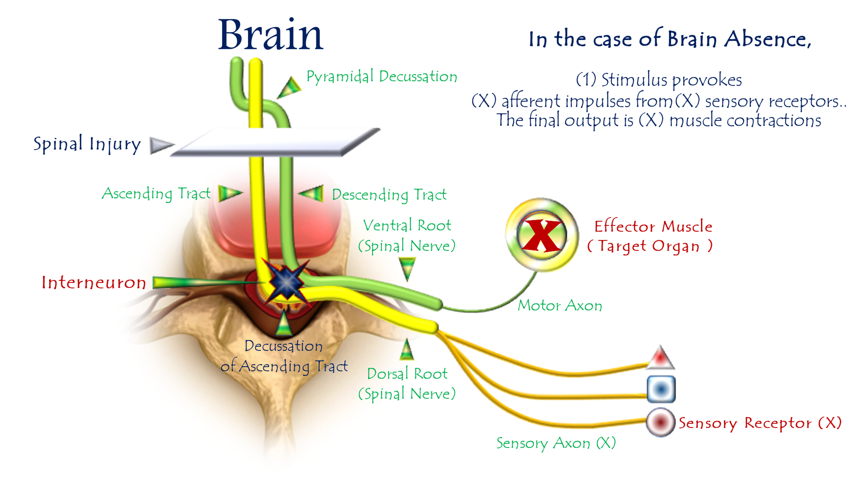
Figure 1: First Hypothesis of Clonus Pathophysiology
(Temporal Dispersion → Clonic Oscillation)
For video explanation, click here:

Core Mechanism: Temporal Dispersion → Rhythmic Oscillations
Normal vs. Pathological Processing
Stage | Healthy State | UMN Lesion State
Afferent Signal | Hybrid impulse (X elements) | Identical hybrid impulse
Integration | Cortical processing → Unified command | Direct spinal relay
Motor Output | Single calibrated response | X sequential responses
Feedback Loop | Purposeful termination | Self-sustaining oscillations
Key Pathophysiological Steps
- Stimulus Application
  - Activates heterogeneous receptor cohort (muscle spindles, Golgi, nociceptors)
- Temporal Dispersion
  - Variable conduction velocities → Staggered afferent arrival at spinal cord
- Spinal Relay Hijacking
  - Interneurons deliver raw volleys directly to LMNs
- Serial Motor Firing
  - Fastest volley → Initial contraction (e.g., dorsiflexion)
  - Intermediate volley → Secondary contraction
  - Slowest volley → Tertiary contraction
"One stretch becomes a symphony of desynchronized commands - each afferent volley demanding its own motor encore"
Clinical Validation
Observation | Explained by Hypothesis
>5 beats pathological | Minimum volleys needed for sustained rhythm
Ankle predominance | Longest nerve → Maximal temporal dispersion
Velocity-dependence | Faster stretch → More receptors recruited
33 Hz frequency | Matches 30ms delay (1/0.03s = 33 Hz)
Conclusion: The Neurology of Desynchronization
This model reveals clonus as:
"A temporal breakdown in neural orchestration - where lost cortical conduction exposes the inherent asynchrony of sensory pathways, converting singular stimuli into rhythmic motor cascades."
Diagnostic Imperatives:
- Test for >5 beats even without hyperreflexia
- Prioritize ankle assessment (highest diagnostic yield)
- Early intervention prevents circuit entrenchment

Clonus: 2nd Pathophysiological Hypothesis
"An endless duel of action-reaction—where each reflex fuels its enemy's retaliation"
To watch a detailed video explaining this hypothesis, click:
Clonus may alternatively be conceptualized as a cascade of spatially opposed, functionally antagonistic spinal reflexes. These reflexes fire sequentially yet overlap temporally – where the termination of one reflex triggers its functional counterpart in a self-perpetuating kinetic chain. Each reflex conclusion serves as the initiator for its successor, creating a movement continuum that may persist for prolonged durations.
In Upper Motor Neuron (UMN) injuries, sudden ankle dorsiflexion elicits clonus – clinically characterized by involuntary, rhythmic ankle flexion-extension oscillations. Deconstructing this movement reveals its elemental composition: each oscillation embodies the sequential firing of two antagonistic reflexes:
- Achilles Reflex (Plantarflexion via S1-L5)
- Tibialis Anterior Reflex (Dorsiflexion via L4-L5)
Pathomechanics of Ankle Clonus
Initial Trigger:
Sudden ankle dorsiflexion imposes axial tension on the Achilles tendon. This stimulates tendon receptors (Golgi organs) to detect abrupt structural changes, activating the pathological spinal reflex circuit.
Phase 1: Plantarflexion Reflex
Violently and abruptly, the target muscles (Gastrocnemius and Soleus) contract Resulting in powerful plantarflexion.
Phase 2: Reciprocal Reflex Triggering
This forceful and sudden plantarflexion stretches the antagonistic muscle group (tibialis anterior), activating a second pathological spinal reflex – the hyperreflexic tibialis anterior reflex.
Following its own violent and sudden stretch, the Tibialis Anterior Muscle contracts with equal force and abruptness, producing forceful dorsal flexion (ankle dorsiflexion) as the kinetic counter-response. This antagonistic rebound inevitably reignites the opposing reflex cascade.
Here, both logic and function vanish – transforming movement into a self-perpetuating feud of action and counter-action. An unstoppable cascade of involuntary motions ceases only when:
- Muscular energy reserves deplete, OR
- Spontaneous reflex decay dampens the pathological circuits.
Terminal Phase:
The action fades... its reaction falters... until both dissolve into neurological silence. Thus concludes the combatants' ceasefire – a temporary armistice awaiting inevitable future battles. (Figure 2).

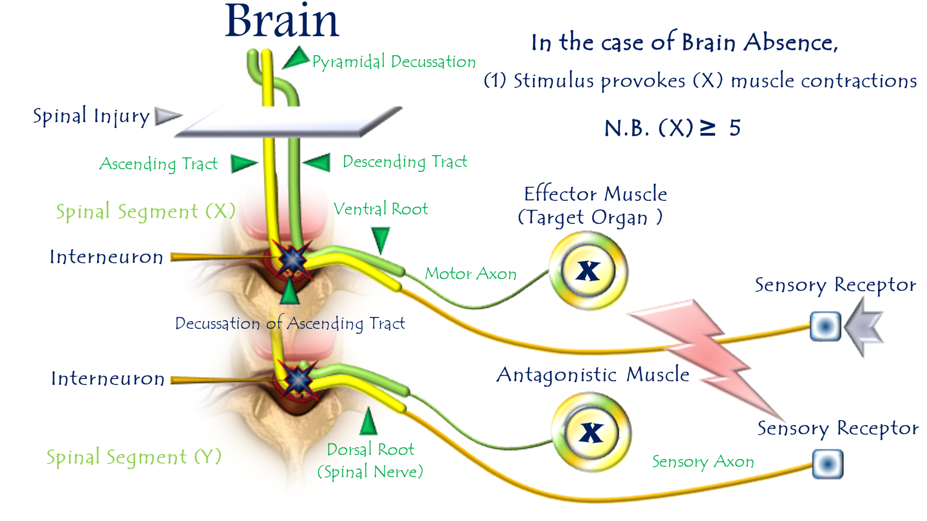
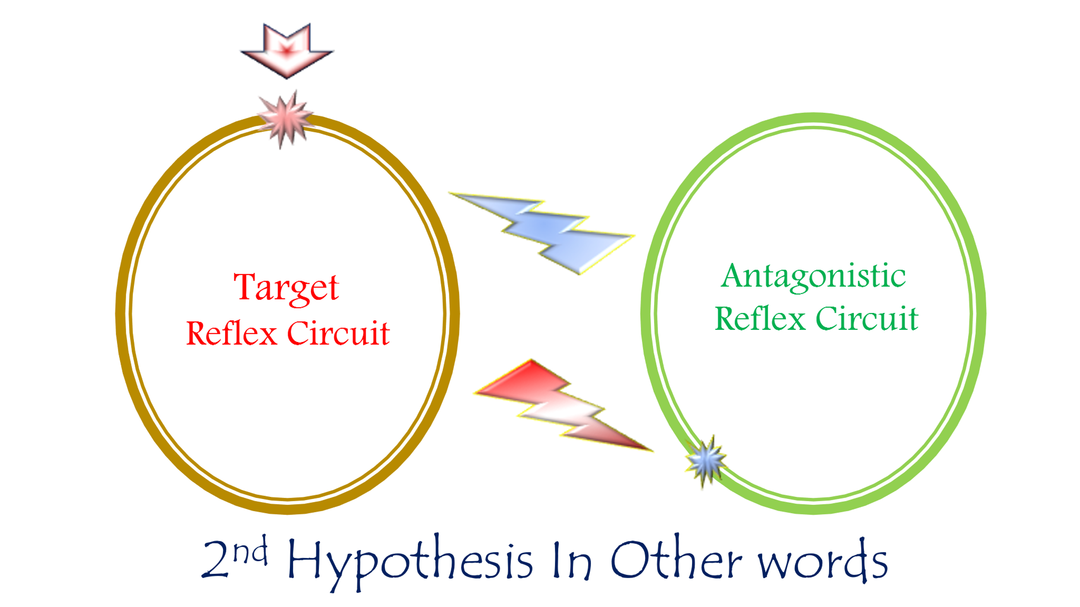

Figure 2: Second Hypothesis of Clonus Pathophysiology
(The Lifecycle of Pathological Oscillations)
For video explanation, click here:
Core Mechanism: Antagonistic Reflex Warfare
An endless duel of action-reaction—where each reflex fuels its enemy's retaliation.
Key Pathological Features
Phase | Neurophysiological Event | Clinical Manifestation
Initiation | Violent Achilles tendon stretch | Sudden ankle dorsiflexion
Counterstrike 1 | Unchecked plantarflexion reflex | Explosive foot downward jerk
Counterstrike 2 | Tibialis anterior stretch → Reflex contraction | Forceful foot upward jerk
Perpetuation | Cyclical re-stretching | Rhythmic oscillations (clonus)
Cessation | ATP depletion + neural fatigue | Self-limiting collapse (>5 beats)
Why This Explains Clinical Clonus
- Rhythmicity:
  - Alternating agonist/antagonist firing creates stereotyped flexion-extension cycles
- Ankle Predilection:
  - Maximal mechanical advantage between gastrocnemius (PF) and tibialis anterior (DF)
- Self-Limitation:
  - Terminates when:
    - Muscles exhaust ATP reserves
    - LMNs enter refractory state
    - Reflex gain spontaneously dampens
- UMN Specificity:
  - Requires lost reciprocal inhibition (normally mediated by UMNs)

Contrast with Normal Physiology
Normal Reflexes | Clonus State
Reciprocal inhibition blocks antagonists | Mutual excitation of enemies
Cortical modulation grades responses | Explosive, non-calibrated contractions
Functionally protective | Purposeless energy waste
Therapeutic Targets
Goal | Intervention | Mechanism
Break the Loop | Botulinum toxin to gastrocnemius & tibialis anterior | Chemodenervation of combatant muscles
Restore Inhibition | Intrathecal baclofen | GABA-B receptor agonism
Limit Stretch | Ankle-foot orthosis (AFO) | Prevents sudden dorsiflexion trigger
Conclusion: Neurology of Reflex Combat
This hypothesis reframes clonus as:
"A futile neural war—where Achilles and tibialis anterior reflexes become locked in mutual destruction, each contraction stretching the opponent into retaliation, until biochemical exhaustion forces a temporary truce."
Clinical Imperatives:
- Test for >5 beats after sudden dorsiflexion
- Address early (before maladaptive circuit entrenchment)
- Combine chemical denervation + mechanical containment
……………………………………………………………………………………………………
In other contexts, you can also read the following articles:
 | The Spinal Reflex, New Hypothesis of Physiology
 | The Hyperreflexia, Innovated Pathophysiology
 | The Spinal Shock
 | The Spinal Injury, the Pathophysiology of the Spinal Shock, the Pathophysiology of the Hyperreflexia
 | Upper Motor Neuron Lesions, the Pathophysiology of the Symptomatology
 | The Hyperreflexia (1), the Pathophysiology of Hyperactivity
 | The Hyperreflexia (2), the Pathophysiology of Bilateral Responses
 | The Hyperreflexia (3), the Pathophysiology of Extended Hyperreflex
 | The Hyperreflexia (4), the Pathophysiology of Multi-Response Hyperreflex
- | The pathophysiology of Triple flexion Reflex
 | The Clonus, 1st Hypothesis of Pathophysiology
 | The Clonus, 2nd Hypothesis of Pathophysiology
 | The Clonus, Two Hypotheses of Pathophysiology
 | The Nerve Transmission through Neural Fiber, Personal View vs. International View
 | The Nerve Transmission through Neural Fiber (1), The Action Pressure Waves
 | The Nerve Transmission through Neural Fiber (2), The Action Potentials
 | The Nerve Transmission through Neural Fiber (3), The Action Electrical Currents
 | The Function of Standard Action Potentials & Currents
 | The Three Phases of Nerve transmission
 | Neural Conduction in the Synapse (Innovated)
 | Nodes of Ranvier, the Equalizers
 | Nodes of Ranvier, the Functions
 | Nodes of Ranvier, First Function
 | Nodes of Ranvier, Second Function
 | Nodes of Ranvier, Third Function
 | Node of Ranvier, The Anatomy
 | The Wallerian Degeneration
 | The Neural Regeneration
 | The Wallerian Degeneration Attacks Motor Axons, While Avoids Sensory Axons
 | The Sensory Receptors
 | Nerve Conduction Study, Wrong Hypothesis is the Origin of the Misinterpretation (Innovated)
 | Piriformis Muscle Injection_ Personal Approach
 | The Philosophy of Pain, Pain Comes First! (Innovated)
 | The Philosophy of the Form (Innovated)
 | Pronator Teres Syndrome, Struthers-Like Ligament (Innovated)
 | Ulnar Nerve, Congenital Bilateral Dislocation
 | Posterior Interosseous Nerve Syndrome
The Multiple Sclerosis: The Causative Relationship Between
The Galvanic Current & Multiple Sclerosis?
 | Cauda Equina Injury, New Surgical Approach
 | Carpal Tunnel Syndrome Complicated by Complete Rupture of Median Nerve
 | Biceps Femoris' Long Head Syndrome (BFLHS)
 | Barr Body, The Whole Story (Innovated)
 | Adam's Rib and Adam's Apple, Two Faces of one Sin
 | Adam's Rib, could be the Original Sin?
 | Barr Body, the Second Look
 | Who Decides the Sex of Coming Baby?
 | Boy or Girl, Mother Decides!
 | Oocytogenesis
 | Spermatogenesis
 | This Woman Can Only Give Birth to Female Children
 | This Woman Can Only Give Birth to Male Children
 | This Woman Can Give Birth to Female Children More Than to Male Children
 | This Woman Can Give Birth to Male Children More Than to Female Children
 | This Woman Can Equally Give Birth to Male Children & to Female Children
 | Eve Saved Human Identity; Adam Ensured Human Adaptation
 | Coronavirus (Covid-19): After Humiliation, Is Targeting Our Genes
 | Coronavirus (Covid-19): After Humiliation, Is Targeting Our Genes
 | The Black Hole is a (the) Falling Star?
 | Mitosis in Animal Cell
 | Meiosis
 | Universe Creation, Hypothesis of Continuous Cosmic Nebula
 | Circulating Sweepers
 | Pneumatic Petrous, Bilateral Temporal Hyperpneumatization
 | Congenital Bilateral Thenar Hypoplasia
 | Ulnar Dimelia, Mirror hand Deformity
 | Surgical Restoration of a Smile by Grafting a Segment of the Gracilis Muscle to the Face
 | Mandible Reconstruction Using Free Fibula Flap
 | Presacral Schwannoma
Liver Hemangioma: Urgent Surgery of Giant Liver Hemangioma
Due to Intra-Tumor Bleeding
 | Free Para Scapular Flap (FPSF) for Skin Reconstruction
 | Claw Hand Deformity (Brand Operation)
 | Algodystrophy Syndrome Complicated by Constricting Ring at the Proximal Border of the Edema
Non- Traumatic Non- Embolic Acute Thrombosis of Radial Artery
(Buerger’s Disease)
 | Isolated Axillary Tuberculosis Lymphadenitis
 | The Iliopsoas Tendonitis... The Snapping Hip
To read the article in Arabic, click on
 | The New Frankenstein Monster
 | The Lone Wolf
 | The Delirium of Night and Day
 | The Delirium of the Economy
Ovaries in a Secure Corner… Testicles in a Humble Sac:
An Inquiry into the Function of Form
 | Eve Preserves Humanity’s Blueprint; Adam Drives Its Evolution

2/6/2020

