AMMAR YASEEN MANSOUR
Barr Body,
The Whole Story
Barr body is omnipresent in the human female somatic cells.
Since its discovery by Murray Barr in 1949, the Barr body rests the most mysterious secret of the human cell. For a long time, its origin and its function have alimented the academic debates. Since, any of the related hypothesis has not gotten the unanimity. Therefore, I tried to dive deep into the cell and find out what could be the reality. Astonishingly, in the passage, many other secrets have turned out. Hereafter, you will find out the entire story; just click on the following link.

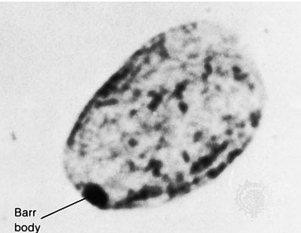
Barr Body

In another context, one can read:
- | Neural Conduction, Personal View vs. International View (Innovated)
 | Neural Conduction, Action Pressure Waves (Innovated)
 | Neural Conduction, Action Potentials (Innovated)
 | Neural Conduction, Action Electrical Currents (Innovated)
 | The Function of Action Potentials (Innovated)
 | The Three Phases of Neural Conduction
 | Neural Conduction in the Synapse (Innovated)
 | Sensory Receptors
- | Nodes of Ranvier, the Equalizers (Innovated)
 | Nodes of Ranvier, the Functions (Innovated)
 | Nodes of Ranvier, Function N1 (Innovated)
 | Nodes of Ranvier, Function N2 (Innovated)
 | Nodes of Ranvier, Function N3 (Innovated)
- | The Philosophy of Pain, Pain Comes First! (Innovated)
- | The Philosophy of Form (Innovated)
- | Spinal Injury, pathology of Spinal Shock, Pathology of Hyperreflexia
 | Spinal Shock (Innovated)
 | The Clonus (Innovated)
 | Hyperactivity Hyperreflexia (Innovated)
 | Hyperreflexia, Extended Sector of Reflex
 | Hyperreflexia, Bilateral Responses
 | Hyperreflexia, Multiple Responses
- | Nerve Conduction Study, Wrong Hypothesis is the Origin of Misinterpretation (Innovated)
 | Wallerian Degeneration (Innovated)
 | Neural Regeneration (Innovated)
- | Wallerian Degeneration Attacks Motor Axons, While Avoids Sensory Axons
 | Boy or Girl, Mother Decides!
 | Adam's Rib and Adam's Apple, Two Faces of one Sin
 | The Black Hole is a (the) Falling Star?
06/012/2019

