AMMAR YASEEN MANSOUR

Ulnar Reconstruction
Using Free Fibula Flap
With bone defects > 5cm, classical bone graft most likely fails.
Accompanied by poorly perfused environment, bone graft failure becomes certain.
In such difficult cases free bone flaps, as the free fibula flap, gain.
Mr. (S.D), 36 y/o, came to my private clinic holding the x-ray below, figure (1). The cause of lesion was gun shot in the left forearm 3 months ago. The osseous defect seemed to be of 6 cm long. The injury was associated with complete paralysis of the left ulnar nerve with no signals on EMG twice in two months intervals. Complete absence of left ulnar pulse in the first visit, and the return of weak pulse in the second, suggested complete injury of the ulnar artery in the first, and the compensation of the collaterals in the second. Figure (1).
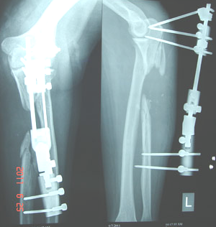

Figure (1)
Pre-op x- ray of the left forearm
The estimated bone need (>6 cm) to bridge the distance between the two ends of ulna, the severity of regional fibrosis, and the poorly perfused environment, pushed us toward a free fibula flap. Figures (2), figure (3).
Via posterior approach, the two ends of the left ulna fracture were prepared. The gap between the two ends became of 7 cm long. Then, via anterior approach, the vascular tree was exposed to choose the site of future vascular anastomosis.
The raison for choosing the right fibula as donor site was to give more space for two surgical teams to work simultaneously. The bone flap was 7 cm long. The vascular pedicle was 4 cm long. The fibular vein was single and of 6 mm diameter. The large caliber of the vein can be explained by the arterio-venous fistulas mostly found in athletes (e.g. Cyclists).
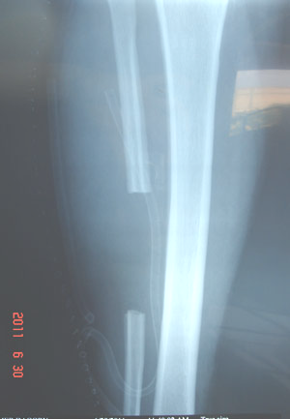

Figure (2)
Post-op x- ray of the right leg.
The bone flap (7 cm) was harvested from the middle of the fibula; 3 cm above and 4 cm below the middle point of the bone. Thus, the blood supply to the flap is double. One of them is the marrow branch, and the others are the periosteal branches.
A long plate, bridging the gap between the two ends of ulna, was fixed to the bone by screws. Whereas, the bone flap has been attached to the plate by two wires (cerclage). Figure (3). Figure (4).
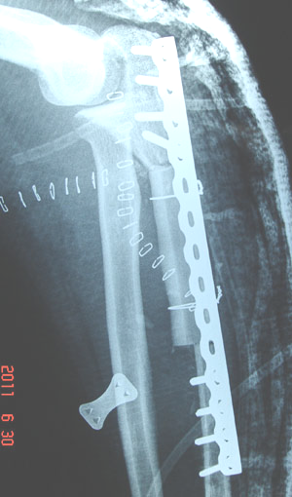

Figure (3)
Post-op x- ray
The fibular flap in its final position. Long plate, bridging the gap between the two ends of the left ulna, has been fixed by screws. whereas the bone flap rested free from any screw in order to preserve the marrow branch of fibular artery; the principal source of blood supply to this flap. Two wires were necessary to attach the flap to the plate.
Arterial anastomosis, via saphenous bypass, between the brachial and fibular arteries. In contrast, a definitive ligation of the only present vein was preferred for me to a venous anastomosis for two reasons:
- A short bone flap of 7cm long was not of enough venous return to sufficiently fill such large vein and keep open any venous anastomosis.
- A weak venous return could be drained through bone marrow of adjacent bones.
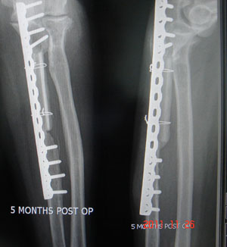

Figure (4)
5- months post-op x-ray of the left elbow and forearm
Proximal and distal callus formation, thickening of bone cortex, both indicate the good flap take.

............................................................................................................................
( *) More reported cases of using Free Fibula Flap in bone reconstruction
(Personal Archives):
- Maxilla Reconstruction.
- Mandible Reconstruction.
- Ulna Reconstruction.
- Tibia reconstruction in case of recalcitrant osteitis (1).
- Tibia Reconstruction (2).
- Radius Reconstruction (1).
- Radius Reconstruction (2).

In another context, one can read:

- | Neural Conduction, Personal View vs. International View (Innovated)
 | Neural Conduction, Action Pressure Waves (Innovated)
 | Neural Conduction, Action Potentials (Innovated)
 | Neural Conduction, Action Electrical Currents (Innovated)
 | The Function of Action Potentials (Innovated)
 | The Three Phases of Neural Conduction
 | Neural Conduction in the Synapse (Innovated)
 | Sensory Receptors
- | Nodes of Ranvier, the Equalizers (Innovated)
 | Nodes of Ranvier, the Functions (Innovated)
 | Nodes of Ranvier, Function N1 (Innovated)
 | Nodes of Ranvier, Function N2 (Innovated)
 | Nodes of Ranvier, Function N3 (Innovated)
- | The Philosophy of Pain, Pain Comes First! (Innovated)
- | The Philosophy of Form (Innovated)
- | Spinal Injury, pathology of Spinal Shock, Pathology of Hyperreflexia
 | Spinal Shock (Innovated)
 | The Clonus (Innovated)
 | Hyperactivity Hyperreflexia (Innovated)
 | Hyperreflexia, Extended Sector of Reflex
 | Hyperreflexia, Bilateral Responses
 | Hyperreflexia, Multiple Responses
- | Nerve Conduction Study, Wrong Hypothesis is the Origin of Misinterpretation (Innovated)
 | Wallerian Degeneration (Innovated)
 | Neural Regeneration (Innovated)
- | Wallerian Degeneration Attacks Motor Axons, While Avoids Sensory Axons
 | Barr Body, the Whole Story (Innovated)
 | Boy or Girl, Mother Decides!
 | Adam's Rib and Adam's Apple, Two Faces of one Sin
 | The Black Hole is a (the) Falling Star?
 | Adam's Rib, could be the Original Sin?
 | Pronator Teres Syndrome, Struthers _ like Ligament (Innovated)

25/6/2011

