Thumb Reconstruction
Using Microvascular Second Toe to Thumb Transfer
Dr. Ammar Yaseen MANSOUR

To view the details of the operation, watch the video at the following link:

A 50-year-old male patient was a victim of an explosive injury. Among other induced injuries, he lost his right thumb at the level of the metacrpo-phalangeal joint. (Figure 1). The cutaneous coverage of the stump and the 1st metacarpal bone was severely scarry. Moreover, the 1st metacarpal bone itself has subjected to a considerable loss of its bonny mass and was severely angulated as well (> 30 degree). (Figure 2).
The right hand is dominant. Therefore, the thumb reconstruction has for sure been indicated. As mentioned above, the radiographical findings concerning the 1st metacarpal bone, and the bad situation of the regional skin, both were incompatible with the 1st metacarpal bone's elongation process. Hence, I was apt to the second option; i.e. to the thumb reconstruction using the microvascular left second toe to the right thumb transfer.
Two wires of Kirschner were used to stabilize the bonny montage. The 1st K-wire is axial, whereas the second K-wire is anti-rotatory oblique. (Figure 8).
The implant's artery has been anastomosed to the radial artery, end-to-lateral anastomosis, in the radial side of the wrist. The implant's vein has been anastomosed to the cephalic vein, end-to-end anastomosis, in the same region.
The tendon of flexor digitorum profundus of the neo-thumb is animated by the flexor pollicis longus muscle of the ancient thumb. The tendon of the extensor digitorum longus of the neo- thumb is animated by the extensor pollicis longus muscle of the amputated thumb. Intentionally, I overcorrected the extension of the new thumb in order to overcome the spontaneous flexion of the interphalangeal joints of the second toe. The remained-intact thenar muscles will give the neo thumb the force and the dexterity as well.
To sensibilize the new thumb, the two collateral nerves of the implant (the second toe) were sutured to the ulnar collateral nerve of the amputated thumb.

 | 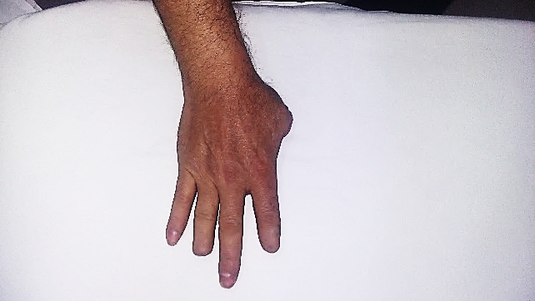 | 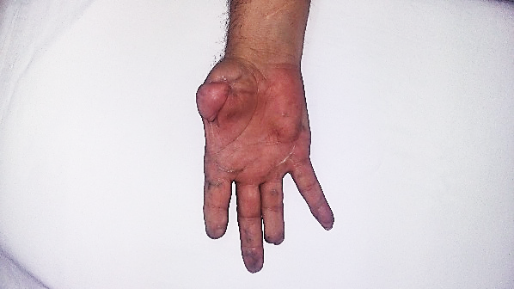
Figure (1)
Pre-operative View- The Right Hand
The right thumb is amputated at the level of the metacarpo-phalangeal joint (degree III). The distal phalanges of the index and the ring finger are also amputated.

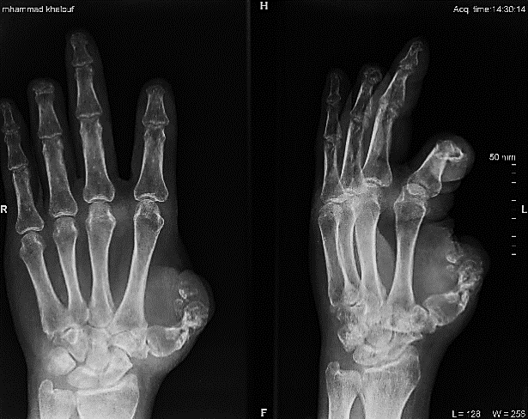 |  | 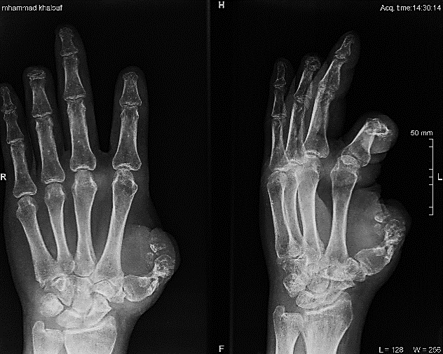
Figure (2)
Pre-operative Radiography- The Right Hand
Notice the malunion of the 1st metcarpal bone. It lost most of its mass, ans is angulated for more than 30 dgree. It is also 25% shorter than the normal contralateral homologue.

 | 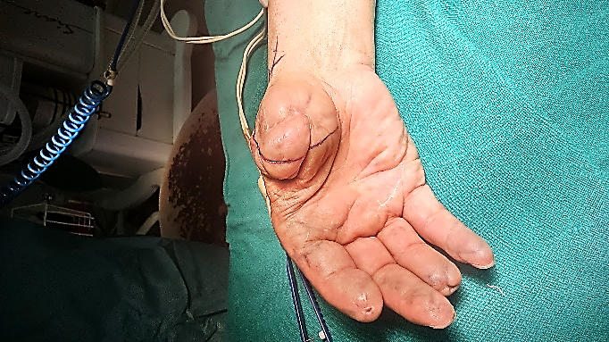 | 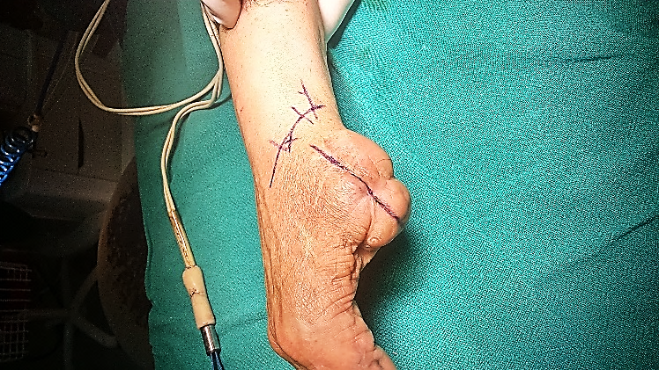
Figure (3)
Per-operative Views- The Surgical Lines
At the amputation stump, the anterior-posterior surgical line is to approach the bonny stump, the two collateral nerves, and the profound flexor tendon if it is still in situ. At the anatomical snuff, the obligue surgical line is to approch the long extensor tendon, the recepient radial artery, and the recepient cephalic vein for the future vascular anastomosis.

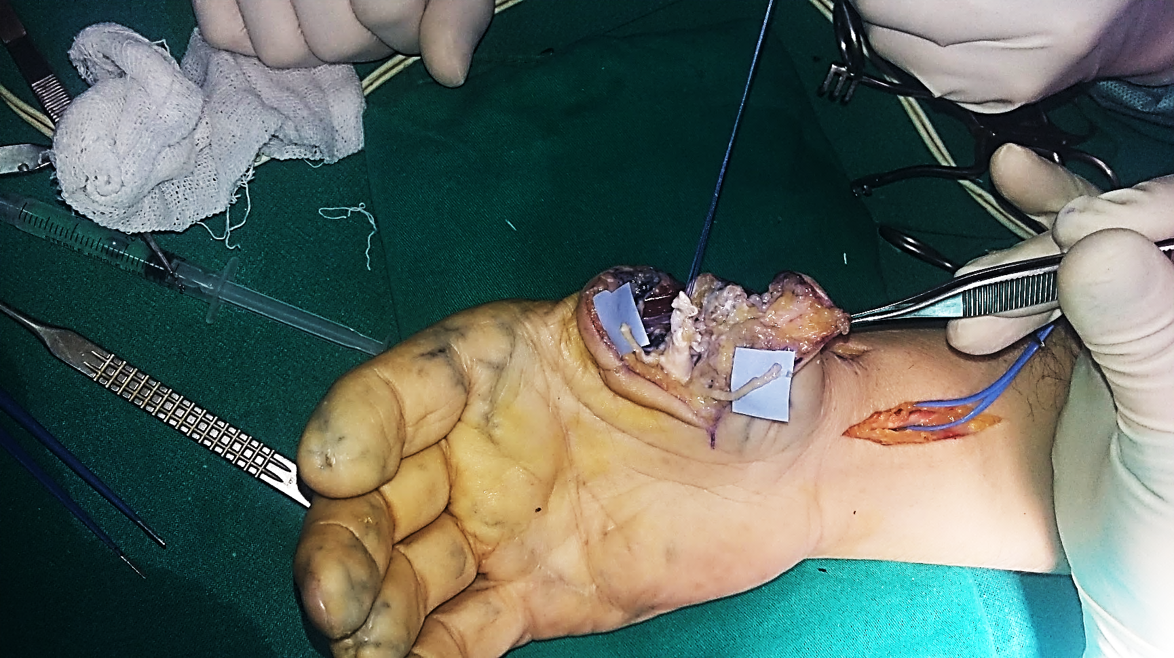
Figure (4)
Per-operative View of Recepient Site- Surgical Anatomy
The two collateral nerves are on the blue backgrounds.
In-between is the tendon of flexor pollicis longus muscle (white arrow).
In behind is the 1st metacarpal bone (yellow arrow).

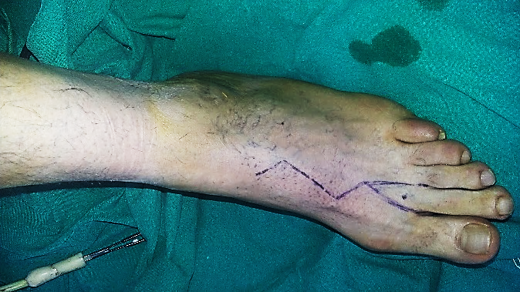
Figure (5)
Per-operative View- The Left Foot
A triangle dorsal skin flap is harvested with the second toe flap to ensure the veinous return.

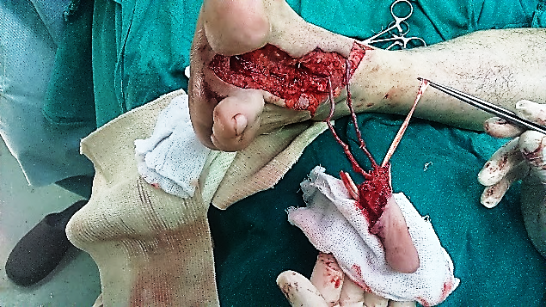
Figure (6)
Per-operative View- The Secon Toe Flap in Situ
Per-operative video:

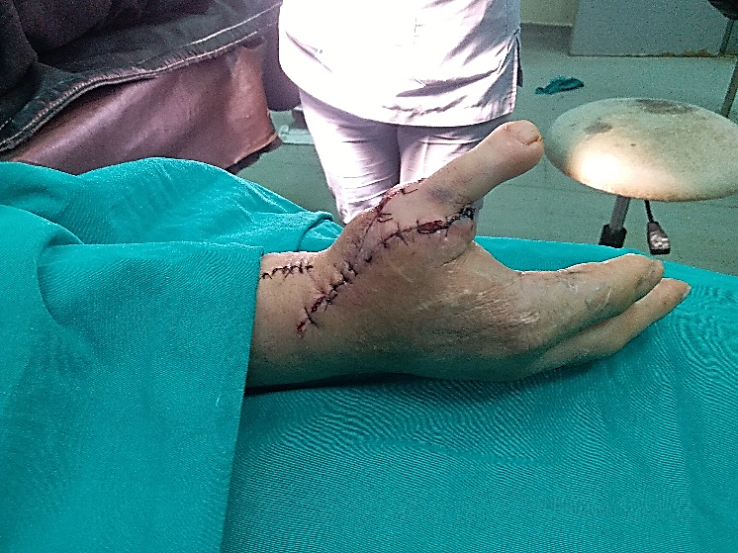 | 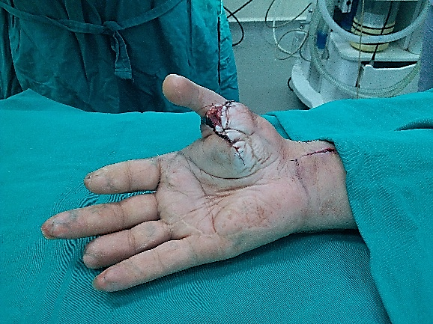
Figure (7)
4-day Post-operative View- The New Thumb

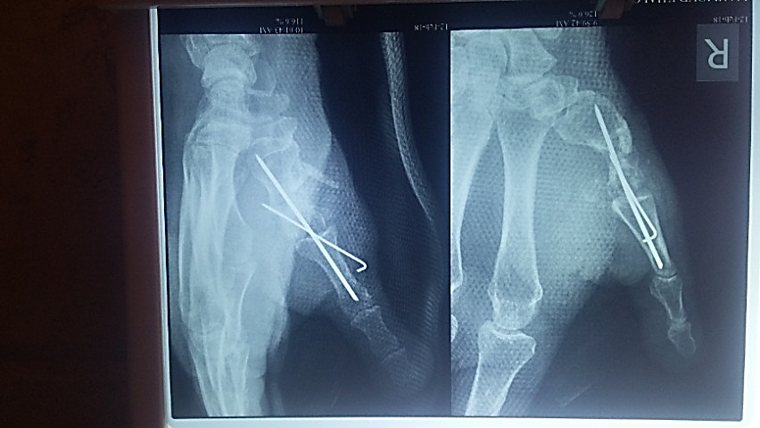 | 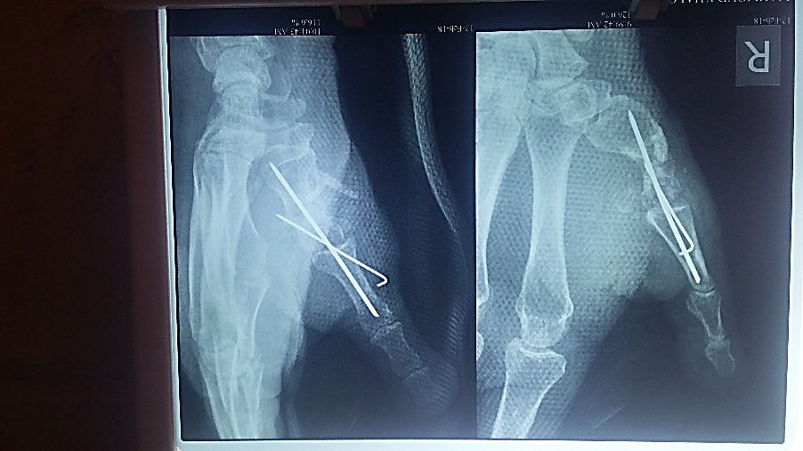
Figure (8)
5-day Post-operative Radiography
The first phalange of the second toe has become part of the 1st metacarpal bone. The new 1st metacarpal bone became longer than the original in order to compensate the short of the distal phalanges of the new thumb. Two wires of Kirschner are used to fix the montage. One of the K-wires is axial, while the other one is anti-rotatory oblique. The axial K-wire has been slightly bent backward in order to compensate the induced flexion of the 1st metacarpal bone.
......................................................................................................................
Per-operative video, the harvested second toe in situ: | 
3-month postoperative video 1:
3-month postoperative video 2 :
2-year postoperative video :

In other contexts, you can also read the following articles:
 | DOI | The Spinal Reflex, New Hypothesis of Physiology
 | - | The Hyperreflexia, Innovated Pathophysiology
 | DOI | The Spinal Shock
 | - | The Spinal Injury, the Pathophysiology of the Spinal Shock, the Pathophysiology of the Hyperreflexia
 | DOI | Upper Motor Neuron Lesions, the Pathophysiology of the Symptomatology
 | - | The Hyperreflexia (1), the Pathophysiology of Hyperactivity
 | - | The Hyperreflexia (2), the Pathophysiology of Bilateral Responses
 | - | The Hyperreflexia (3), the Pathophysiology of Extended Hyperreflex
 | - | The Hyperreflexia (4), the Pathophysiology of Multi-Response Hyperreflex
- | - | The pathophysiology of Triple flexion Reflex
 | - | The Clonus, 1st Hypothesis of Pathophysiology
 | - | The Clonus, 2nd Hypothesis of Pathophysiology
 | DOI | The Clonus, Two Hypotheses of Pathophysiology
 | DOI | The Nerve Transmission through Neural Fiber, Personal View vs. International View
 | - | The Nerve Transmission through Neural Fiber (1), The Action Pressure Waves
 | - | The Nerve Transmission through Neural Fiber (2), The Action Potentials
 | - | The Nerve Transmission through Neural Fiber (3), The Action Electrical Currents
 | - | The Function of Standard Action Potentials & Currents
 | - | The Three Phases of Nerve transmission
 | DOI | Neural Conduction in the Synapse (Innovated)
 | DOI | Nodes of Ranvier, the Equalizers
 | - | Nodes of Ranvier, the Functions
 | - | Nodes of Ranvier, First Function
 | - | Nodes of Ranvier, Second Function
 | - | Nodes of Ranvier, Third Function
 | - | Node of Ranvier, The Anatomy
 | - | The Wallerian Degeneration
 | - | The Neural Regeneration
 | - | The Wallerian Degeneration Attacks Motor Axons, While Avoids Sensory Axons
 | DOI | The Sensory Receptors
 | - | Nerve Conduction Study, Wrong Hypothesis is the Origin of the Misinterpretation (Innovated)
 | - | Piriformis Muscle Injection_ Personal Approach
 | - | The Philosophy of Pain, Pain Comes First! (Innovated)
 | - | The Philosophy of the Form (Innovated)
 | - | Pronator Teres Syndrome, Struthers-Like Ligament (Innovated)
 | - | Ulnar Nerve, Congenital Bilateral Dislocation
 | - | Posterior Interosseous Nerve Syndrome
 | - | The Multiple Sclerosis: The Causative Relationship Between  The Galvanic Current & Multiple Sclerosis?
 | - | Cauda Equina Injury, New Surgical Approach
 | - | Carpal Tunnel Syndrome Complicated by Complete Rupture of Median Nerve
 | - | Biceps Femoris' Long Head Syndrome (BFLHS)
 | DOI | Barr Body, The Whole Story (Innovated)
 | - | Adam's Rib and Adam's Apple, Two Faces of one Sin
 | - | Adam's Rib, could be the Original Sin?
 | - | Barr Body, the Second Look
 | DOI | Who Decides the Sex of Coming Baby?
 | - | Boy or Girl, Mother Decides!
 | - | Oocytogenesis
 | - | Spermatogenesis
 | - | This Woman Can Only Give Birth to Female Children
 | - | This Woman Can Only Give Birth to Male Children
 | - | This Woman Can Give Birth to Female Children More Than to Male Children
 | - | This Woman Can Give Birth to Male Children More Than to Female Children
 | - | This Woman Can Equally Give Birth to Male Children & to Female Children
 | - | Eve Saved Human Identity; Adam Ensured Human Adaptation
 | - | Coronavirus (Covid-19): After Humiliation, Is Targeting Our Genes
 | - | Coronavirus (Covid-19): After Humiliation, Is Targeting Our Genes
 | - | The Black Hole is a (the) Falling Star?
 | - | Mitosis in Animal Cell
 | - | Meiosis
 | - | Universe Creation, Hypothesis of Continuous Cosmic Nebula
 | - | Circulating Sweepers
 | - | Pneumatic Petrous, Bilateral Temporal Hyperpneumatization
 | - | Congenital Bilateral Thenar Hypoplasia
 | - | Ulnar Dimelia, Mirror hand Deformity
 | DOI | Surgical Restoration of a Smile by Grafting a Segment of the Gracilis Muscle to the Face
 | - | Mandible Reconstruction Using Free Fibula Flap
 | - | Presacral Schwannoma
 | DOI | Liver Hemangioma: Urgent Surgery of Giant Liver Hemangioma  Due to Intra-Tumor Bleeding
 | - | Free Para Scapular Flap (FPSF) for Skin Reconstruction
 | - | Claw Hand Deformity (Brand Operation)
 | - | Algodystrophy Syndrome Complicated by Constricting Ring at the Proximal Border of the Edema
 | - | Non- Traumatic Non- Embolic Acute Thrombosis of Radial Artery (Buerger’s Disease)
 | - | Isolated Axillary Tuberculosis Lymphadenitis
 | - | The Iliopsoas Tendonitis... The Snapping Hip
 | To read the article in Arabic, click on
 | DOI | The New Frankenstein Monster
 | DOI | The Lone Wolf
 | DOI | The Delirium of Night and Day
 | DOI | The Delirium of the Economy
 | DOI | Ovaries in a Secure Corner… Testicles in a Humble Sac:  An Inquiry into the Function of Form
 | DOI | Eve Preserves Humanity’s Blueprint; Adam Drives Its Evolution
 | DOI | The Manufacture of the Unconscious
 | DOI | The Ballad of Eternity
 | DOI | Two Truths Woman Would Never Accept
 | DOI | The 'Iddah (Waiting Period) in Islamic Law: A Comparative Analysis of its Rationale for Divorced Women and Widows
 | DOI | The IVF/ICSI-Conceived Child: A Biologically Suboptimal Outcome

13/02/2018

