Clinical Case

Bilateral Congenital Thenar Aplasia
Bilateral Isolated Congenital Aplasia of the Abductor Pollicis Brevis and Opponens Pollicis
Dr. Ammar Yaseen MANSOUR
Numerically, only two such cases existed in medical literature—with no third—until mine. While similar cases have been documented, most were unilateral. Thus, bilateral isolated congenital thenar aplasia now comprises exactly three cases worldwide.
Anatomically, there is a congenital bilateral absence of the Abductor Pollicis Brevis (APB) and Opponens Pollicis (OP) muscles. Conversely, the Flexor Pollicis Brevis (FPB) and Adductor Pollicis (ADP) muscles remain intact.
Functionally, this condition has no significant impact on thumb function specifically or on overall hand performance. Consequently, such cases typically do not require surgical intervention; see Figure (1).

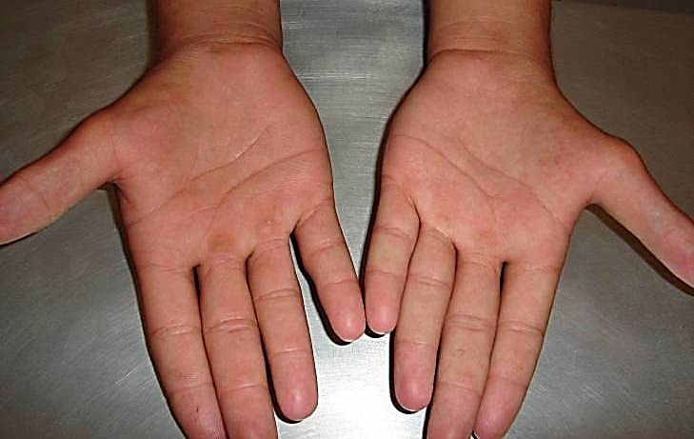
Figure (1): Bilateral Congenital Thenar Aplasia
In both hands, there is absence of the Abductor Pollicis Brevis (APB) muscle. The thenar eminence is also flat bilaterally. This congenital defect is isolated, with no associated anomalies in the hand or elsewhere in the body.
Sensation remains intact in the thumb and hand (normal sensation in the median nerve and ulnar nerve territories). However, thumb abduction is mildly compromised, though this has negligible overall impact on hand function.
.
Note: I significantly delayed presenting this case pending MRI imaging of both hands. However, the wait proved prolonged, and the patient did not return for the requested investigation—likely reassured about their functional prognosis.
The absence of both the Abductor Pollicis Brevis (APB) and Opponens Pollicis (OP) muscles was clinically inferred through direct inspection and kinetic examination. Identifying the presence of the Adductor Pollicis (ADP) muscle was straightforward. Conversely, the intact Flexor Pollicis Brevis (FPB) muscle was accounted for by the stability of the first metacarpophalangeal joint (1st MCP joint).
………………………………………………………………………………………..
In other contexts, you can also read the following articles:
 | DOI | The Spinal Reflex, New Hypothesis of Physiology
 | - | The Hyperreflexia, Innovated Pathophysiology
 | DOI | The Spinal Shock
 | - | The Spinal Injury, the Pathophysiology of the Spinal Shock, the Pathophysiology of the Hyperreflexia
 | DOI | Upper Motor Neuron Lesions, the Pathophysiology of the Symptomatology
 | - | The Hyperreflexia (1), the Pathophysiology of Hyperactivity
 | - | The Hyperreflexia (2), the Pathophysiology of Bilateral Responses
 | - | The Hyperreflexia (3), the Pathophysiology of Extended Hyperreflex
 | - | The Hyperreflexia (4), the Pathophysiology of Multi-Response Hyperreflex
- | - | The pathophysiology of Triple flexion Reflex
 | - | The Clonus, 1st Hypothesis of Pathophysiology
 | - | The Clonus, 2nd Hypothesis of Pathophysiology
 | DOI | The Clonus, Two Hypotheses of Pathophysiology
 | DOI | The Nerve Transmission through Neural Fiber, Personal View vs. International View
 | - | The Nerve Transmission through Neural Fiber (1), The Action Pressure Waves
 | - | The Nerve Transmission through Neural Fiber (2), The Action Potentials
 | - | The Nerve Transmission through Neural Fiber (3), The Action Electrical Currents
 | - | The Function of Standard Action Potentials & Currents
 | - | The Three Phases of Nerve transmission
 | DOI | Neural Conduction in the Synapse (Innovated)
 | DOI | Nodes of Ranvier, the Equalizers
 | - | Nodes of Ranvier, the Functions
 | - | Nodes of Ranvier, First Function
 | - | Nodes of Ranvier, Second Function
 | - | Nodes of Ranvier, Third Function
 | - | Node of Ranvier, The Anatomy
 | - | The Wallerian Degeneration
 | - | The Neural Regeneration
 | - | The Wallerian Degeneration Attacks Motor Axons, While Avoids Sensory Axons
 | DOI | The Sensory Receptors
 | - | Nerve Conduction Study, Wrong Hypothesis is the Origin of the Misinterpretation (Innovated)
 | - | Piriformis Muscle Injection_ Personal Approach
 | - | The Philosophy of Pain, Pain Comes First! (Innovated)
 | - | The Philosophy of the Form (Innovated)
 | - | Pronator Teres Syndrome, Struthers-Like Ligament (Innovated)
 | - | Ulnar Nerve, Congenital Bilateral Dislocation
 | - | Posterior Interosseous Nerve Syndrome
 | - | The Multiple Sclerosis: The Causative Relationship Between  The Galvanic Current & Multiple Sclerosis?
 | - | Cauda Equina Injury, New Surgical Approach
 | - | Carpal Tunnel Syndrome Complicated by Complete Rupture of Median Nerve
 | - | Biceps Femoris' Long Head Syndrome (BFLHS)
 | DOI | Barr Body, The Whole Story (Innovated)
 | - | Adam's Rib and Adam's Apple, Two Faces of one Sin
 | - | Adam's Rib, could be the Original Sin?
 | - | Barr Body, the Second Look
 | DOI | Who Decides the Sex of Coming Baby?
 | - | Boy or Girl, Mother Decides!
 | - | Oocytogenesis
 | - | Spermatogenesis
 | - | This Woman Can Only Give Birth to Female Children
 | - | This Woman Can Only Give Birth to Male Children
 | - | This Woman Can Give Birth to Female Children More Than to Male Children
 | - | This Woman Can Give Birth to Male Children More Than to Female Children
 | - | This Woman Can Equally Give Birth to Male Children & to Female Children
 | - | Eve Saved Human Identity; Adam Ensured Human Adaptation
 | - | Coronavirus (Covid-19): After Humiliation, Is Targeting Our Genes
 | - | Coronavirus (Covid-19): After Humiliation, Is Targeting Our Genes
 | DOI | Fibromyalgia
 | - | The Black Hole is a (the) Falling Star?
 | - | Mitosis in Animal Cell
 | - | Meiosis
 | - | Universe Creation, Hypothesis of Continuous Cosmic Nebula
 | - | Circulating Sweepers
 | - | Pneumatic Petrous, Bilateral Temporal Hyperpneumatization
 | - | Congenital Bilateral Thenar Hypoplasia
 | DOI | Ulnar Dimelia, Mirror hand Deformity
 | DOI | Thumb Reconstruction Using Microvascular Second Toe to Thumb Transfer
 | DOI | Surgical Restoration of a Smile by Grafting a Segment of the Gracilis Muscle to the Face
 | DOI | Mandible Reconstruction Using Free Fibula Flap
 | DOI | Presacral Schwannoma
 | DOI | Liver Hemangioma: Urgent Surgery of Giant Liver Hemangioma  Due to Intra-Tumor Bleeding
 | DOI | Free Para Scapular Flap (FPSF) for Skin Reconstruction
 | DOI | Claw Hand Deformity (Brand Operation)
 | DOI | Algodystrophy Syndrome Complicated by Constricting Ring at the Proximal Border of the Edema
 | DOI | Non- Traumatic Non- Embolic Acute Thrombosis of Radial Artery (Buerger’s Disease)
 | DOI | Isolated Axillary Tuberculosis Lymphadenitis
 | DOI | The Iliopsoas Tendonitis... The Snapping Hip
 | To read the article in Arabic, click on
 | DOI | The New Frankenstein Monster
 | DOI | The Lone Wolf
 | DOI | The Delirium of Night and Day
 | DOI | The Delirium of the Economy
 | DOI | Ovaries in a Secure Corner… Testicles in a Humble Sac:  An Inquiry into the Function of Form
 | DOI | Eve Preserves Humanity’s Blueprint; Adam Drives Its Evolution
 | DOI | The Manufacture of the Unconscious
 | DOI | The Ballad of Eternity
 | DOI | Two Truths Woman Would Never Accept
 | DOI | The 'Iddah (Waiting Period) in Islamic Law: A Comparative Analysis of its Rationale for Divorced Women and Widows
 | DOI | The IVF/ICSI-Conceived Child: A Biologically Suboptimal Outcome

03/08/2015

