Surgical Case
Acute Non-Traumatic Radial Artery Occlusion (Buerger's Disease)
Dr. Ammar Yaseen MANSOUR
Apart from the numerous cases of radial artery occlusion of traumatic origin, I delving into the medical literature struggle to find cases that quench my thirst regarding radial artery thrombosis without an apparent cause.
With the advancement of cardiac investigation techniques, cases of traumatic radial artery thrombosis have increased at an unprecedented, accelerated rate. Subsequently, researchers began to focus their interest on this artery, which had long remained sidelined from research due to the scarcity of its pathologies – to the point where we had come to accept its benign nature and positive neutrality.
I will present to you here one of the rare uprisings of the radial artery. You will find no history of overt trauma or strenuous exertion in the presentation that could easily be attributed as the traumatic origin of the radial artery clot. Persistent, severe cold exposure over long hours is the sole factor demanding analytical attention. Here now is the story, followed by the analysis.
Our patient is a young man in his fourth decade of life, physically and psychologically healthy, with a clean personal and family medical history. He happened to be in a high-altitude mountainous area. He had not planned for this visit and was unprepared for the severe cold for which the host region is notorious. He felt intense cold. He sensed impending trouble, yet he did not voice his pain at the time. Nor could he avoid or manage the awkward situation in which he found himself.
Night fell heavily upon our patient, settling the account of what had passed. Intense pain in the anterior forearm prevented the patient from sleeping, threatening him with worse to come. His left forearm became swollen and hardened. The radial pulse was absent at the wrist.
Movement of the hand and fingers was unaffected. Neither active nor passive movements were painful. Only active flexion of the fingers against the examiner's resistance provoked severe pain in the mid-anterior forearm. The neurological examination appeared normal except for a positive Tinel's sign over the course of the median nerve in the middle of the volar aspect of the forearm.
Later, after days of treatment with Non-Steroidal Anti-Inflammatory Drugs (NSAIDs), pain killers, and Low Molecular Weight Heparin (LMWH), the inflammatory episode subsided. This allowed a new complaint to surface: coldness in the left thumb.
All radiological findings pointed towards thrombosis of the left radial artery. The Echo-Doppler indicated normal perfusion pressure in the palmar arterial arches. The Multi-Slice CT scan provided definitive evidence of radial artery occlusion extending over an estimated distance of 14 cm. Collateral circulation successfully filled the distal segment of the radial artery. The Erythrocyte Sedimentation Rate (ESR), C-Reactive Protein (CRP), and White Blood Cell count (WBC) were all within normal limits; see Figure (1).

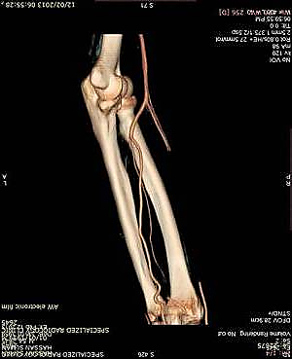
Distal Segment of Radial Artery
Ulnar Artery
Radial Artery
Thrombosed Segment
Brachial Artery
Figure 1: Multi-Slice CT Angiography of Left Forearm
  - Radial Artery Occlusion: Absent contrast filling along 14 cm of the radial artery.
  - Distal Radial Artery Patency: Contrast opacification of the distal radial artery.
  - Collateral Pathway: Filling via ulnar artery collaterals (inter-arterial anastomoses).
Finding | Diagnostic Significance
14 cm occlusion | Confirms surgical/histological extent of thrombosis
Distal radial filling | Proves functional collateral circulation from ulnar artery → Deep palmar arch
Intact ulnar artery | Explains preserved hand perfusion (normal capillary refill)

(Source: Private Archive)

The decision was made for surgical intervention: excision of the thrombosed segment of the left radial artery without bypass grafting, for the following objectives:
- Histopathological study of the excised specimen to determine the underlying pathological cause of the radial artery thrombosis;
- Excision of the thrombosed artery practically entails removal of its accompanying sympathetic nerve network. This network is subject to continuous stimulation (irritation) due to the primary inflammatory process or the inflammation secondary to the arterial thrombosis;
- When the capillary refill time at the fingertips is less than 6 seconds, replacing the excised artery with a venous graft becomes a superfluous procedure with no necessity;
- Fasciotomy of the deep fascia of the left anterior forearm compartment. The severe pain in the anterior forearm region, coupled with the positive Tinel's sign over the course of the median nerve, particularly at the mid-forearm, gave the impression of elevated pressure within the anterior compartment of the left forearm.
The surgical procedure proceeded with the expected smoothness. The most significant per-operative findings consisted of the presence of scattered hemorrhagic foci, limited in number and extent. I also observed extension of the thrombosis into the small branches of the radial artery, specifically mentioning the perforating branches; see Figure (2).

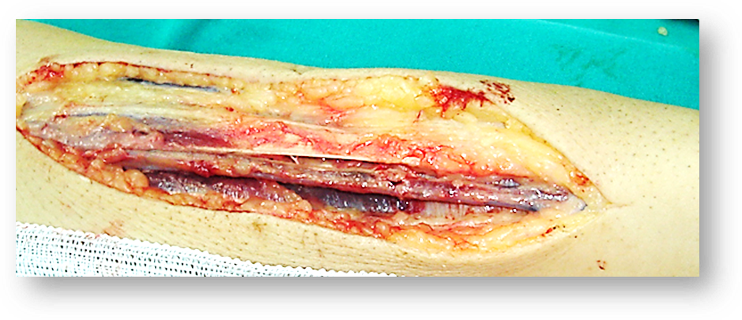
14 cm- Thrombosed Segment of Radial Artery

Figure 2: Surgical Observations (Per-Operative View)
- Radial Artery Thrombosis:
  - Occlusion extending 14 cm distally from its origin.
  - Origin point: 5 cm distal to the brachial artery bifurcation.
- Microvascular Involvement:
  - Thrombosis observed in:
    - Small distal branches
    - Perforating branches (critical observation)
  - Significance: Confirms transmural inflammatory spread beyond the main vessel.
- Hemorrhagic Manifestations:
  - Scattered hemorrhagic foci of limited extent.
  - Interpretation: Suggests acute vascular inflammation with microvascular fragility.
(Source: Private Archive)

The initial pathological study of the excised specimen suggested Polyarteritis Nodosa (PAN). However, the second pathological study resolved the diagnostic uncertainty in favor of Buerger's Disease (Thromboangiitis Obliterans); see Figure (3).

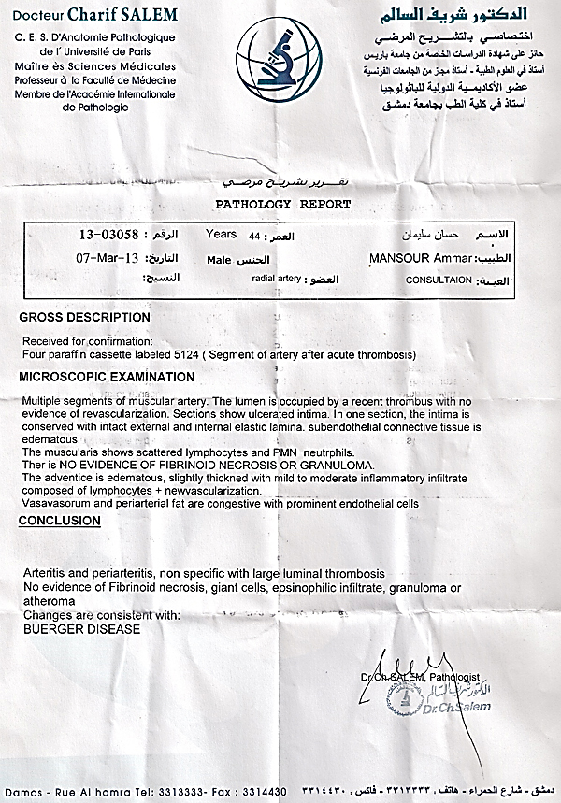
(Figure 3): Pathology Report
Key Histopathological Observations:
- Absence of Diagnostic Features:
  - ❌ Fibrinoid necrosis
  - ❌ Giant cells
  - ❌ Eosinophilic infiltrates
  - ❌ Granulomatous inflammation
  - ❌ Atheromatous plaques
- Positive Findings:
  - ✅ Non-specific arteritis & periarteritis (inflammatory changes in vessel wall and surrounding tissues)
  - ✅ Large luminal thrombus occluding the arterial lumen
Conclusion: The combined findings – non-specific transmural inflammation, absence of systemic vasculitis markers, and acute thrombosis – are histopathologically consistent with Buerger's Disease (Thromboangiitis Obliterans)."

Case Discussion:
I do not believe the initial pathologist's report suggesting Polyarteritis Nodosa (PAN) was correct, for the following reasons:
- The abrupt onset of symptoms in an otherwise completely healthy individual;
- The isolated, single-vessel involvement of the radial artery argues against systemic and/or multifocal disease;
- The absence of the typical clinical manifestations of PAN – such as fatigue, fever, myalgia, or preceding skin lesions – prior to the acute thrombosis;
- The lack of laboratory markers indicating an acute inflammatory process, as the Erythrocyte Sedimentation Rate (ESR) and C-Reactive Protein (CRP) were within normal limits;
- The diagnosis of PAN is typically definitive and unambiguous upon examination of the affected vessel. The pathologist's initial confusion only served to complicate matters;
- The scarcity of clinically documented cases in the medical literature describing radial artery involvement specifically by PAN.
In light of all the aforementioned points, and based on the interpretation of the patient's history and surgical findings, I favor severe cold exposure and concomitant vasospasm as the responsible factors for this acute pathological event.
Based on the detailed pathological findings and clinical correlation, the second pathology report confirming Buerger's Disease (Thromboangiitis Obliterans) is well-supported. Here's a breakdown of the key evidence and implications:
Key Pathological Findings Supporting Buerger's Diagnosis
- Acute Thrombotic Event Without Underlying Inflammation:
  - The pathology explicitly ruled out specific inflammatory or autoimmune vasculitis (e.g., PAN) due to the absence of:
    - Fibrinoid necrosis
    - Giant cells, granulomas, or eosinophilic infiltrates
    - Atherosclerotic plaques (atheroma)
  - This aligns with Buerger's hallmark: non-atherosclerotic, segmental thrombotic occlusion affecting small-to-medium vessels.
- Inflammatory Infiltrate Limited to Vessel Wall:
  - The noted polymorphous inflammatory infiltrate (lymphocytes, macrophages) within the vessel wall is characteristic of Buerger's acute phase. Unlike systemic vasculitis, this inflammation is thrombus-centric and lacks necrosis.
- Exclusion of Differential Diagnoses:
  - Absence of PAN features (e.g., systemic symptoms, multiorgan involvement, necrotizing lesions).
  - Normal inflammatory markers (ESR, CRP) during the acute phase further contradict PAN or autoimmune vasculitis.
Clinical-Pathological Correlation
- Cold Exposure as Trigger: The acute thrombosis following prolonged cold exposure aligns with Buerger's vasospastic reactivity. Cold induces hypercoagulability and endothelial injury in susceptible individuals, particularly tobacco users.
- Compartment Syndrome Suspicion: Severe forearm pain, Tinel's sign, and swelling suggested possible compartment syndrome, warranting fasciotomy—a complication seen in advanced Buerger's due to microvascular thrombosis.
Table: Histological Comparison of Buerger’s vs. PAN
Feature | Buerger's Disease | Polyarteritis Nodosa (PAN)
Fibrinoid Necrosis | Absent | Present (hallmark)
Giant Cells/Granulomas | Absent | Common
Inflammatory Infiltrate | Vessel wall-focused | Transmural, necrotizing
Systemic Symptoms | Rare | Fever, myalgia, weight loss
ESR/CRP Elevation | Typically normal | Markedly elevated

Final Confirmation
The second pathology report’s conclusion is definitive:
The acute thrombotic event, inflammatory infiltrate restricted to the thrombus/vessel wall, and absence of systemic vasculitis features confirm Buerger’s Disease.
This diagnosis emphasizes cold-induced vasospasm as the primary trigger in a previously healthy patient, consistent with Buerger’s thromboangiitis mechanism.
Buerger's Disease (Thromboangiitis Obliterans) is a vasculopathy affecting small-to-medium arteries in the upper and lower extremities. Smoking plays a major and well-established role in its pathogenesis. Radiological findings often precede clinical symptoms by variable intervals. Typically, patients report cold intolerance, claudication in lower limbs/hands, and ischemic digital necrosis. Some studies implicate cold exposure as a trigger in ~10% of cases.
In our patient, both essential (smoking) and contributory (cold) factors converged, precipitating acute arterial thrombosis. Crucially, systemic inflammatory indicators were entirely absent:
- Clinical: No fever or fatigue
- Laboratory: Normal ESR and CRP
- No prior vascular history
Histopathology revealed:
✓ Intact arterial wall architecture
✓ Mild acute inflammatory infiltrate
✗ No fibrinoid necrosis/granulomas/atheroma
This constellation of findings aligns definitively with Buerger's Disease
In conclusion, I state: This case presents three features conferring distinct clinical uniqueness:
- First, isolated radial artery involvement as the initial manifestation of Buerger’s Disease.
- Second, absence of classic prodromal symptoms in the patient’s history – no cold intolerance, intermittent claudication, or treatment-resistant ischemic ulcers.
- Third, lack of compensatory collateral circulation – a hallmark of chronic occlusive vascular diseases.
These three elements collectively establish this case’s singularity
……………………………………………………………………………………………..
In other contexts, you can also read the following articles:
 | DOI | The Spinal Reflex, New Hypothesis of Physiology
 | - | The Hyperreflexia, Innovated Pathophysiology
 | DOI | The Spinal Shock
 | - | The Spinal Injury, the Pathophysiology of the Spinal Shock, the Pathophysiology of the Hyperreflexia
 | DOI | Upper Motor Neuron Lesions, the Pathophysiology of the Symptomatology
 | - | The Hyperreflexia (1), the Pathophysiology of Hyperactivity
 | - | The Hyperreflexia (2), the Pathophysiology of Bilateral Responses
 | - | The Hyperreflexia (3), the Pathophysiology of Extended Hyperreflex
 | - | The Hyperreflexia (4), the Pathophysiology of Multi-Response Hyperreflex
- | - | The pathophysiology of Triple flexion Reflex
 | - | The Clonus, 1st Hypothesis of Pathophysiology
 | - | The Clonus, 2nd Hypothesis of Pathophysiology
 | DOI | The Clonus, Two Hypotheses of Pathophysiology
 | DOI | The Nerve Transmission through Neural Fiber, Personal View vs. International View
 | - | The Nerve Transmission through Neural Fiber (1), The Action Pressure Waves
 | - | The Nerve Transmission through Neural Fiber (2), The Action Potentials
 | - | The Nerve Transmission through Neural Fiber (3), The Action Electrical Currents
 | - | The Function of Standard Action Potentials & Currents
 | - | The Three Phases of Nerve transmission
 | DOI | Neural Conduction in the Synapse (Innovated)
 | DOI | Nodes of Ranvier, the Equalizers
 | - | Nodes of Ranvier, the Functions
 | - | Nodes of Ranvier, First Function
 | - | Nodes of Ranvier, Second Function
 | - | Nodes of Ranvier, Third Function
 | - | Node of Ranvier, The Anatomy
 | - | The Wallerian Degeneration
 | - | The Neural Regeneration
 | - | The Wallerian Degeneration Attacks Motor Axons, While Avoids Sensory Axons
 | DOI | The Sensory Receptors
 | - | Nerve Conduction Study, Wrong Hypothesis is the Origin of the Misinterpretation (Innovated)
 | - | Piriformis Muscle Injection_ Personal Approach
 | - | The Philosophy of Pain, Pain Comes First! (Innovated)
 | - | The Philosophy of the Form (Innovated)
 | - | Pronator Teres Syndrome, Struthers-Like Ligament (Innovated)
 | - | Ulnar Nerve, Congenital Bilateral Dislocation
 | - | Posterior Interosseous Nerve Syndrome
 | - | The Multiple Sclerosis: The Causative Relationship Between  The Galvanic Current & Multiple Sclerosis?
 | - | Cauda Equina Injury, New Surgical Approach
 | - | Carpal Tunnel Syndrome Complicated by Complete Rupture of Median Nerve
 | - | Biceps Femoris' Long Head Syndrome (BFLHS)
 | DOI | Barr Body, The Whole Story (Innovated)
 | - | Adam's Rib and Adam's Apple, Two Faces of one Sin
 | - | Adam's Rib, could be the Original Sin?
 | - | Barr Body, the Second Look
 | DOI | Who Decides the Sex of Coming Baby?
 | - | Boy or Girl, Mother Decides!
 | - | Oocytogenesis
 | - | Spermatogenesis
 | - | This Woman Can Only Give Birth to Female Children
 | - | This Woman Can Only Give Birth to Male Children
 | - | This Woman Can Give Birth to Female Children More Than to Male Children
 | - | This Woman Can Give Birth to Male Children More Than to Female Children
 | - | This Woman Can Equally Give Birth to Male Children & to Female Children
 | - | Eve Saved Human Identity; Adam Ensured Human Adaptation
 | - | Coronavirus (Covid-19): After Humiliation, Is Targeting Our Genes
 | - | Coronavirus (Covid-19): After Humiliation, Is Targeting Our Genes
 | - | The Black Hole is a (the) Falling Star?
 | - | Mitosis in Animal Cell
 | - | Meiosis
 | - | Universe Creation, Hypothesis of Continuous Cosmic Nebula
 | - | Circulating Sweepers
 | - | Pneumatic Petrous, Bilateral Temporal Hyperpneumatization
 | - | Congenital Bilateral Thenar Hypoplasia
 | - | Ulnar Dimelia, Mirror hand Deformity
 | DOI | Thumb Reconstruction Using Microvascular Second Toe to Thumb Transfer
 | DOI | Surgical Restoration of a Smile by Grafting a Segment of the Gracilis Muscle to the Face
 | DOI | Mandible Reconstruction Using Free Fibula Flap
 | DOI | Presacral Schwannoma
 | DOI | Liver Hemangioma: Urgent Surgery of Giant Liver Hemangioma  Due to Intra-Tumor Bleeding
 | DOI | Free Para Scapular Flap (FPSF) for Skin Reconstruction
 | DOI | Claw Hand Deformity (Brand Operation)
 | DOI | Algodystrophy Syndrome Complicated by Constricting Ring at the Proximal Border of the Edema
 | - | Non- Traumatic Non- Embolic Acute Thrombosis of Radial Artery (Buerger’s Disease)
 | - | Isolated Axillary Tuberculosis Lymphadenitis
 | DOI | The Iliopsoas Tendonitis... The Snapping Hip
 | To read the article in Arabic, click on
 | DOI | The New Frankenstein Monster
 | DOI | The Lone Wolf
 | DOI | The Delirium of Night and Day
 | DOI | The Delirium of the Economy
 | DOI | Ovaries in a Secure Corner… Testicles in a Humble Sac:  An Inquiry into the Function of Form
 | DOI | Eve Preserves Humanity’s Blueprint; Adam Drives Its Evolution
 | DOI | The Manufacture of the Unconscious
 | DOI | The Ballad of Eternity
 | DOI | Two Truths Woman Would Never Accept
 | DOI | The 'Iddah (Waiting Period) in Islamic Law: A Comparative Analysis of its Rationale for Divorced Women and Widows
 | DOI | The IVF/ICSI-Conceived Child: A Biologically Suboptimal Outcome

18/02/2013

