Surgical Case
Reflex Sympathetic Dystrophy (RSD)
Characterized by the appearance of a constrictive skin ring at the proximal border of the cutaneous edema
Dr. Ammar Yaseen MANSOUR
A 42-year-old female patient presented with severe pain in her left hand and diffuse edema extending from the hand to the mid-forearm. She was greatly troubled by severely limited mobility in the wrist, particularly in the fingers of her left hand; see Figure (1).
The complaint was longstanding, dating back approximately over a year, and involved numerous therapeutic trials without success. Upon careful review of the medical history, the clinical findings were consistent with a neglected Left Carpal Tunnel Syndrome. The patient reported the gradual onset of edema and worsening pain two weeks after the onset of neurological symptoms. The radiographic image of the left wrist revealed, in addition to osteoporosis (radiological density loss) affecting all bony structures in the region, radiographic signs of Ulno-Lunate Conflict; see Figure (2).
The patient was started on treatment for Algodystrophy Syndrome (Reflex Sympathetic Dystrophy/RSD), which we postulated as the diagnosis for her current condition.
Five months into treatment, when confidence in recovery had been established both in the patient and myself—as the edema had significantly receded, the pain had vanished or nearly so, and active movement had returned in the left wrist and small joints of the hand (albeit to varying degrees)—a relapse occurred, bringing her back to square one. The relapse was attributed to aggressive physical therapy sessions administered by inexperienced hands.
Crucially, what stood out was the severity of the edema, accompanied by the strange appearance of a circular, constricting skin ring at the upper border of this edema; see Figure (3).
Surgically, the anterior three-quarters of the skin ring were excised, followed by restoration of skin continuity between proximal and distal healthy skin. The wound line was broken at both ends to prevent potential constrictive scarring that might compromise the surgical site.
Noteworthy intraoperative observations included:
- Complete absence of subcutaneous adipose tissue in the constricting ring zone
- Thrombosis of all superficial veins within the affected region (See Figure 4)
Histopathological examination of the resected specimen revealed only non-specific chronic dermal inflammation.
Postoperatively, rapid positive progression toward recovery was observed, evidenced by: Near-complete resolution of edema. Disappearance of pain. Restoration of active mobility approaching near-normal function (See Figure 5)
An important observation:
The etiology, pathophysiology, and clinical significance of this constricting skin ring—whether it initiated the primary condition or triggered the relapse—continue to occupy my clinical thinking since its first appearance.

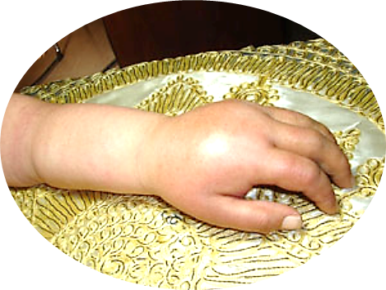
Figure (1): Pre-Operative View- Left Upper Limb
Diffuse edema involving the left hand extending to the mid-forearm.
Note: Well-demarcated proximal border of edema with initial formation of a bracelet-like skin ring.

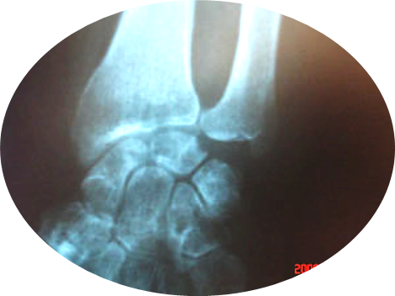
Figure (2): Pre-Operative X-Ray- Left Wrist
Positive ulno-radial index. Erosion of the lunate articular surface opposing the ulnar head. Radiographic osteoporosis in carpal bones and distal forearm bones.

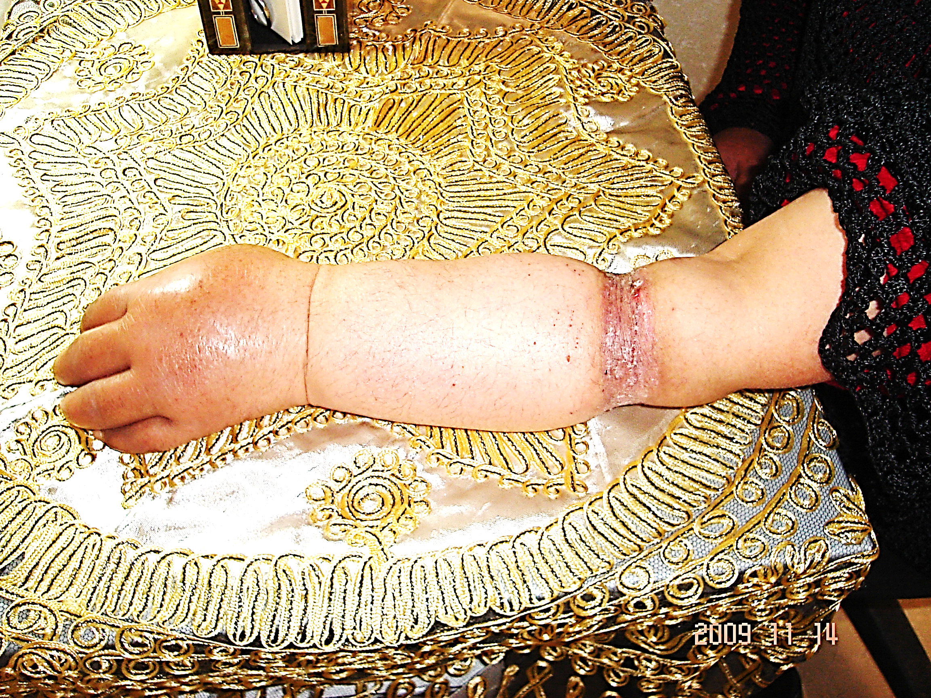 |  | 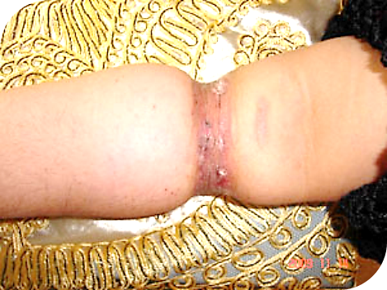
Figure (3): Pre-Operative View- Left Upper Limb
Note: Constricting skin ring representing the proximal border of edema.
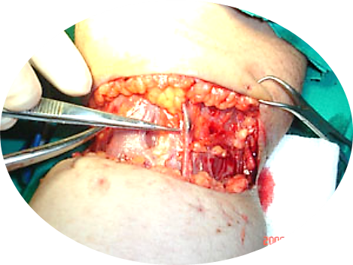 | 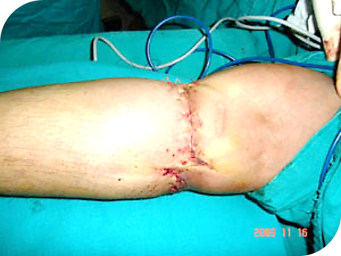
(a) | (b)
Figure (4): Per-Operative View- Left Upper Limb
Figure (4-a): Intraoperative Finding
Absence of subcutaneous adipose tissue with thrombosis of superficial veins in the constriction zone.
Figure (4-b): Surgical Technique
Wound line broken at both ends to prevent recurrent constriction during scar maturation.

Figure (5): 3-month Post-Operative Views- Left Upper Limb
Demonstrating functional and aesthetic outcomes: Near-complete edema resolution. Restoration of near-normal active mobility. Satisfactory cosmetic appearance
(From the surgeon’s archive)

…………………………………………………………………….

In other contexts, you can also read the following articles:
 | DOI | The Spinal Reflex, New Hypothesis of Physiology
 | - | The Hyperreflexia, Innovated Pathophysiology
 | DOI | The Spinal Shock
 | - | The Spinal Injury, the Pathophysiology of the Spinal Shock, the Pathophysiology of the Hyperreflexia
 | DOI | Upper Motor Neuron Lesions, the Pathophysiology of the Symptomatology
 | - | The Hyperreflexia (1), the Pathophysiology of Hyperactivity
 | - | The Hyperreflexia (2), the Pathophysiology of Bilateral Responses
 | - | The Hyperreflexia (3), the Pathophysiology of Extended Hyperreflex
 | - | The Hyperreflexia (4), the Pathophysiology of Multi-Response Hyperreflex
- | - | The pathophysiology of Triple flexion Reflex
 | - | The Clonus, 1st Hypothesis of Pathophysiology
 | - | The Clonus, 2nd Hypothesis of Pathophysiology
 | DOI | The Clonus, Two Hypotheses of Pathophysiology
 | DOI | The Nerve Transmission through Neural Fiber, Personal View vs. International View
 | - | The Nerve Transmission through Neural Fiber (1), The Action Pressure Waves
 | - | The Nerve Transmission through Neural Fiber (2), The Action Potentials
 | - | The Nerve Transmission through Neural Fiber (3), The Action Electrical Currents
 | - | The Function of Standard Action Potentials & Currents
 | - | The Three Phases of Nerve transmission
 | DOI | Neural Conduction in the Synapse (Innovated)
 | DOI | Nodes of Ranvier, the Equalizers
 | - | Nodes of Ranvier, the Functions
 | - | Nodes of Ranvier, First Function
 | - | Nodes of Ranvier, Second Function
 | - | Nodes of Ranvier, Third Function
 | - | Node of Ranvier, The Anatomy
 | - | The Wallerian Degeneration
 | - | The Neural Regeneration
 | - | The Wallerian Degeneration Attacks Motor Axons, While Avoids Sensory Axons
 | DOI | The Sensory Receptors
 | - | Nerve Conduction Study, Wrong Hypothesis is the Origin of the Misinterpretation (Innovated)
 | - | Piriformis Muscle Injection_ Personal Approach
 | - | The Philosophy of Pain, Pain Comes First! (Innovated)
 | - | The Philosophy of the Form (Innovated)
 | - | Pronator Teres Syndrome, Struthers-Like Ligament (Innovated)
 | - | Ulnar Nerve, Congenital Bilateral Dislocation
 | - | Posterior Interosseous Nerve Syndrome
 | - | The Multiple Sclerosis: The Causative Relationship Between  The Galvanic Current & Multiple Sclerosis?
 | - | Cauda Equina Injury, New Surgical Approach
 | - | Carpal Tunnel Syndrome Complicated by Complete Rupture of Median Nerve
 | - | Biceps Femoris' Long Head Syndrome (BFLHS)
 | DOI | Barr Body, The Whole Story (Innovated)
 | - | Adam's Rib and Adam's Apple, Two Faces of one Sin
 | - | Adam's Rib, could be the Original Sin?
 | - | Barr Body, the Second Look
 | DOI | Who Decides the Sex of Coming Baby?
 | - | Boy or Girl, Mother Decides!
 | - | Oocytogenesis
 | - | Spermatogenesis
 | - | This Woman Can Only Give Birth to Female Children
 | - | This Woman Can Only Give Birth to Male Children
 | - | This Woman Can Give Birth to Female Children More Than to Male Children
 | - | This Woman Can Give Birth to Male Children More Than to Female Children
 | - | This Woman Can Equally Give Birth to Male Children & to Female Children
 | - | Eve Saved Human Identity; Adam Ensured Human Adaptation
 | - | Coronavirus (Covid-19): After Humiliation, Is Targeting Our Genes
 | - | Coronavirus (Covid-19): After Humiliation, Is Targeting Our Genes
 | - | The Black Hole is a (the) Falling Star?
 | - | Mitosis in Animal Cell
 | - | Meiosis
 | - | Universe Creation, Hypothesis of Continuous Cosmic Nebula
 | - | Circulating Sweepers
 | - | Pneumatic Petrous, Bilateral Temporal Hyperpneumatization
 | - | Congenital Bilateral Thenar Hypoplasia
 | - | Ulnar Dimelia, Mirror hand Deformity
 | DOI | Thumb Reconstruction Using Microvascular Second Toe to Thumb Transfer
 | DOI | Surgical Restoration of a Smile by Grafting a Segment of the Gracilis Muscle to the Face
 | DOI | Mandible Reconstruction Using Free Fibula Flap
 | DOI | Presacral Schwannoma
 | DOI | Liver Hemangioma: Urgent Surgery of Giant Liver Hemangioma  Due to Intra-Tumor Bleeding
 | DOI | Free Para Scapular Flap (FPSF) for Skin Reconstruction
 | DOI | Claw Hand Deformity (Brand Operation)
 | - | Algodystrophy Syndrome Complicated by Constricting Ring at the Proximal Border of the Edema
 | - | Non- Traumatic Non- Embolic Acute Thrombosis of Radial Artery (Buerger’s Disease)
 | - | Isolated Axillary Tuberculosis Lymphadenitis
 | DOI | The Iliopsoas Tendonitis... The Snapping Hip
 | To read the article in Arabic, click on
 | DOI | The New Frankenstein Monster
 | DOI | The Lone Wolf
 | DOI | The Delirium of Night and Day
 | DOI | The Delirium of the Economy
 | DOI | Ovaries in a Secure Corner… Testicles in a Humble Sac:  An Inquiry into the Function of Form
 | DOI | Eve Preserves Humanity’s Blueprint; Adam Drives Its Evolution
 | DOI | The Manufacture of the Unconscious
 | DOI | The Ballad of Eternity
 | DOI | Two Truths Woman Would Never Accept
 | DOI | The 'Iddah (Waiting Period) in Islamic Law: A Comparative Analysis of its Rationale for Divorced Women and Widows
 | DOI | The IVF/ICSI-Conceived Child: A Biologically Suboptimal Outcome

16/11/2009

