Ammar Yaseen MANSOUR
Ulnar Nerve
Congenital Bilateral Dislocation
For more radiological details, see the linked video: 
A 15 -year old male, a student, presented complaining for snap on the medial side
of both elbows, especially on the left non – dominant arm. The patient
was asymptomatic, his consultation mainly consisting of visible and detectable snap around the medial humeral epicondyle. The bilateral snap was always present, becomes more evident in activities that require a phase of resisted flexion of the elbow beyond 90 to 100 degrees as well as resisted extension; such as push-ups, lifting weights; figure (1).
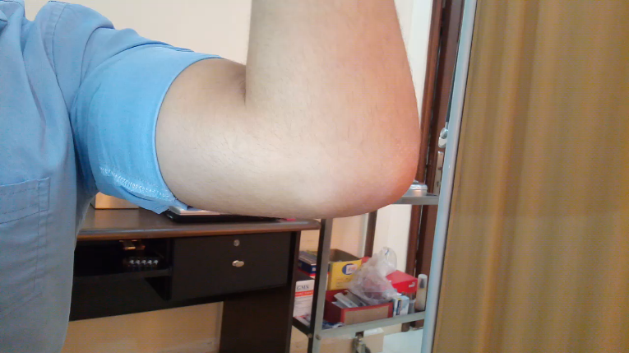

Figure (1)
Congenital Bilateral Ulnar Nerve Dislocation.
The snap on the medial side of both elbows, especially on the left non – dominant arm.
The snap and nerve dislocation were constant every time the patient flexed and extended his elbow.
It becomes more evident in activities that require a phase of resisted flexion of the elbow beyond 90 to 100 degrees as well as resisted extension; such as push-ups, lifting weights.
On examination no clinical findings indicative of nerve compression were found. Investigations including plain X-rays were remarked with a hypoplastic medial epicondyle more evident in the left elbow; Figure (2).
Repeat clinical examinations revealed bilaterally unstable ulnar nerves by palpation. The nerve was felt to completely dislocate anteriorly sliding over the medial epicondyle during flexion and then relocating posteriorly during elbow extension. The snap and nerve dislocation were constant every time the patient flexed and extended his elbows.
N.B. If the nerve's snap is blocked in some way during elbow flexion and extension
( Using computer and the elbow fixed on the surface of table for example),
the patient feels inconvenient and Tinel's sign is produced.
The adopted treatment for this particular case was to wait and watch the natural evolution of the pathology (waiting & watching strategy). Some recommendations have been made to smoothen the course and to avoid any irritation of the ulnar nerve.

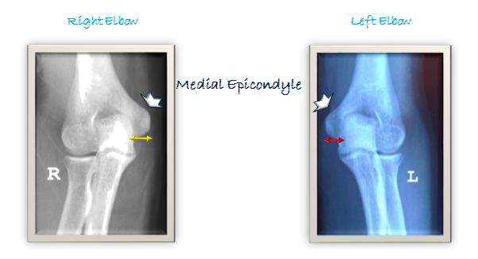
Figure (2)
Radiological Findings
Bilateral hypoplastic medial epicondyle, more evident in left

Discussion
In the presented case, recurring snap and luxation of the ulnar nerve at the elbow are present since little age suggesting the congenital origin of the lesion. The patient was a 15- year non-athlete student. The greater mobility was at the non-dominant left arm.
The congenital laxity of supporting ligaments is traditionally considered to be the cause of a such dislocation. However, I suggest other pathologies such as the hypoplasia or dysplasia of the medial intermuscular septum of the arm, the hypoplasia of the medial epicondyle. However, they still need to be approved.
The abnormally mobile nerve is more vulnerable to injury than normally positioned nerves. Therefore, neuritis can occur at any time of the course. Subluxating nerves which stop on the tip of the medial humeral epicondyle upon 90 degrees or more of flexion at the elbow, are more subject to direct trauma than completely displaced nerves which cross the epicondyle upon elbow flexion.
Careful palpation could easily distinguish snapping ulnar nerve on the medial side of the elbow. In such a way, a snap produced by more less probable dislocation of the medial head of the triceps could be excluded. The two pathologies can occur in combination; however, they did not do in my case.
I adopted the waiting and watching strategy in treating this case of asymptomatic congenital bilateral and especially complete ulnar nerve instability. I recommended the patient to avoid activities that involve repetitive flexion and extension of the elbow, such as push-ups, weight lifting. I also recommended him not to port the elbow Ortheses or the other compressive bands over the elbow in order to allow the nerve to move freely.
The aim of this treatment is to lessen the chance to develop neuritis. It does not eliminate the underlying pathology. Later on, if the underlying pathology manifests differently, one can change the strategy toward operative management.
There are several surgical alternatives for symptomatic recurrent dislocation of the ulnar nerve. Anterior transposition of the ulnar nerve is usually selected by the majority of orthopaedic surgeons because of the simplicity of the operative procedure and the early return to previous activities.
Furthermore, because of the constant complete dislocation and relocation, the nerve always adopts the shortest course. In elbow flexion at 90 degree it dislocates anterior to the medial epicondyle, which is the shortest course. However, it relocates behind the epicondyle in elbow extension, which also is the shortest course. Therefore, the ulnar nerve become shorter than usual. The fact that precludes any attempt to restore the original nerve's course behind the medial epicondyle. For that raison, I will always apt for anterior transposition of ulnar nerve when the indication of a such surgical management comes.
……………………………………………………………………………………………
In another context, one can also read:
- | Neural Conduction, Personal View vs. International View (Innovated)
- | Upper Motor Neuron Lesions, Pathophysiology of Symptomatology
 | Neural Conduction, Action Pressure Waves (Innovated)
 | Neural Conduction, Action Potentials (Innovated)
 | Neural Conduction, Action Electrical Currents (Innovated)
 | The Function of Action Potentials (Innovated)
 | The Three Phases of Neural Conduction
 | Neural Conduction in the Synapse (Innovated)
 | Sensory Receptors
- | Nodes of Ranvier, the Equalizers (Innovated)
 | Nodes of Ranvier, the Functions (Innovated)
 | Nodes of Ranvier, Function N1 (Innovated)
 | Nodes of Ranvier, Function N2 (Innovated)
 | Nodes of Ranvier, Function N3 (Innovated)
- | The Philosophy of Pain, Pain Comes First! (Innovated)
- | The Philosophy of Form (Innovated)
- | Spinal Injury, Pathophysiology of Spinal Shock, Pathophysiology of Hyperreflexia
 | Spinal Shock (Innovated)
 | The Clonus (Innovated)
 | Hyperactivity Hyperreflexia (Innovated)
 | Hyperreflexia, Extended Sector of Reflex
 | Hyperreflexia, Bilateral Responses
 | Hyperreflexia, Multiple Responses
- | Nerve Conduction Study, Wrong Hypothesis is the Origin of Misinterpretation (Innovated)
 | Wallerian Degeneration (Innovated)
 | Neural Regeneration (Innovated)
- | Wallerian Degeneration Attacks Motor Axons, While Avoids Sensory Axons
 | Barr Body, the Whole Story (Innovated)
 | Boy or Girl, Mother Decides!
 | Adam's Rib and Adam's Apple, Two Faces of one Sin
 | The Black Hole is a (the) Falling Star?
 | Adam's Rib, could be the Original Sin?
 | Pronator Teres Syndrome, Struthers Like Ligament (Innovated)
 | Function of Standard Action Potentials & Currents
 | Posterior Interosseous Nerve Syndrome
 | Spinal Reflex, New Hypothesis of Physiology
 | Hyperreflexia, Innovated Pathophysiology
 | Clonus, 1st Hypothesis of Pathophysiology
 | Clonus, 2nd Hypothesis of Pathophysiology
 | Clonus, Two Hypotheses of Pathophysiology
 | Hyperreflexia (1), Pathophysiology of Hyperactivity
 | Hyperreflexia (2), Pathophysiology of bilateral Responses
 | Hyperreflexia (3), Pathophysiology of Extended Hyperreflex
 | Hyperreflexia (4), Pathophysiology of Multi-Response Hyperreflex
 | Barr Body, the Second Look
 | Mitosis in Animal Cell
 | Meiosis
 | Universe Creation, Hypothesis of Continuous Cosmic Nebula
 | Circulating Sweepers
 | Pneumatic Petrous, Bilateral Temporal Hyperpneumatization

23/11/2020

