Dr. Ammar Yaseen Mansour
The Clonus: 2nd Hypothesis of Pathophysiology
For more details concerning the 2nd Hypothesis of the Pathophysiology of Clonus,
see the linked video:


Clonus is a rhythmic, oscillating, stretch reflex, the cause of which is not totally known; however, it relates to the lesions of the upper motor neurons and therefore is generally accompanied by the hyperreflexia. It can be evaluated in many joints but is most commonly seen in the ankle joint by briskly dorsiflexing the foot.
Sometimes, we obtain a similar movement in normal individuals, however it should be less than five oscillations in such cases. Provided, it is accompanied by other signs and/or symptoms of hyperreflexia, one should think of its morbidity even in a low rhythm.
Normally, one stimulus launches its related reflex circuit only. For an example, tapping on Achilles tendon launches its own reflex circuit (i.e., the ankle jerk reflex). However, in the upper motor injuries and because of the induced overactive hyperreflex, the contraction of the related muscles (i.e., the Gastrocnemius and Soles muscles in our example) can be brisk and too severe. The severe muscle contraction could activate another group of receptors that belong to the antagonistic muscle(s) (i.e., the Tibial muscle in the same example).
In turn, the severe tibial muscle contraction will activate the receptors of the antagonist muscles (i.e., the Gastrocnemius & the Sole muscles). Hence, a vicious circle of two opposite overactive hyperreflexes arises. In such a way, one overactive hyperreflex activates the antagonistic overactive hyperreflex circuit, and vice versa.
However, every coming hyperreflex circuit will be of less energy than the precedent. At times, the muscle contraction ends to be too weak to launch a new circle of the vicious circle. The clonus then stops. Moreover, the abused muscles of both sides of the vicious circle will eventually exsanguinate the stock of energy. So finally, they give up the game. And the clonus also stops; figure (1).

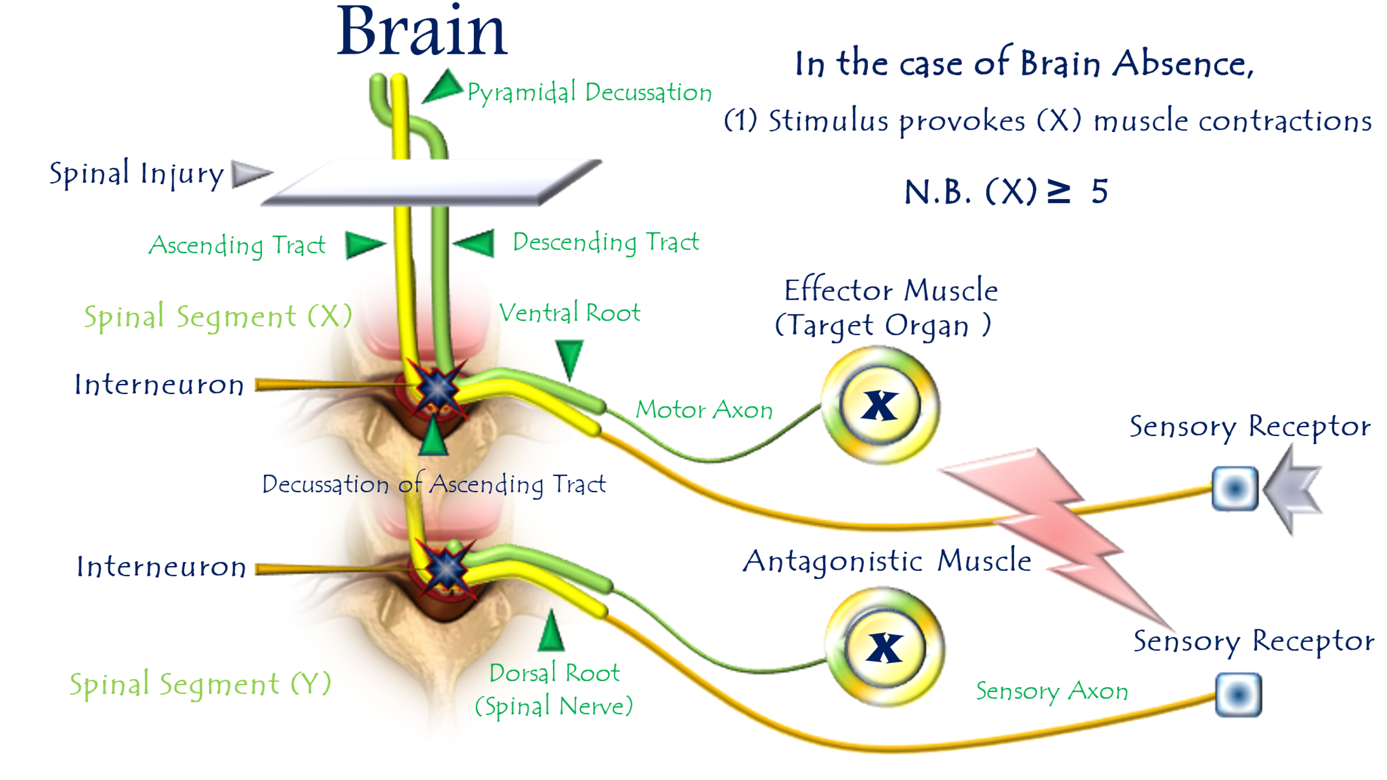

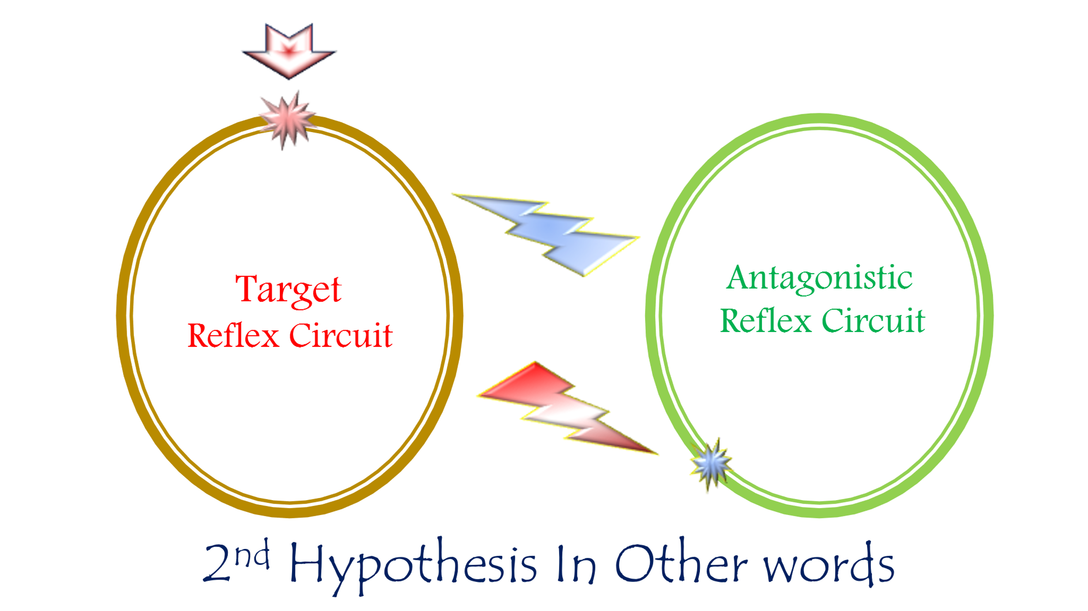
Figure (1)
The Pathophysiology of the Clonus, 2nd Hypothesis
For more details concerning the 2nd Hypothesis of Pathophysiology of the Clonus, see the linked video:
In upper motor injuries,
and because of the induced hyperactive hyperreflex, the contraction of the effector muscles (i.e., the Gastrocnemius and the Soles muscles in the case of ankle jerk reflex) can be brisk and too severe.
However, the severe muscle contraction could activate another group of receptors that belong to the antagonistic muscle(s) (i.e., the Tibial muscle in the same example).
Hence, a vicious circle of two opposite hyperactive hyperreflexes arises.
In such a way, one hyperactive hyperreflex activates the antagonistic hyperactive hyperreflex circuit, and vice versa.

…………………………………………………………………..
In other contexts, you can also read the following articles:
 | DOI | The Spinal Reflex, New Hypothesis of Physiology
 | - | The Hyperreflexia, Innovated Pathophysiology
 | DOI | The Spinal Shock
 | - | The Spinal Injury, the Pathophysiology of the Spinal Shock, the Pathophysiology of the Hyperreflexia
 | DOI | Upper Motor Neuron Lesions, the Pathophysiology of the Symptomatology
 | DOI | Hyperreflexia (1): Pathophysiology of Disproportionate Motor Response
 | DOI | Hyperreflexia (2): Pathophysiology of Bilateral-Response Hyperreflexia
 | DOI | Hyperreflexia (3): Pathophysiology of Extended Hyperreflexia
 | DOI | Hyperreflexia (4): Pathophysiology of Multi-Motor-Response Hyperreflexia
- | DOI | The pathophysiology of Triple flexion Reflex
 | - | The Clonus, 1st Hypothesis of Pathophysiology
 | - | The Clonus, 2nd Hypothesis of Pathophysiology
 | DOI | The Clonus, Two Hypotheses of Pathophysiology
 | DOI | The Nerve Transmission through Neural Fiber, Personal View vs. International View
 | - | The Nerve Transmission through Neural Fiber (1), The Action Pressure Waves
 | - | The Nerve Transmission through Neural Fiber (2), The Action Potentials
 | - | The Nerve Transmission through Neural Fiber (3), The Action Electrical Currents
 | - | The Function of Standard Action Potentials & Currents
 | - | The Three Phases of Nerve transmission
 | DOI | Neural Conduction in the Synapse (Innovated)
 | DOI | Nodes of Ranvier, the Equalizers
 | - | Nodes of Ranvier, the Functions
 | - | Nodes of Ranvier, First Function
 | - | Nodes of Ranvier, Second Function
 | - | Nodes of Ranvier, Third Function
 | - | Node of Ranvier, The Anatomy
 | DOI | Vesicular Dynamics: A Unifying Theory for Wallerian Degeneration and Neural Regeneration
 | - | The Wallerian Degeneration
 | - | The Neural Regeneration
 | DOI | Wallerian Degeneration: Affects Motor Axons while Sparing Sensory Axons
 | DOI | The Sensory Receptors
 | DOI | Electroneurography vs. Neural Reality: Hidden Fallacies in Nerve Conduction Studies
 | DOI | Piriformis Muscle Injection: Personal Approach
 | DOI | In Philosophy of Nerves: Pain First!
 | DOI | In Neurodoctrines: Form is Necessity!
 | - | Pronator Teres Syndrome, Struthers-Like Ligament (Innovated)
 | DOI | Ulnar Nerve, Congenital Bilateral Dislocation
 | - | Posterior Interosseous Nerve Syndrome
 | DOI | The Multiple Sclerosis: The Causative Relationship Between  The Galvanic Current & Multiple Sclerosis?
 | - | Cauda Equina Injury, New Surgical Approach
 | DOI | Carpal Tunnel Syndrome Ends Its Adherence: Complete Median Nerve Transection
 | DOI | Biceps Femoris' Long Head Syndrome (BFLHS)
 | DOI | Barr Body, The Whole Story (Innovated)
 | - | Adam's Rib and Adam's Apple, Two Faces of one Sin
 | - | Adam's Rib, could be the Original Sin?
 | - | Barr Body, the Second Look
 | DOI | Who Decides the Sex of Coming Baby?
 | - | Boy or Girl, Mother Decides!
 | - | Oocytogenesis
 | - | Spermatogenesis
 | - | This Woman Can Only Give Birth to Female Children
 | - | This Woman Can Only Give Birth to Male Children
 | - | This Woman Can Give Birth to Female Children More Than to Male Children
 | - | This Woman Can Give Birth to Male Children More Than to Female Children
 | - | This Woman Can Equally Give Birth to Male Children & to Female Children
 | - | Eve Saved Human Identity; Adam Ensured Human Adaptation
 | DOI | COVID-19: Beyond the Crisis—Is It Targeting Our Genes?
 | DOI | Fibromyalgia
 | - | Mitosis in Animal Cell
 | - | Meiosis
 | - | Universe Creation, Hypothesis of Continuous Cosmic Nebula
 | - | Circulating Sweepers
 | - | The Black Hole is a (the) Falling Star?
 | - | Pneumatic Petrous, Bilateral Temporal Hyperpneumatization
 | DOI | Congenital Bilateral Thenar Hypoplasia
 | DOI | Ulnar Dimelia, Mirror hand Deformity
 | DOI | Thumb Reconstruction Using Microvascular Second Toe to Thumb Transfer
 | DOI | Surgical Restoration of a Smile by Grafting a Segment of the Gracilis Muscle to the Face
 | DOI | Mandible Reconstruction Using Free Fibula Flap
 | DOI | Presacral Schwannoma
 | DOI | Liver Hemangioma: Urgent Surgery of Giant Liver Hemangioma  Due to Intra-Tumor Bleeding
 | DOI | Free Para Scapular Flap (FPSF) for Skin Reconstruction
 | DOI | Claw Hand Deformity (Brand Operation)
 | DOI | Algodystrophy Syndrome Complicated by Constricting Ring at the Proximal Border of the Edema
 | DOI | Non- Traumatic Non- Embolic Acute Thrombosis of Radial Artery (Buerger’s Disease)
 | DOI | Isolated Axillary Tuberculosis Lymphadenitis
 | DOI | The Iliopsoas Tendonitis... The Snapping Hip
- | DOI | Peri- Menopausal Breast Lesions: Towards a More Decisive Approach
 | To read the article in Arabic, click on
 | DOI | The New Frankenstein Monster
 | DOI | The Lone Wolf
 | DOI | The Delirium of Night and Day
 | DOI | The Delirium of the Economy
 | DOI | Ovaries in a Secure Corner… Testicles in a Humble Sac:  An Inquiry into the Function of Form
 | DOI | Eve Preserves Humanity’s Blueprint; Adam Drives Its Evolution
 | DOI | The Manufacture of the Unconscious
 | DOI | The Ballad of Eternity
 | DOI | Two Truths Woman Would Never Accept
 | DOI | The 'Iddah (Waiting Period) in Islamic Law: A Comparative Analysis of its Rationale for Divorced Women and Widows
 | DOI | The IVF/ICSI-Conceived Child: A Biologically Suboptimal Outcome

13/2/2024

