Dr. Ammar Yaseen Mansour

Neural Conduction Across the Synapse
Personal View vs. International View
(Personal View)

NB:
The Arabic version of this article is the authoritative reference. Read it here:
النَّقلُ عبرَ المَشابكِ العَصبيَّةِ (رؤيةٌ شخصيَّةٌ)
The Trans-Synaptic Neural Conduction (Personal View)

Simplicity and Speed—The Twin Pillars of Life
Persistence is the cornerstone of success. From the dawn of creation, life has relied on two imperatives: simplicity of method and speed of execution. Complex answers to life’s questions have always led to extinction. Answers, like questions, must be swift—a blink separates the spark of life from the silence of death.
The human mind, ever restless, sought to theorize neural conduction. Yet its rigid, disjointed hypotheses clashed with life’s elegant rhythm. They reduced it to a line between two points; I propose a simpler, more direct path. Here lies their theory—and here, mine.

The Current Theory of Neural Conduction Across the Synapse (International Hypothesis)
In the neural synapse, the electrical impulse arrives at the presynaptic knob. This activates voltage-gated Ca²⁺ channels, opening their gates (1). Calcium ions (Ca²⁺) flow into the intracellular space (2), where they bind to synaptic vesicles—carriers of neurotransmitters—forming a complex that adheres to the presynaptic membrane (3). The vesicles then rupture, releasing their neurotransmitter payload into the synaptic cleft (4). The neurotransmitters diffuse across the cleft (5), binding to receptors on the postsynaptic membrane (6). These receptors open ion channels, allowing specific ions to enter the postsynaptic dendrite (7). Seven steps later, the neural command is relayed from the presynaptic to the postsynaptic neuron.

My Hypothesis of Neural Conduction Across the Synapse
(Personal View)
For further details on my hypothesis of neural conduction across the synapse,
see the linked video:
My hypothesis rests on three pillars:
- Synaptic conduction is purely electrical.
- Neurotransmitters serve to convert the synaptic cleft from an insulator to a conductor. They are perpetually abundant in the cleft, both at rest and during activity.
- The Action Pressure Wave (APW) is central. Upon reaching the presynaptic knob, the APW’s trough (negative pressure phase) generates the Terminal Action Potential (TAP). Simultaneously, its crest (positive pressure phase) aids propelling the Terminal Electrical Current (TEC) across the synapse.
Though these actions are synchronized, I separate them for clarity:
- The crest, rich in kinetic energy, acts first by compressing the presynaptic membrane.
- The trough follows, creating the TAP via Ca²⁺ influx.
N.B. For further details on this hypothesis, see the three figures below (Figures 1–3). However, I will right now only clarify foundational distinctions from the international view.
I. The Function of the Neurotransmitter
Riding on the backs of microtubules or surfing the Action Pressure Wave at every opportunity, synaptic vesicles traverse the neural axon to reach their destination at the synapse. These vesicles carry neurotransmitters within their cores.
Continuous Neurotransmitter Release:
- Both at rest and during activity, vesicles perpetually release their neurotransmitter payload into the synaptic cleft.
- Dual Role of the Neurotransmitter:
  - Moisturizes the Cleft: Converts the synaptic cleft into an electrically conductive medium.
  - Adsorbs Specific Ions:
    - Excitatory Synapses: Captures positive ions (e.g., Na⁺, Ca²⁺).
    - Inhibitory Synapses: Captures negative ions (e.g., Cl⁻).
(See Figure 1)
Physics of Electrical Current: Three Essential Components
Every electrical current requires three elements:
- Anode (Positive Pole): To be addressed later.
- Cathode (Negative Pole): Already present.
  - The postsynaptic dendrite’s cytoplasm, inherently negatively polarized (-70 mV), serves as the cathode.
- Conductive Medium:
  - The neurotransmitter-saturated cleft acts as the conductor, enabling the Terminal Electrical Current (TEC).
The Missing Anode: Role of the Action Pressure Wave’s Trough
The final piece—the anode—is established by the negative pressure phase (trough) of the Action Pressure Wave. This mechanism, detailed in Figure 3, completes the electrical circuit, allowing the TEC to propagate.
II. The Function of the Action Pressure Wave
A. Role of the Wave’s Crest (The Crest of the Action Pressure Wave)
As previously noted, the synaptic cleft is perpetually saturated with neurotransmitter, ensuring continuous electrical conductivity—both at rest and during activity. To further optimize electrical conduction across the synapse, the Action Pressure Wave (APW) instantly enhances the cleft’s conductivity through two synchronized mechanisms:
- Mechanism 1: Narrowing the Synaptic Cleft
  - The kinetic energy stored in the wave’s crest compresses the presynaptic knob’s membrane upon impact, propelling it into the synaptic cleft.
  - This reduces the synaptic cleft width, effectively shortening the distance between the poles of the Terminal Action Potential (TAP).
  - Result: A dramatic reduction in electrical resistance, ensuring rapid, inevitable current discharge.
For further details on this mechanism, click here:
- Mechanism 2: Maximizing Neurotransmitter Density
  - Simultaneously, the crest’s pressure forcibly ejects the entire neurotransmitter load from vesicles docked at the presynaptic membrane.
  - This surge exponentially increases the neurotransmitter concentration in the cleft, transforming it into a highly conductive medium.
For further details on this mechanism, click here:
Combined Outcome:
- Enhanced electrical efficiency.
- Near-instantaneous synaptic transmission.
- Precision and speed—exactly what biological systems demand.
(See Figure 2)
B. Role of the Wave’s Trough (The Trough of the Action Pressure Wave)
The trough’s negative pressure performs two critical functions:
- Opening Pressure-Gated Ca²⁺ Channels
  - The negative pressure phase opens pressure-sensitive Ca²⁺ channels, drawing extracellular Ca²⁺ ions into the presynaptic knob.
- Establishing Electrical Polarity
  - Accumulated Ca²⁺ ions create a positive polarity in the presynaptic knob, contrasting with the postsynaptic dendrite’s inherent negative polarity (-70 mV).
  - This electrochemical gradient generates the Terminal Action Potential (TAP).
Final Step: The Terminal Electrical Current (TEC)
- The conductive, neurotransmitter-filled cleft bridges the presynaptic anode (positive) and postsynaptic cathode (negative).
- The resulting Terminal Electrical Current (TEC) propagates the neural signal to:
  - Postsynaptic neurons (in interneuron synapses).
  - Effector organs (in neuromuscular or neuroglandular synapses).
(See Figure 3)
For further details on the trough’s role, click here:
Key Innovation
- Synergy of Crest and Trough:
  - The crest prepares the cleft structurally (narrowing) and chemically (neurotransmitter surge).
  - The trough completes the circuit by establishing polarity.
- Outcome: A seamless, ultrafast electromechanical transmission system.
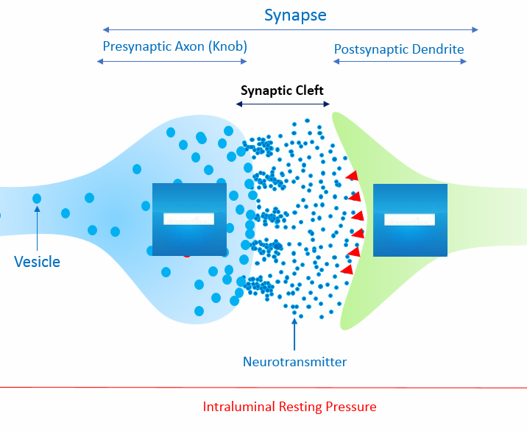
Figure (1)
The Neural Synapse (At Rest)
For an in-depth exploration of the synapse's functional anatomy,
click here:

Structural Components
- Presynaptic Axon Terminal (Knob):
  - The swollen end of the presynaptic neuron’s axon.
- Postsynaptic Dendrite:
  - The receiving extension of the postsynaptic neuron.
- Synaptic Cleft:
  - A fluid-filled gap (~20–40 nm) separating the presynaptic and postsynaptic membranes.

Key Functional Features
- Continuous Neurotransmitter Release:
  - Synaptic vesicles perpetually release neurotransmitters into the cleft, even at rest.
  - Release slows during rest and accelerates during neural activity.
- Permanent Electrical Conductivity:
  - The cleft remains electrically conductive due to constant neurotransmitter presence.
- Ion Adsorption Mechanism:
  - Neurotransmitters selectively adsorb ions within the cleft:
    - Excitatory Synapses: Capture positive ions (Na⁺, Ca²⁺).
    - Inhibitory Synapses: Capture negative ions (Cl⁻).

Polarity at Rest
- Presynaptic & Postsynaptic Cytoplasm:
  - Both maintain a resting membrane potential (~-70 mV) due to:
    - Negatively charged intracellular proteins.
    - Selective ion permeability (e.g., K⁺ leakage channels).
- Synaptic Cleft Charge:
  - Neutral overall, but ion adsorption creates localized charge gradients.

Mechanistic Implications
- Readiness for Instant Transmission:
  - Neurotransmitter priming ensures immediate signal propagation upon activation.
- Synaptic Specificity:
  - Adsorbed ions predefine the synapse’s role (excitation vs. inhibition).


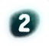
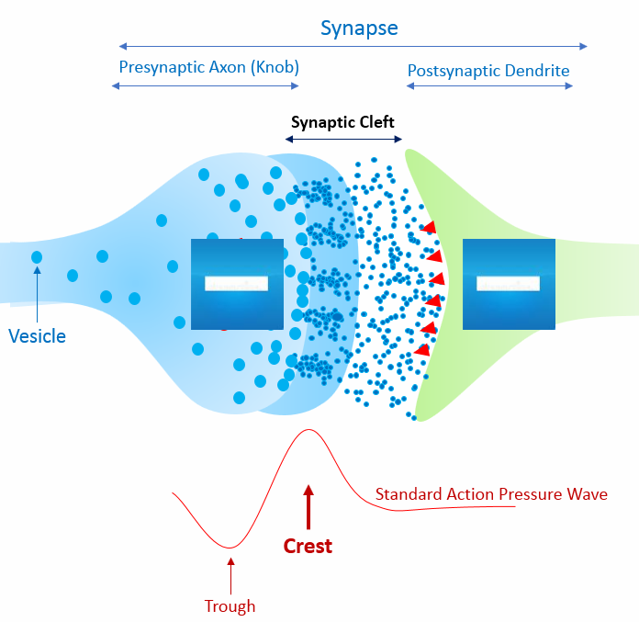
Figure (2)
The Neural Synapse During Neural Conduction:
The Function of the Crest of the Action Pressure Wave
For further details on the first function of the wave’s crest, click here:
For further details on the second function of the wave’s crest, click here:

Mechanism of the Crest’s Action
- Cleft Narrowing and Electrical Discharge:
  - When the crest of the Action Pressure Wave (APW) impacts the presynaptic knob, it propels the membrane into the synaptic cleft.
  - This causes a significant reduction in synaptic cleft width (1), effectively shortening the distance between the poles of the Terminal Action Potential (TAP).
  - Result: A dramatic decrease in electrical resistance, ensuring instantaneous discharge of the Terminal Electrical Current (TEC).
- Forced Neurotransmitter Release:
  - Simultaneously, the crest’s mechanical pressure compresses synaptic vesicles (2) docked at the presynaptic membrane.
  - This forces vesicles to release their entire neurotransmitter payload into the cleft in a single burst.
  - Outcome: A surge in neurotransmitter concentration and density, transforming the cleft into a highly conductive medium.

Combined Effects
- Enhanced Conductivity: The narrowed cleft and neurotransmitter surge optimize electrical transmission.
- Speed and Efficiency: Synchronized mechanical and chemical actions eliminate synaptic delay, ensuring rapid signal propagation.

Key Innovation
- The APW’s crest integrates biomechanical force (cleft compression) and chemical priming (neurotransmitter release) to achieve ultrafast neural conduction.

.

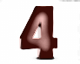
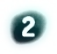

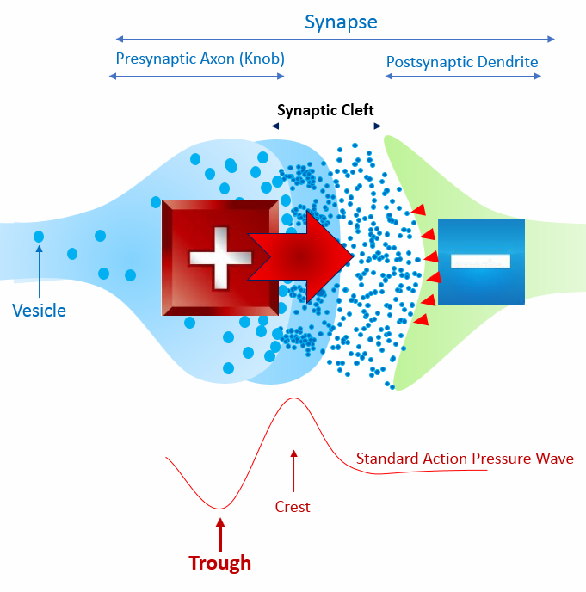
Ca++
Ca++
Figure (3)
The Neural Synapse During Neural Conduction – Role of the Trough of the Action Pressure Wave
For further details on the function of the wave’s trough, click here:
Mechanism of the Trough’s Function
- Negative Pressure and Calcium Influx:
  - The trough (negative pressure phase) of the Action Pressure Wave (APW) mechanically opens pressure-sensitive Ca²⁺ channels on the presynaptic membrane. This is hypothesized to occur via pressure-gated channels responding to pressure changes.
  - Extracellular Ca²⁺ ions flow into the presynaptic knob (1), driven by the negative pressure of the wave’s trough.
- Establishing Electrical Polarity:
  - Accumulated Ca²⁺ ions create a positive polarity in the presynaptic knob (2), contrasting with the inherent negative polarity of the postsynaptic dendrite (resting membrane potential: ~-70 mV).
  - This polarity difference generates the Terminal Action Potential (TAP), a localized voltage gradient.
- Conductive Medium and Terminal Electrical Current (TEC):
  - The neurotransmitter-filled synaptic cleft acts as a conductive medium, enabling the flow of the Terminal Electrical Current (TEC) (3).
  - The TEC bridges the presynaptic (positive) and postsynaptic (negative) poles, completing the electrical circuit.
- Ion Transfer and Signal Transmission:
  - The TEC releases adsorbed ions (Na⁺/Ca²⁺ in excitatory synapses; Cl⁻ in inhibitory synapses) from the cleft into the postsynaptic cell (4).
  - These ions alter the postsynaptic membrane potential, triggering either excitation (depolarization) or inhibition (hyperpolarization).

Key Innovations and Contrasts with Traditional Models
- Mechanical-Electrical Integration: The APW’s trough uses mechanical force (negative pressure) to open Ca²⁺ channels, diverging from classical voltage-gated or ligand-gated mechanisms.
- Role of Calcium: Here, Ca²⁺ establishes presynaptic polarity rather than solely triggering neurotransmitter release. This redefines calcium’s role in synaptic transmission.
- Current-Driven Signal: The TEC is the primary signal carrier, with neurotransmitters serving to maintain cleft conductivity and adsorb specific ions. This contrasts with the chemical-centric model of synaptic transmission.
Implications for Neural Signaling
- Speed and Efficiency: Mechanical pressure waves may enable faster signal propagation than purely chemical diffusion.
- Synaptic Specificity: The type of ions adsorbed in the cleft (excitatory vs. inhibitory) determines the TEC’s effect, aligning with neurotransmitter diversity.
- Effector Organs: Applies to neuromuscular junctions, where the TEC could directly induce muscle contraction via ion transfer.
Conclusion:
Figure 3 illustrates a novel electromechanical model where the APW’s trough establishes polarity via Ca²⁺ influx, driving a Terminal Electrical Current that transmits signals across the synapse. This integrates mechanical forces with electrochemical principles, proposing a faster, more efficient neural conduction mechanism.

…………………………………………………………………………………………
In other contexts. You can also read the following articles:
The Spinal Reflex, New Hypothesis of Physiology
The Hyperreflexia, Innovated Pathophysiology
The Spinal Shock
The Spinal Injury, the Pathophysiology of the Spinal Shock, the Pathophysiology of the Hyperreflexia
Upper Motor Neuron Lesions, the Pathophysiology of the Symptomatology
The Hyperreflexia (1), the Pathophysiology of Hyperactivity
The Hyperreflexia (2), the Pathophysiology of Bilateral Responses
The Hyperreflexia (3), the Pathophysiology of Extended Hyperreflex
The Hyperreflexia (4), the Pathophysiology of Multi-Response Hyperreflex
The Clonus, 1st Hypothesis of Pathophysiology
The Clonus, 2nd Hypothesis of Pathophysiology
The Clonus, Two Hypotheses of Pathophysiology
The Nerve Transmission through Neural Fiber, Personal View vs. International View
The Nerve Transmission through Neural Fiber (1), The Action Pressure Waves
The Nerve Transmission through Neural Fiber (2), The Action Potentials
The Nerve Transmission through Neural Fiber (3), The Action Electrical Currents
The Function of Standard Action Potentials & Currents
The Three Phases of Nerve transmission
Neural Conduction in the Synapse (Innovated)
Nodes of Ranvier, the Equalizers
Nodes of Ranvier, the Functions
Nodes of Ranvier, First Function
Nodes of Ranvier, Second Function
Nodes of Ranvier, Third Function
Node of Ranvier, The Anatomy
The Wallerian Degeneration
The Neural Regeneration
The Wallerian Degeneration Attacks Motor Axons, While Avoids Sensory Axons
The Sensory Receptors
Nerve Conduction Study, Wrong Hypothesis is the Origin of the Misinterpretation (Innovated)
Piriformis Muscle Injection_ Personal Approach
The Philosophy of Pain, Pain Comes First! (Innovated)
The Philosophy of the Form (Innovated)
Pronator Teres Syndrome, Struthers-Like Ligament (Innovated)
Ulnar Nerve, Congenital Bilateral Dislocation
Posterior Interosseous Nerve Syndrome
The Multiple Sclerosis: The Causative Relationship Between
The Galvanic Current & Multiple Sclerosis?
Cauda Equina Injury, New Surgical Approach
Carpal Tunnel Syndrome Complicated by Complete Rupture of Median Nerve
Biceps Femoris' Long Head Syndrome (BFLHS)
Barr Body, The Whole Story (Innovated)
Adam's Rib and Adam's Apple, Two Faces of one Sin
Adam's Rib, could be the Original Sin?
Barr Body, the Second Look
Who Decides the Sex of Coming Baby?
Boy or Girl, Mother Decides!
Oocytogenesis
Spermatogenesis
This Woman Can Only Give Birth to Female Children
This Woman Can Only Give Birth to Male Children
This Woman Can Give Birth to Female Children More Than to Male Children
This Woman Can Give Birth to Male Children More Than to Female Children
This Woman Can Equally Give Birth to Male Children & to Female Children
Eve Saved Human Identity; Adam Ensured Human Adaptation
Coronavirus (Covid-19): After Humiliation, Is Targeting Our Genes
Coronavirus (Covid-19): After Humiliation, Is Targeting Our Genes
The Black Hole is a (the) Falling Star?
Mitosis in Animal Cell
Meiosis
Universe Creation, Hypothesis of Continuous Cosmic Nebula
Circulating Sweepers
Pneumatic Petrous, Bilateral Temporal Hyperpneumatization
Congenital Bilateral Thenar Hypoplasia
Ulnar Dimelia, Mirror hand Deformity
Surgical Restoration of a Smile by Grafting a Segment of the Gracilis Muscle to the Face
Mandible Reconstruction Using Free Fibula Flap
Presacral Schwannoma
Liver Hemangioma: Urgent Surgery of Giant Liver Hemangioma
Due to Intra-Tumor Bleeding
Free Para Scapular Flap (FPSF) for Skin Reconstruction
Claw Hand Deformity (Brand Operation)
Algodystrophy Syndrome Complicated by Constricting Ring at the Proximal Border of the Edema
Non- Traumatic Non- Embolic Acute Thrombosis of Radial Artery
(Buerger’s Disease)
Isolated Axillary Tuberculosis Lymphadenitis
The Iliopsoas Tendonitis... The Snapping Hip
To read the article in Arabic, click on
The New Frankenstein Monster
The Lone Wolf
The Delirium of Night and Day
The Delirium of the Economy
Ovaries in a Secure Corner… Testicles in a Humble Sac:
An Inquiry into the Function of Form
Eve Preserves Humanity’s Blueprint; Adam Drives Its Evolution
14/9/2018

