Dr. AMMAR YASEEN MANSOUR
The Spinal Shock
The Pathophysiology of the Spinal shock
" An Innovated Concept"
N.B.
The Arabic version of this article is the reference,
read it via the following link:
الصَّدمةُ النُّخاعيَّةُ، بحثٌ في الفيزيولوجيا المرضيَّةِ (مفهومٌ جديدٌ)
The Spinal Shock: The Pathophysiology of the Spinal shock
(An Innovated Concept)

Significant questions have lingered unanswered in my mind—questions that have occupied my thoughts since I was a medical student learning the fundamentals of medicine, and persist to this day.
How can a complete transection injury severing the spinal cord at the level of the sixth cervical vertebra (C6) abolish—even temporarily—a spinal reflex whose motor pathway originates, for instance, from the first sacral root (S1)? The distance between the traumatic lesion site and the spinal reflex arc location is vast. Yet, we were taught about the autonomy of spinal reflexes, with their decision-making residing in the Lower Motor Neurons (LMNs) within the spinal cord's anterior horns.
Moreover, despite a persistent, unrecovered complete high cervical spinal cord transection, how could these blocked spinal reflexes reappear later? Furthermore, why do the returning reflexes exhibit characteristics different from the original ones?
These pivotal questions form the core of the following article. Herein, I present my innovative concept regarding the actual circuitry of spinal reflexes.
By adopting this innovative concept, one can clarify all the mysteries surrounding spinal shock and identify the true pathophysiology underlying the altered characteristics of the returning spinal reflexes. Moreover, we may finally reach therapeutic conclusions that could help alter the devastating prognosis of such injuries.
Misguided Foundations, Pillars of Failure
In a manner I do not understand, and in order to explain the dynamics of spinal reflexes, humanity proceeded from the theory of the "Lower Motor Neuron (LMN) Circuit."
This theory posits that, in response to a sudden stimulus, the Lower Motor Neuron (LMN) assumes the role of generating a direct, rapid response to emergent sensory input – this is what is technically termed the spinal reflex. The spinal reflex circuit consists of:
- A sensory neuron, located in the spinal ganglion of the posterior root of the spinal nerve;
- A lower motor neuron, residing in the anterior horn of the spinal cord;
- An intermediate neuron, which connects them and occupies the intervening space between the two.
These three elements are organized within the same spinal segment of the cord, or within two adjacent segments... it makes no difference.
At this level of the spinal cord – which varies ascendingly or descendingly depending on the specific spinal reflex in question – the incoming afferent impulse is received. Urgently, via the intermediate neuron, the signal is relayed to the lower motor neuron. The LMN then takes charge itself of directing the appropriate motor response. Without delay, and with complete independence from higher centers, this LMN issues the efferent (motor) impulse, which reaches the relevant executor for implementation; see Figure (1).
Belatedly, the sensory input (the origin of the crisis), as well as the motor output (characterized by its spontaneity), reach the higher centers. Equipped with a comprehensive overview of the situation after the crisis conditions have passed, these centers analyze all incoming data and outgoing responses to derive appropriate conclusions. The outcome is either certificates of appreciation and medals of praise, or corrective orders issued in anticipation of future crises resembling past events.

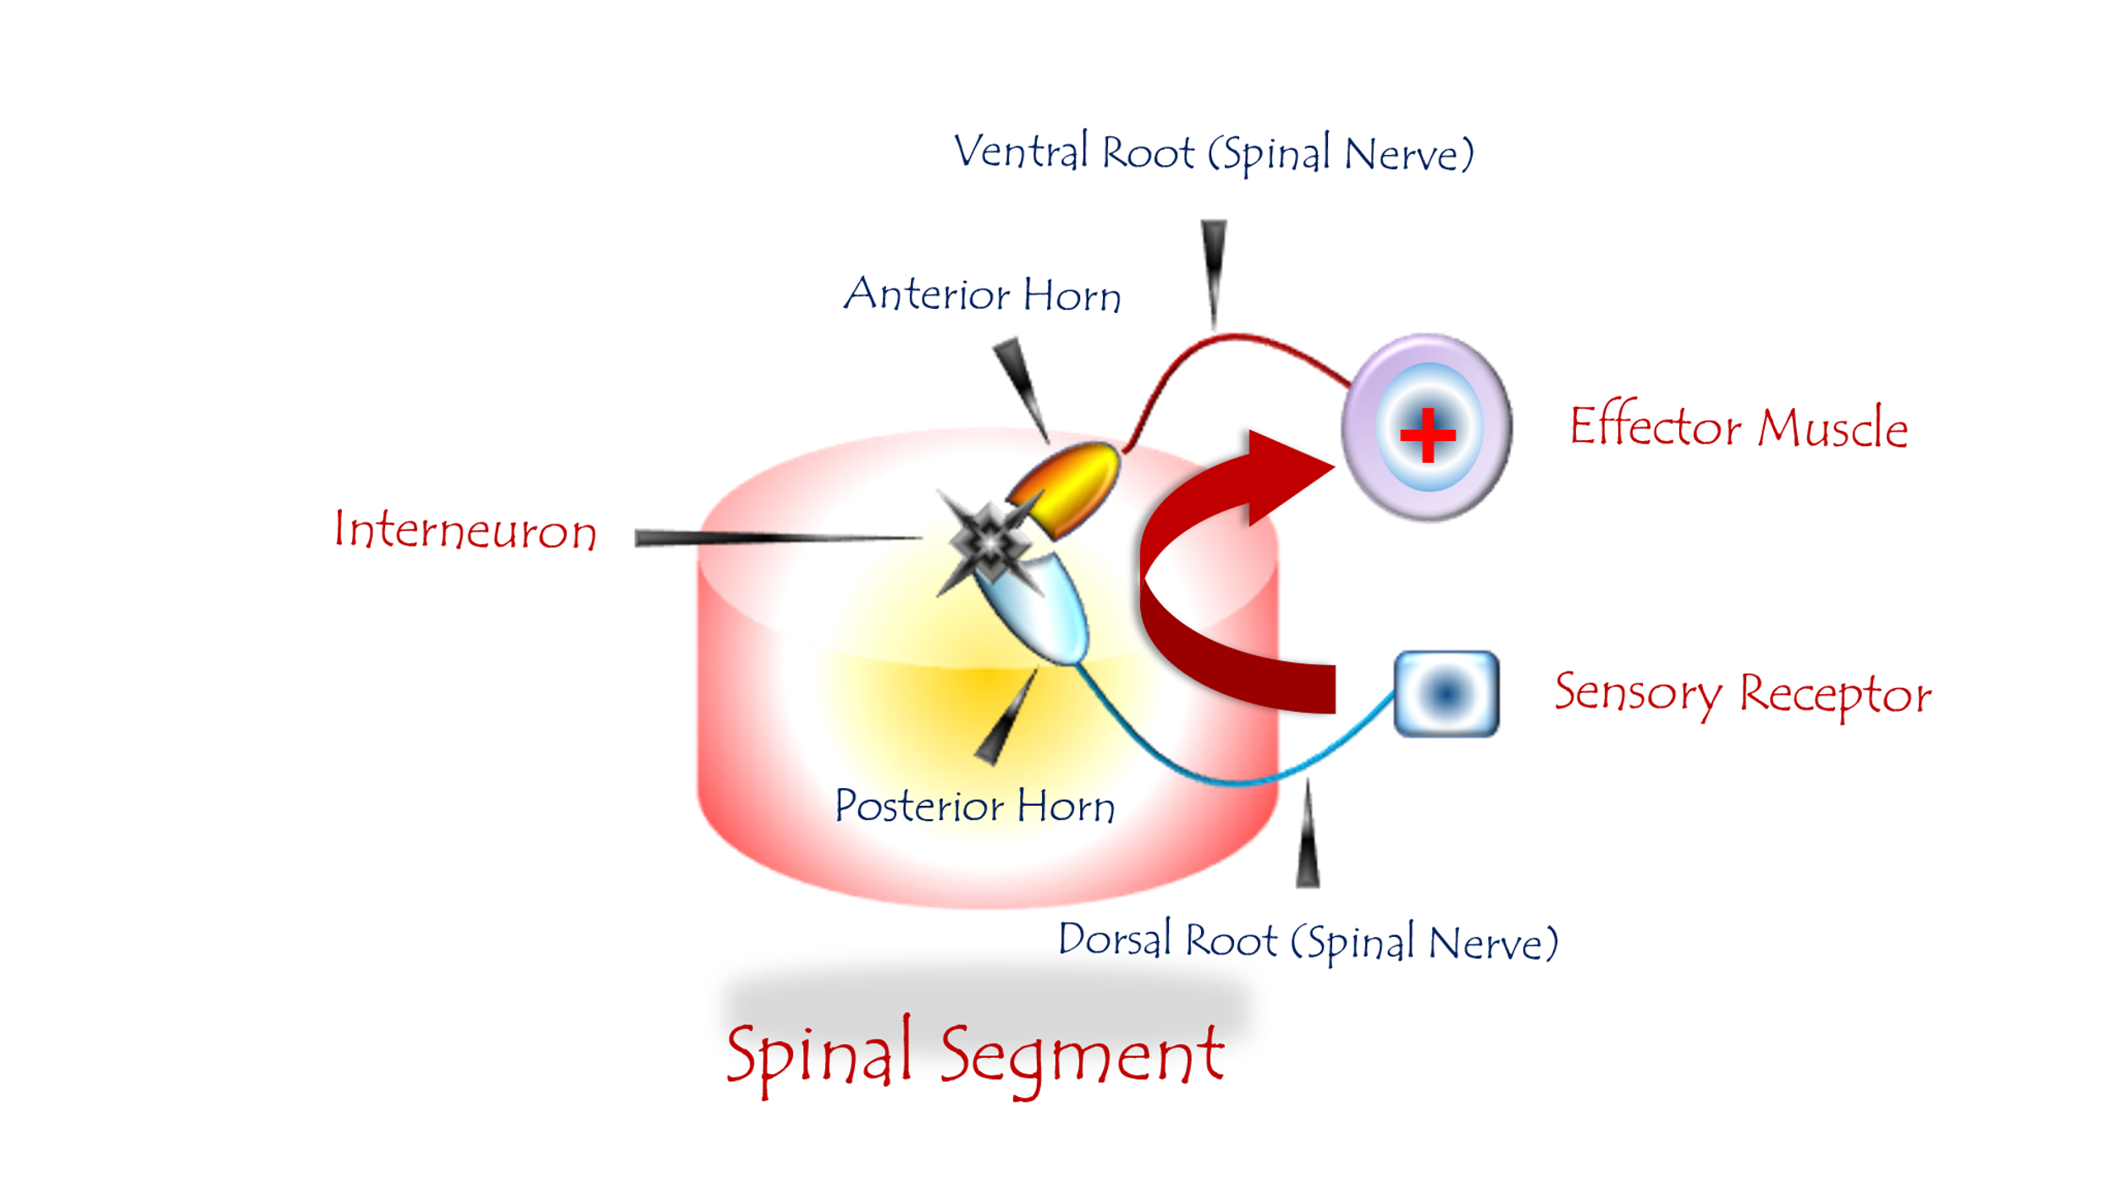
Figure (1): The Spinal Reflex (Traditional Concept)

To watch a short video explaining the classical physiology of the spinal reflex in detail, click this link:

The spinal reflex circuit comprises three elements:
- A sensory neuron (SN)
- An intermediate neuron
- A lower motor neuron (LMN)
- The sensory neuron (SN) resides in the spinal ganglion of the dorsal root of the spinal nerve.
- The intermediate neuron resides in the posterior horn of the spinal cord.
- The lower motor neuron (LMN) occupies the anterior horn of the spinal cord.
All aforementioned neural elements belong to one or two adjacent spinal segment(s).
Sensory input arrives at the sensory neuron. The stimulus is then relayed via an intermediate neuron to the lower motor neuron. The sensory input to the LMN carries mandatory execution orders for motor commands. The lower motor neurons promptly issue their motor commands, which reach all relevant executors for implementation.
Here, the upper motor neuron (UMN) remains detached from the decision site. It merely observes and evaluates the reflex action without direct engagement in the execution.

Spontaneity and simultaneity are crucial elements for navigating crises and averting dangers. Given the potential delays inherent in processes of relay, analysis, and subsequent execution, the architects of this theory likely assumed that the speed required to respond to an ambiguous external threat necessitates complete autonomy for the "field commanders" – those neural structures closest to the event site and the executors.
Of course, this is purely human logic. It presupposes inefficiency, and perhaps even a lack of fidelity, in the transmission of information and its execution. It may also assume that the higher centers lack absolute readiness – whether at rest or during activity – to confront every sudden intruder. This is a human logic that fails to rise to the level of the most organized and efficient system we know: the nervous system.
This marvelous system has carried humanity for thousands of years – known only to God – and continues to do so. It is a human logic that casts doubt between human intelligence and organic intelligence – and the difference between them is undeniably vast.
The Command Neuron
The Upper Motor Neuron (UMN) never relinquishes command—day or night, at rest or during activity. All motor commands issue through its sovereign gate. It establishes its throne upon the cerebral cortex, presiding from on high over the entire scene.
It maintains a network of robust relationships with all command centers: The midbrain, the cerebellum. These centers supply it with the latest intelligence and counsel specific actions. The accumulated experiences gathered throughout humanity’s long existence are perpetually accessible. Every action has its equivalent response. The margin of error is vanishingly small. And its effort persists—so long as man stands—to refine its control ever further; see Figure (2).
These are my contentions; their proof lies in an oft-observed clinical tale recurring with every traumatic spinal cord injury.

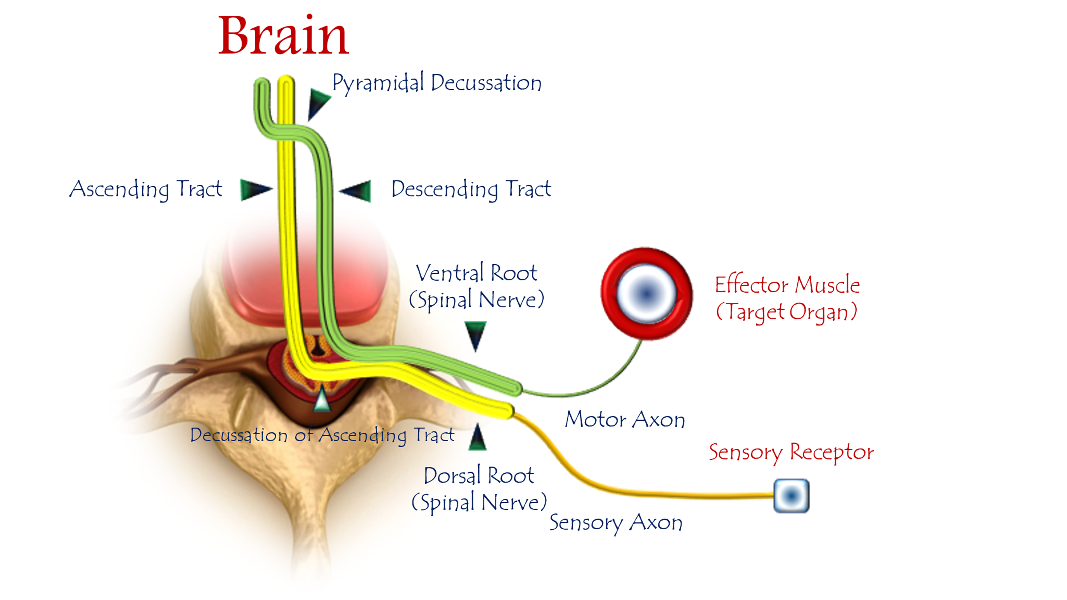
Figure (2): The Spinal Reflex: Innovated Physiology
To watch a short video explaining the modern physiology of the spinal reflex in detail, click this link:

Personally, I contend that all spinal reflexes are governed by the Upper Motor Neuron (UMN). All sensory input ascends to specialized centers in the brain. There, sensory data undergoes comprehensive processing to derive actionable insights. Subsequently, recommendations are relayed to the UMN to formulate an appropriate response. The resulting decision—a contextually calibrated motor command—is transmitted to the Lower Motor Neuron (LMN) via descending neural pathways.
I harbor no concern regarding pathway length or the multiplicity of engaged neural centers. The operating organism possesses a vast cognitive repository; it has mastered both the speed of conduction and the precision of execution through lived experience.
Thus, the spinal reflex is a deliberate response, even if clothed in immediacy and spontaneity.
In Summary:
The sensory neuron in the spinal ganglion, the upper motor neuron in the cerebral cortex, and the lower motor neuron in the anterior horn of the spinal cord constitute the vertices of the spinal reflex arc... as I contend.
Note: Sensory input decussates to the contralateral cerebral hemisphere. Motor output from the cerebral cortex likewise descends to the LMN in the contralateral spinal cord.

The Upper Motor Neuron Injury
Below the level of the spinal lesion, movement and sensation vanish—this is Spinal Shock. Weeks or months pass, then movement returns with a coarse, inconsistent character, termed clinically as Spastic Paralysis.
Here—to avoid entrapment in narrow alleys of nuance—I shall not dissect gradations of trauma severity or clinical manifestations. Instead, I take both to their extreme: complete transection as cause, total paralysis as effect. For maximal simplicity, I select a C6-level cervical cord transection. As a motor transformation witness, I focus on the Achilles Tendon Reflex—a spinal reflex exemplar to which all principles of this family apply.
Immediately following complete transection of the spinal cord at the C6 level, the Achilles tendon reflex vanishes entirely. This reflex remains absent for days or months. Subsequently, it reappears—but with fundamentally altered characteristics. It now manifests exaggerated vigor and diffuseness. Even light stimuli to the Achilles tendon, even outside its traditional receptive field, can provoke a violent response. In essence, we confront a new pathological iteration reflex—utterly distinct from its pre-injury state.
So, what transpired?
According to adherents of the Lower Motor Neuron (LMN) Circuit theory, no explanation exists. The phenomena unfold exactly as described—yet remain uninterpreted within their paradigm.
Thus, I challenge them: If the lower motor neuron at the S1 sacral segment truly enjoys autonomous control over the Achilles tendon reflex, how do you explain its prolonged abolition following a high cervical injury at C6? All elements of the reflex arc remain intact, far beyond the reach of trauma.
Faced with their inability to explain even the absence of the reflex, I shall mercifully spare them the greater burden of accounting for its pathological transformation—sparing the believers.
Under the illumination of my hypothesis—which vests command in the Upper Motor Neuron (UMN)—the enigma resolves with graceful simplicity:
The lines of communication between the UMN in the cerebral cortex and the LMN at the S1 sacral segment lie severed. No sensory input ascends; no motor command descends. All pathways are decommissioned at the level of the C6 spinal injury.
The Lower Motor Neuron, unaccustomed to such isolation, finds its receptors bereft of signals. No movement orders → No movement.
Thus settles the deadly quiet—the utter paralysis—as it awaits the turn of days yet to come.
The void is terrible; its sole inhabitant is anxiety—anxiety over threats to the organism’s survival. The three elements governing the Achilles reflex mobilize:
- Sensory Neuron (S1 dorsal root ganglion)
- Lower Motor Neuron (S1 anterior horn)
- Upper Motor Neuron (cerebral cortex, commander of this reflex)
The UMN dispatches its neural battalions to the C6 transection site for assessment and repair. Yet this reparative endeavor is:
- Arduously protracted (months to years)
- Unpredictable in outcomes (chaotic rewiring → spasticity)
In the waiting, the lower echelons at S1 attempt autonomous crisis management. Sensory neurons strive to discharge their signals through newly forged collateral pathways. Simultaneously, lower motor neurons labor to secure input via improvised communication networks.
When these desperate efforts intersect, sensory neurons succeed in venting their pent-up signals, while motor neurons secure their ersatz commands. The LMN interprets this chaotic input as binding orders—and executes them without hesitation. Thus, the reflex reappears but in borrowed robes.
What has been described regarding the Achilles tendon reflex holds equally true for all spinal reflexes below the level of spinal injury. It likewise applies to movement—all movement in the body caudal to the spinal lesion.
Thus,
Complete loss of motor function and sensation occurs below the injury level due to disrupted signaling between the Upper Motor Neuron (UMN) and its subordinate Lower Motor Neuron (LMN).
Following a latent period, and after successful reticulation between sensory and motor LMNs, movement reemerges—but solely in its crude, unregulated form.
Critically, we must acknowledge the pivotal role of intermediate neurons in these aforementioned linkage and networking processes. Their contribution to such synaptic reorganization is profound.
Thus, flaccid paralysis followed by spastic paralysis—this is the hallmark of upper spinal cord lesions. A shocking clinical picture whose raison d'être can only be justified by affirming the absolute responsibility of the Upper Motor Neuron for spinal reflexes under physiological conditions; see Figure (2).
The Lower Motor Neuron Circuit: A Pathological Entity
This "circuit" is a pathological construct (Pathological Circuit) formed following disruption of neural signaling between Upper (UMN) and Lower Motor Neurons (LMN). The LMN secures neural transmission by networking with sensory neurons—both within its segment and adjacent levels. It interprets all sensory input as mandatory motor commands. To the isolated LMN, neural traffic carries no identity—only the imperative energy of action.
It is a defective circuit—a Vicious Circuit at the same time. From the moment it was established, it entrenched the elements of its existence and etches its pathways irreversibly, making it thereafter impossible for the organism to sever its bonds.
Suppose the organism finally succeeded in repairing the transmission bridges between the upper and lower motor neurons. At that point, the descending transmission current from the higher centers would collide with an impervious functional fortress formed by the lower motor neuron circuit through the interweaving of its elements.
For the lower circuit is young and strong, whereas the upper circuit is still weak, carving its descending path with great difficulty amidst the debris of compressive forces and the subsequent repair processes. In fact, the lower motor neuron circuit is a poor prognostic factor that worsens the outlook in upper spinal cord injuries.
This circuit transforms the spinal cord from a subordinate executor into a pathological dictator—making spasticity not a sign of "recovery," but of permanent neurological divorce from cortical command; see Figure (3).

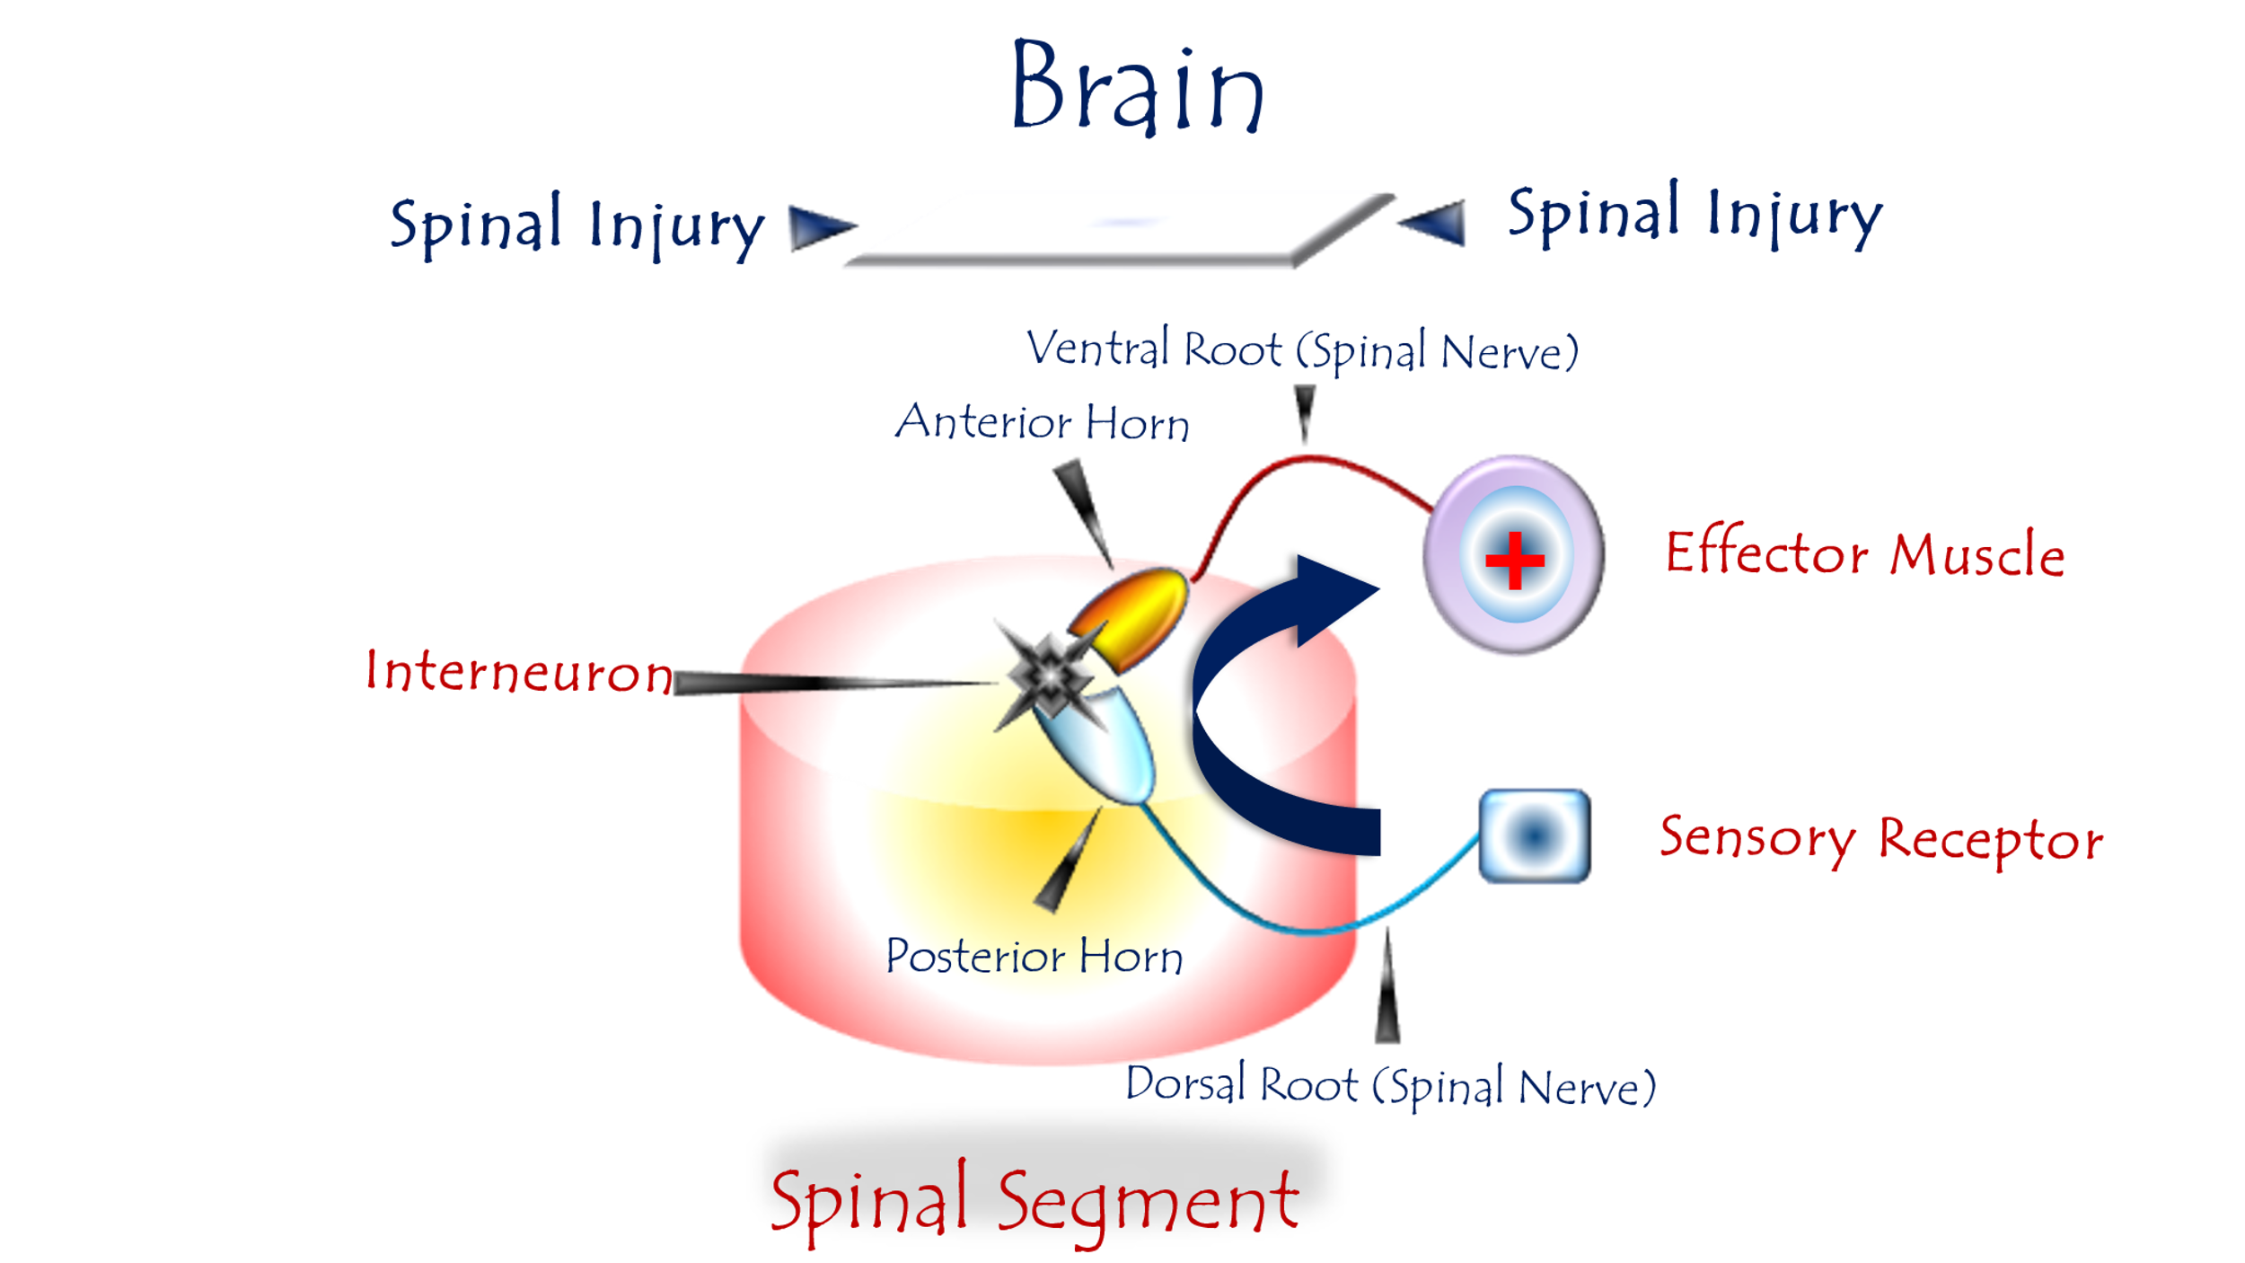
Figure (3): Pathophysiology of Hyperreflexia:
(The Lower Motor Neuron Circuit)
To watch a short video explaining the Lower Motor Neuron Circuit in detail, click this link:

Pathological Genesis of the Circuit
When neural pathways between upper motor centers (cortical UMN) and lower spinal elements (LMN, sensory neurons, interneurons) are severed, these isolated spinal components forge new communication bridges. This desperate networking births a new spinal reflex circuit—one that never exists under physiological conditions.
The Circuit's Structural & Functional Defects
Component | Pathological Mechanism | Clinical Consequence
Sensory Neuron | Dumps unprocessed raw sensory input directly onto LMNs | Loss of signal modulation
Lower Motor Neuron | Interprets all sensory input as mandatory motor commands | Obligatory hyperexcitability
Intermediate Neurons | Facilitate aberrant connections across segments | Loss of spatial specificity (radiation of reflexes)

Sound Foundations
We cannot grasp the truth of spinal shock without first demolishing the fallacies surrounding spinal reflexes—specifically, the actual locus of their command. Correct understanding of spinal shock’s mechanisms and the subsequent spastic paralysis is pivotal for developing clinical protocols to improve prognosis in spinal cord injuries.
Spinal Shock: The Mandatory Prelude
Spinal shock is the indispensable prelude to spastic paralysis. It is a latent period of profound impending transformations within the central nervous system's command centers. This phase marks the perilous transition:
- From Rational Sovereignty: The eternal dominion of the Upper Motor Neuron (UMN) over movement and spinal reflexes— a reign defined by wisdom, precision, and purpose.
- To Emergent Anarchy: The sudden usurpation by the Lower Motor Neuron (LMN) and its nascent pathological circuit—
a mindless regime of chaos and compulsory reactions.

Spastic Paralysis: The Product of Failed Governance
Spastic paralysis—with its coarse, uncoordinated movements and non-functional hyperreflexic spinal reflexes—is the direct product of Lower Motor Neuron (LMN) circuit governance. This is an emergency regime, devoid of wisdom and inept by design. It receives abrupt sensory alerts devoid of identity and responds in an irrational, autonomous fashion.
A Spark of Light
For years, we traced the destinies of those afflicted with spinal injuries using the ink of futility... Time has come to cast aside blunt tools and darkened wells. Let us grasp brushes dipped in light to scatter illumination, shatter the night’s opacity, and gladden the soul. A change in approach is imperative. These injuries are catastrophic—yet is there no escape?
In an attempt to defy fate, I distinguish two periods in the course of spinal cord injury. The first is the period of spinal shock, namely the phase of flaccid paralysis. The second is the period of spastic paralysis, occurring after the maturation of the pathological lower motor neuron circuit.
Phase I: Acute Surgical Imperatives
In the initial period, immediately following injury, every effort is made to expedite and facilitate repair processes—whether through the body’s own self-repair mechanisms or via external surgical intervention.
Here, I emphasize the necessity of early surgical intervention whenever radiological investigation confirms a breach of the spinal cord compartment or the integrity of the spinal column that houses it.
We surgically work to reconnect severed structures, decompress injured elements, improve their perfusion, remove all invasive debris violating the sanctity of the spinal cord and vertebral canal, and finally, stabilize the spinal column as necessitated by the circumstances.
Phase II: Strategic Assault on the Pathological LMN Circuit
In the secondary phase, it becomes essential—in addition to the aforementioned measures—to disrupt the lower motor neuron circuit, given its established detrimental role in prognosis as previously outlined.
Theoretically, I propose that the sensory neuron constitutes the weakest link in this lower motor neuron circuit, and thus should be the primary target of our interventional strategies.
Temporarily disabling the sensory neuron's function removes a significant competitor. This grants the upper motor neuron a critical window of time to regain some of its diminished authority over the lower motor neuron.
Similarly, the absence of its input from the sensory neuron may prompt the lower motor neuron to reactivate its old synapses with the upper motor neuron. Hoping that both intrinsic and extrinsic restorative processes have succeeded in reconnecting some of what was severed, the upper motor neuron may eventually succeed in transmitting some of its efferent impulses toward the lower motor neuron. Thus, it regains command over spinal reflexes as well as movement.
In the same context, and similar to pain management mechanisms, radiofrequency waves can disable the function of sensory neurons as well as intermediate neurons in the spinal ganglion and the posterior horn of the spinal cord, respectively.
Experimentally, appropriate frequencies can be identified for those neurons. The radiofrequency waves are applied to the corresponding dorsal root, thereby paralyzing the function of the sensory neurons supplying that root. The procedure is repeated for all targeted nerve roots. In this way, we break the circuit of the lower motor neuron where necessary. This is a procedural suggestion that must withstand the test of time before its merits become evident.
…………………………………………………………………………….
In other contexts, you can also read the following articles:
 | The Spinal Reflex, New Hypothesis of Physiology
 | The Hyperreflexia, Innovated Pathophysiology
 | The Spinal Shock
 | The Spinal Injury, the Pathophysiology of the Spinal Shock, the Pathophysiology of the Hyperreflexia
 | Upper Motor Neuron Lesions, the Pathophysiology of the Symptomatology
 | The Hyperreflexia (1), the Pathophysiology of Hyperactivity
 | The Hyperreflexia (2), the Pathophysiology of Bilateral Responses
 | The Hyperreflexia (3), the Pathophysiology of Extended Hyperreflex
 | The Hyperreflexia (4), the Pathophysiology of Multi-Response Hyperreflex
- | The pathophysiology of Triple flexion Reflex
 | The Clonus, 1st Hypothesis of Pathophysiology
 | The Clonus, 2nd Hypothesis of Pathophysiology
 | The Clonus, Two Hypotheses of Pathophysiology
 | The Nerve Transmission through Neural Fiber, Personal View vs. International View
 | The Nerve Transmission through Neural Fiber (1), The Action Pressure Waves
 | The Nerve Transmission through Neural Fiber (2), The Action Potentials
 | The Nerve Transmission through Neural Fiber (3), The Action Electrical Currents
 | The Function of Standard Action Potentials & Currents
 | The Three Phases of Nerve transmission
 | Neural Conduction in the Synapse (Innovated)
 | Nodes of Ranvier, the Equalizers
 | Nodes of Ranvier, the Functions
 | Nodes of Ranvier, First Function
 | Nodes of Ranvier, Second Function
 | Nodes of Ranvier, Third Function
 | Node of Ranvier, The Anatomy
 | The Wallerian Degeneration
 | The Neural Regeneration
 | The Wallerian Degeneration Attacks Motor Axons, While Avoids Sensory Axons
 | The Sensory Receptors
 | Nerve Conduction Study, Wrong Hypothesis is the Origin of the Misinterpretation (Innovated)
 | Piriformis Muscle Injection_ Personal Approach
 | The Philosophy of Pain, Pain Comes First! (Innovated)
 | The Philosophy of the Form (Innovated)
 | Pronator Teres Syndrome, Struthers-Like Ligament (Innovated)
 | Ulnar Nerve, Congenital Bilateral Dislocation
 | Posterior Interosseous Nerve Syndrome
The Multiple Sclerosis: The Causative Relationship Between
The Galvanic Current & Multiple Sclerosis?
 | Cauda Equina Injury, New Surgical Approach
 | Carpal Tunnel Syndrome Complicated by Complete Rupture of Median Nerve
 | Biceps Femoris' Long Head Syndrome (BFLHS)
 | Barr Body, The Whole Story (Innovated)
 | Adam's Rib and Adam's Apple, Two Faces of one Sin
 | Adam's Rib, could be the Original Sin?
 | Barr Body, the Second Look
 | Who Decides the Sex of Coming Baby?
 | Boy or Girl, Mother Decides!
 | Oocytogenesis
 | Spermatogenesis
 | This Woman Can Only Give Birth to Female Children
 | This Woman Can Only Give Birth to Male Children
 | This Woman Can Give Birth to Female Children More Than to Male Children
 | This Woman Can Give Birth to Male Children More Than to Female Children
 | This Woman Can Equally Give Birth to Male Children & to Female Children
 | Eve Saved Human Identity; Adam Ensured Human Adaptation
 | Coronavirus (Covid-19): After Humiliation, Is Targeting Our Genes
 | Coronavirus (Covid-19): After Humiliation, Is Targeting Our Genes
 | The Black Hole is a (the) Falling Star?
 | Mitosis in Animal Cell
 | Meiosis
 | Universe Creation, Hypothesis of Continuous Cosmic Nebula
 | Circulating Sweepers
 | Pneumatic Petrous, Bilateral Temporal Hyperpneumatization
 | Congenital Bilateral Thenar Hypoplasia
 | Ulnar Dimelia, Mirror hand Deformity
 | Surgical Restoration of a Smile by Grafting a Segment of the Gracilis Muscle to the Face
 | Mandible Reconstruction Using Free Fibula Flap
 | Presacral Schwannoma
Liver Hemangioma: Urgent Surgery of Giant Liver Hemangioma
Due to Intra-Tumor Bleeding
 | Free Para Scapular Flap (FPSF) for Skin Reconstruction
 | Claw Hand Deformity (Brand Operation)
 | Algodystrophy Syndrome Complicated by Constricting Ring at the Proximal Border of the Edema
Non- Traumatic Non- Embolic Acute Thrombosis of Radial Artery
(Buerger’s Disease)
 | Isolated Axillary Tuberculosis Lymphadenitis
 | The Iliopsoas Tendonitis... The Snapping Hip
To read the article in Arabic, click on
 | The New Frankenstein Monster
 | The Lone Wolf
 | The Delirium of Night and Day
 | The Delirium of the Economy
Ovaries in a Secure Corner… Testicles in a Humble Sac:
An Inquiry into the Function of Form
 | Eve Preserves Humanity’s Blueprint; Adam Drives Its Evolution
 | The Manufacture of the Unconscious
 | The Ballad of Eternity
4/6/2018

