Ammar Yaseen Mansour
Surgical Restoration of a Smile
by Grafting a Segment of the Gracilis Muscle to the Face
To view the details of the operation, watch the video at the following link:

The patient is a 31-year-old female who has suffered from complete left facial nerve palsy of unknown etiology (clinically termed Bell’s Palsy) for 18 years. The paralysis is total on the left side of her face. After such a prolonged duration, the options for managing facial paralysis become limited. However, in this case, I opted to perform a left Gracilis muscle transfer to restore the patient’s ability to smile. This procedure is known as a Segmental Gracilis Muscle Transfer, wherein the anterior half of the Gracilis muscle is harvested along with its associated nerve and nourishing vascular pedicle; Figure (1).

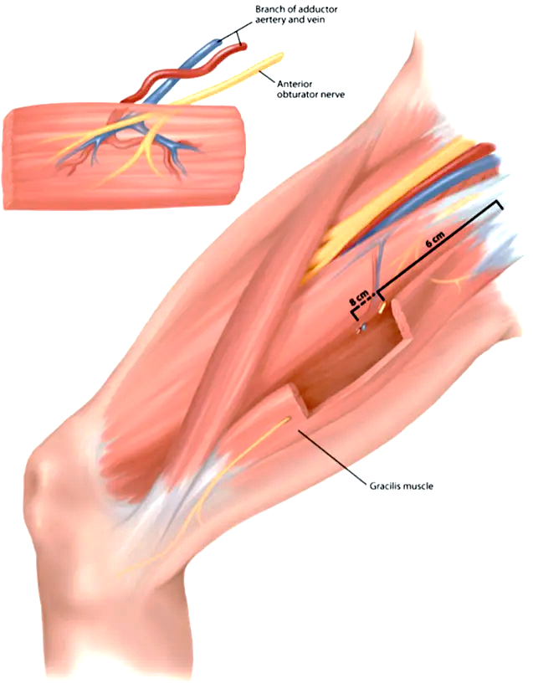
We harvest only
the anterior half of the Gracilis muscle. We leave the posterior half and the remaining part of the muscle in place.
Segmental Gracilis Muscle Free Flap
Remained Gracilis Muscle
Figure (1)
Segmental Gracilis Muscle Free Flap
To reduce the size of the graft,
we do not harvest the entire circumference of the muscle.
Instead, we limit ourselves to the anterior half or occasionally a third of the anterior portion of the muscle, leaving the remainder in place.
On one hand, this portion suffices for the intended purpose of the graft.
On the other hand, it is more aesthetically and structurally favorable.
A smaller muscle graft integrates more seamlessly into the contours of the area,
ensuring that post-procedure bulging in the facial region where
the graft is implanted is less noticeable to the eye.

In reality, to reduce the size of the muscle, we suffice with half its width and sometimes a third, as this adequately serves and even exceeds the purpose. As for the length of the segment, it has two determinants. The first is the oral commissure (Modiolus), which is a fixed boundary in all specialized surgical procedures for this purpose. The second is the selected site for anchoring the flap in the surrounding area, which is near the ear in a region anterior to the pinna; slightly superior, directly anterior, or inferior to it, varying depending on the intended goal and the type of smile to be obtained. In our case, we chose the temporal fascia superior to the ear to anchor the muscular flap in the periphery.
We measured the distance between the oral commissure and the fixation point on the temporal fascia above the ear, which was 11 cm. We added 2 cm for suturing and securing the flap in place. Thus, the target became harvesting a 13 cm segment from the Gracilis muscle. For precision, this was 13 cm from the anterior half of the muscle. During harvesting, we ensured that the entry point of the vascular bundle into the muscle coincided with the midpoint of the intended muscular segment.
Surgical Approach:
This is achieved via a preauricular incision. The surgical incision extends vertically from the superior aspect of the pinna (auricle), behind the sideburn area, tracing the contours of the anterior edge of the pinna. Subsequently, it curves posteriorly around the ear lobe (earlobe), adopting a horizontal path from posterior to anterior, parallel to the inferior border of the mandible. It terminates at the boundary of the facial artery; Figure (2).

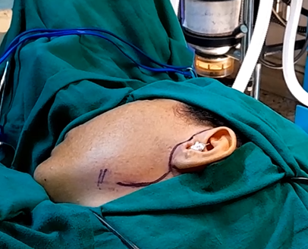
Ear Lobe
Tragus
Facial Artery
Surgical Incision
Sideburn
Pinna
Figure (2)
Preauricular Surgical Incision

It extends vertically from the top of the pinna behind the sideburn,
tracing the contours of the anterior edge of the pinna. It then curves backward around the ear lobe and follows a horizontal path from posterior to anterior, parallel to the lower border of the mandible. It terminates near the region of the facial artery.
From the private archive
Preliminary Steps
The procedure begins by elevating the facial skin flap up to the oral commissure (Modiolus). During this dissection, we first encounter the facial vein and then the facial artery. These two structures are critical for muscle flap transplantation. Meticulous care is taken to dissect and mobilize these vessels adequately in preparation for their later use.
The facial vein follows a different course than the facial artery. It ascends almost vertically along the anterior border of the masseter muscle and disappears into the buccal fat pad (Bichat’s pad) at the mid-cheek level.
In contrast, the facial artery courses obliquely upward and forward toward the ipsilateral oral commissure. In cases of congenital absence of facial muscles, tracing the facial artery reliably guides the surgeon to the commissure. At the commissure, the facial artery divides into its terminal branches: the superior labial artery (to the upper lip) and the inferior labial artery (to the lower lip).
During this vascular-focused phase, it is advisable to excise as much of the buccal fat pad (Bichat’s pad) as possible. The muscle flap, which will soon occupy this space, often causes significant cheek swelling due to its bulk. To mitigate this, we first reduce the width of the muscle flap by half or more. Second, we resect a portion of Bichat’s pad.
After safely reaching the oral commissure, we place a thick absorbable suture (size 1 or 0) precisely at the commissure. Additional sutures are placed on the lower lip and one or two on the upper lip. These four sutures are not tied immediately but are reserved for securing the muscle flap in the final stage of the procedure. Care is taken to ensure the sutures are positioned close to the mouth and at an adequate depth to withstand tension forces during the three-week healing period required for flap integration. We also confirm that none of the sutures penetrate the oral cavity.
Once the sutures are securely placed and the anatomy is confirmed, the four sutures are pulled along an axis extending from the oral commissure (the future site of the muscle flap) toward the temporal fascia above the auricle (the flap’s origin). During this step, we monitor the effect on the oral commissure. Ideal positioning involves upward and backward traction without inversion or eversion of the lips. Lip eversion suggests the sutures are too superficial, while inversion indicates excessive depth.

Muscular Free Flap Harvesting
The ipsilateral lower limb is positioned in the “frog leg” posture: moderate flexion of the hip and knee joints, with thigh abduction and external rotation.
For the muscle flap, we select the gracilis muscle. It is located along the line connecting the pubic symphysis and the medial femoral condyle.
To facilitate identification, we locate the adductor tubercle and the adjacent adductor longus muscle. The gracilis lies approximately two fingerbreadths below the free edge of the adductor longus.
After incising the skin and subcutaneous tissues, the gracilis muscle is readily identified by its longitudinal fibers parallel to the femoral axis. We dissect the muscle from its external fascia but preserve the internal fascia where the neurovascular bundle enters.
Next, we identify the neurovascular bundle. The vascular pedicle is typically found 10 cm below the anterior thigh crease. The nerve lies 1–2 cm proximal to the vascular bundle. Initially, the neurovascular bundle courses between the adductor longus and adductor magnus muscles, emerging beneath the free edge of the adductor longus. After a short path, it penetrates the gracilis at the midpoint of its medial surface.
The vascular pedicle consists of one artery and two venae comitantes, with a length of 6 cm and a diameter of 2 mm (varying with muscle mass). The motor nerve to the gracilis arises from the anterior branch of the obturator nerve and follows a separate oblique course from the vascular bundle; Figure (3).

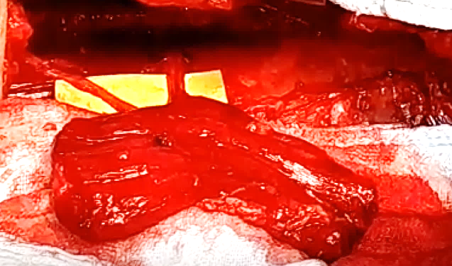
The Nerve
Vascular Pedicle
Muscular Flap
Adductor Longus Muscle
Distal End
Figure (3)
Neurovascular Pedicle of the Muscle Flap

The vascular pedicle consists of an artery and two accompanying veins.
The pedicle is 6 cm in length, and its elements have a diameter of 2 mm. The diameter of the vessels varies depending on the mass of the muscle itself.
The muscle’s nerve originates from the anterior branch of the obturator nerve.
The nerve follows an oblique course, separate from the muscle’s vascular bundle. The vascular pedicle of the muscle is typically found 10 cm below the anterior femoral crease. The nerve is situated approximately 1–2 cm above the vascular bundle.
Initially, the neurovascular bundle lies between the two adductor muscles: the Adductor Longus Muscle and the Adductor Magnus Muscle.
It then emerges from beneath the free edge of the Adductor Longus Muscle. After a short course, it penetrates the muscle at the midpoint of its internal surface.

From the private archive

Muscle Flap Preparation
- Dissection: The muscle and its neurovascular pedicle are fully exposed.
- Dimensions:
  - Length: Pedicle entry point is the midpoint of the flap. In this case, 6.5 cm is taken above and below the pedicle.
  - Width: Anterior half of the muscle’s circumference is used to balance functional movement and avoid facial bulk.
- Distal Sutures: Five absorbable sutures (Vicryl 2/0) are placed at the distal end of the flap. The five sutures serve as anchors for four previously placed threads.
- Flap Harvesting
- The flap is detached by cutting the neurovascular pedicle after securing the five distal sutures.
- Immediate transfer to the face is performed for transplantation.
Transplantation Steps
Step 1: Distal Fixation
- The distal end is anchored near the mouth using four pre-placed sutures.
  - Each suture loops through the muscle twice and anchors to two adjacent sutures of the original five (e.g., suture 1 anchors to sutures 1+2, suture 2 to 2+3, etc.).
  - Ensures secure attachment for dynamic movement (e.g., smile restoration).
Step 2: Revascularization (Critical Timing ≤1 Hour)
- Vascular Anastomoses:
  - Flap artery → Facial artery (end-to-end).
  - Flap vein → Facial vein (end-to-end); second vein is ligated.
- Ensures blood supply to prevent ischemia and flap failure.
Step 3: Nerve Coaptation
- Flap nerve is connected to the masseteric nerve (motor source).
  - Less time-sensitive, allowing careful alignment for optimal reinnervation.
Step 4: Proximal Fixation
- Proximal end is secured to the temporal fascia with interrupted sutures (Vicryl 1/0 or 0/0).
  - Provides stable anchoring point for muscle contraction.
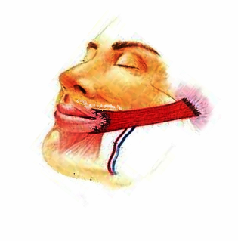
The distal end of the flap is secured to
the inferior lip, the modiolus, and the superior lip.
Vascular Anastomoses
The proximal end of the flap
is secured to the temporal fascia
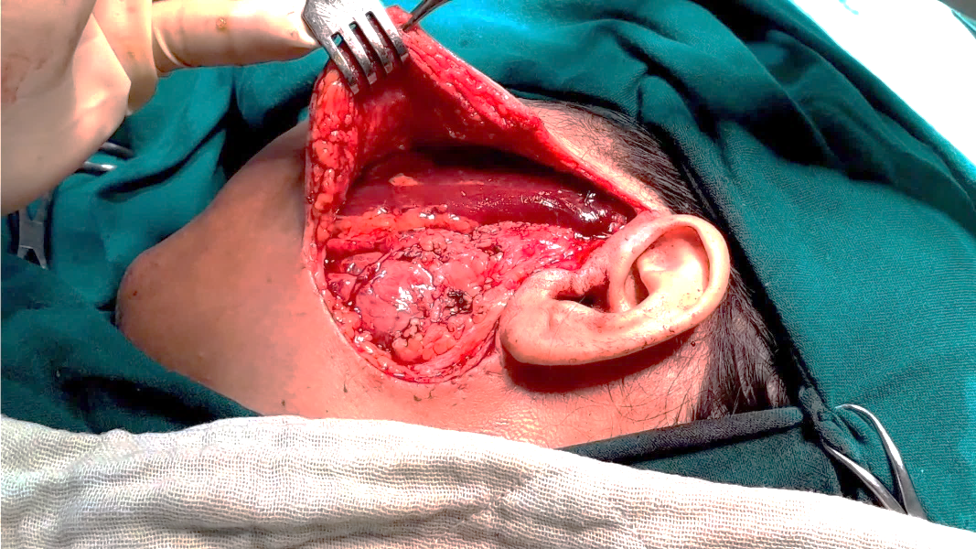
Muscular Flap
Figure (4)
Segmental Gracilis Muscle Flap Implantation

    - Objective: Secure the distal end of the flap near the mouth using four sutures in an overlapping pattern anchored to five pre-placed sutures.
Setup: Five sutures are pre-placed in a linear arrangement. Four threads are used, each anchored to two adjacent sutures (out of the five).
Thread Anchoring Pattern:
  - Thread 1: Sutures 1 & 2 (lowest position).
  - Thread 2: Sutures 2 & 3.
  - Thread 3: Sutures 3 & 4.
  - Thread 4: Sutures 4 & 5 (highest position).
Each subsequent thread shifts upward by one suture, creating an overlapping structure.
Technique:
  - Each thread is passed through the muscle twice consecutively at its anchor points (e.g., a horizontal mattress suture technique).
  - Suturing begins at the bottom (sutures 1–2) and progresses upward to ensure proper alignment and tension distribution.
Purpose of Overlapping:
  - Distributes mechanical load evenly across all five sutures.
  - Prevents slippage or misalignment of the flap.
  - Shared sutures (e.g., suture 2 used by both Threads 1 and 2) enhance stability.
Visualization:
Imagine five sutures labeled 1 to 5. Each thread bridges two adjacent
sutures, forming a "ladder-like" pattern. The double passes through the
muscle at each anchor point create robust fixation for the flap’s distal end.
2) Therefore, we act swiftly to restore perfusion to the muscle flap within a maximum of one hour from harvest. To achieve this, we expedite vascular anastomoses. We connect the flap’s artery to the facial artery, and the flap’s vein to the facial vein. The second vein of the flap is ligated and omitted. The vascular anastomoses are performed end-to-end.
3) Suturing the flap’s nerve to the masseteric nerve is more time-tolerant. We perform this critical step leisurely and meticulously.
4) Finally, we fixate the proximal end of the flap to the temporal fascia using interrupted sutures (Vicryl 1 or 00).

From the private archive

At the end of securing the muscle flap, a slight outward pulling movement of the mouth angle must be observed. Care should be taken to never exaggerate this movement to avoid compromising future symmetry with the opposite side of the mouth. The surgical incision is then closed, and a soft drain is placed beneath the skin flap.
Post-Operative Follow-Up:
The surgical procedure typically takes a median of nine hours of continuous work. The patient is restricted to a diet of liquids and well-cooked, pureed foods for three weeks post-surgery. After this period, she may gradually reintroduce solid foods as desired. Anticoagulants are preferably avoided. Vigilant efforts are made to combat nausea, vomiting, and infection, as these pose significant threats to the success of the graft. Finally, all involved are cautioned about the critical importance of avoiding pressure on the surgical site during the six weeks following the procedure.
The drain is typically removed on the second or third post-operative day. Facial edema (swelling) generally subsides by the third or fourth week, though mild perioral swelling may persist for up to a year. To expedite resolution of facial edema, the patient is encouraged to engage in light physical activity at home to stimulate blood circulation and to increase fluid intake. Additionally, sleeping on multiple pillows is recommended to reduce cephalic congestion. Prolonged sensations of numbness or tingling in the surgical area are common and should not cause concern.
The patient is prohibited from working or using public transportation for six weeks. Rehabilitation sessions commence in the fourth week. Restoration of muscle flap tension is not expected until one month post-surgery, while full muscle contraction may take three to nine months to develop.
.....................................................................................................
In other contexts, you can also read the following articles:
The Spinal Reflex, New Hypothesis of Physiology
The Hyperreflexia, Innovated Pathophysiology
The Spinal Shock
The Spinal Injury, the Pathophysiology of the Spinal Shock, the Pathophysiology of the Hyperreflexia
Upper Motor Neuron Lesions, the Pathophysiology of the Symptomatology
The Hyperreflexia (1), the Pathophysiology of Hyperactivity
The Hyperreflexia (2), the Pathophysiology of Bilateral Responses
The Hyperreflexia (3), the Pathophysiology of Extended Hyperreflex
The Hyperreflexia (4), the Pathophysiology of Multi-Response Hyperreflex
The Clonus, 1st Hypothesis of Pathophysiology
The Clonus, 2nd Hypothesis of Pathophysiology
The Clonus, Two Hypotheses of Pathophysiology
The Nerve Transmission through Neural Fiber, Personal View vs. International View
The Nerve Transmission through Neural Fiber (1), The Action Pressure Waves
The Nerve Transmission through Neural Fiber (2), The Action Potentials
The Nerve Transmission through Neural Fiber (3), The Action Electrical Currents
The Function of Standard Action Potentials & Currents
The Three Phases of Nerve transmission
Neural Conduction in the Synapse (Innovated)
Nodes of Ranvier, the Equalizers
Nodes of Ranvier, the Functions
Nodes of Ranvier, First Function
Nodes of Ranvier, Second Function
Nodes of Ranvier, Third Function
Node of Ranvier, The Anatomy
The Wallerian Degeneration
The Neural Regeneration
The Wallerian Degeneration Attacks Motor Axons, While Avoids Sensory Axons
The Sensory Receptors
Nerve Conduction Study, Wrong Hypothesis is the Origin of the Misinterpretation (Innovated)
Piriformis Muscle Injection_ Personal Approach
The Philosophy of Pain, Pain Comes First! (Innovated)
The Philosophy of the Form (Innovated)
Pronator Teres Syndrome, Struthers-Like Ligament (Innovated)
Ulnar Nerve, Congenital Bilateral Dislocation
Posterior Interosseous Nerve Syndrome
The Multiple Sclerosis: The Causative Relationship Between
The Galvanic Current & Multiple Sclerosis?
Cauda Equina Injury, New Surgical Approach
Carpal Tunnel Syndrome Complicated by Complete Rupture of Median Nerve
Biceps Femoris' Long Head Syndrome (BFLHS)
Barr Body, The Whole Story (Innovated)
Adam's Rib and Adam's Apple, Two Faces of one Sin
Adam's Rib, could be the Original Sin?
Barr Body, the Second Look
Who Decides the Sex of Coming Baby?
Boy or Girl, Mother Decides!
Oocytogenesis
Spermatogenesis
This Woman Can Only Give Birth to Female Children
This Woman Can Only Give Birth to Male Children
This Woman Can Give Birth to Female Children More Than to Male Children
This Woman Can Give Birth to Male Children More Than to Female Children
This Woman Can Equally Give Birth to Male Children & to Female Children
Eve Saved Human's Identity, Adam Ensured Human's Adaptation
Corona Virus (Covid-19): After Humiliation, Is Targeting Our Genes
Corona Virus (Covid-19): After Humiliation, Is Targeting Our Genes
The Black Hole is a (the) Falling Star?
Mitosis in Animal Cell
Meiosis
Universe Creation, Hypothesis of Continuous Cosmic Nebula
Circulating Sweepers
Congenital Bilateral Thenar Hypoplasia
Ulnar Dimelia, Mirror hand Deformity
Mandible Reconstruction Using Free Fibula Flap
Presacral Schwannoma
Liver Hemangioma: Urgent Surgery of Giant Liver Hemangioma
Due to Intra-Tumor Bleeding
Free Para Scapular Flap (FPSF) for Skin Reconstruction
Claw Hand Deformity (Brand Operation)
Algodystrophy Syndrome Complicated by Constricting Ring at the Proximal Border of the Edema
Non- Traumatic Non- Embolic Acute Thrombosis of Radial Artery
(Buerger’s Disease)
Isolated Axillary Tuberculosis Lymphadenitis
The Iliopsoas Tendonitis... The Snapping Hip

24/9/2022

