Dr. Ammar Yaseen Mansour
The Overactive Hyperreflexia
The Pathophysiology of Disproportionate Motor Response
To watch a short video explaining in detail the pathological mechanism of the overactive spinal hyperreflexia, click on this link:


Under normal conditions, where the brain is dominant over all sensory afferent input as well as all motor efferent output, each spinal reflex retains its own specific and independent circuit, separate from others. Stimulating the receptive field of a specific spinal reflex triggers a motor response unique to that reflex. It is a singular, non-repetitive response, specific to the reflex being studied, controlled in its intensity and strength, and localized to the same side where the stimulation occurred.
In contrast, in Upper Motor Neuron injuries, the brain becomes functionally absent, and matters escape the effects of control and regulation. At that point, the Interneurons become active to fill the functional void. They activate old, abandoned neural pathways from early childhood, and/or work on forming new neural pathways that did not previously exist.
They connect the Sensory Neurons with the Motor Neurons of the Anterior Horn on the same side and within the same Spinal Segment. Consequently, new Neural Circuits are formed. It is a functional, aberrant circuit that did not exist before; it is the Hyperreflex Circuit. When this emergent circuit is stimulated, the neural signal travels directly from the Sensory Receptor to the sensory neuron, then to the Lower Motor Neuron, and finally to the Effector Muscle (Target Muscle).
Here, and as a result of the functional absence of the brain, the Afferent Signal is not subjected to processing and modulation. Rather, it dumps its entire load of energy directly into the lap of the Lower Motor Neuron. The response of the latter is consequently violent, sudden, non-objective, and disproportionate to the strength of the stimulus itself. This is precisely the intended meaning of the concept of an overactive, hyperactive reflex (Overactive Hyperreflex); see Figure (1).

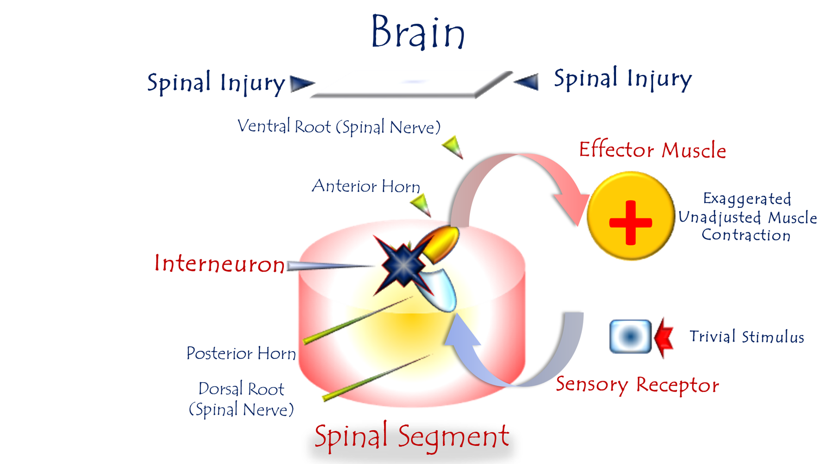
Figure (1)
The Pathophysiology of the Overactive Hyperreflex
To watch a short video explaining the pathological mechanism of overactive hyperreflexia in detail, click on this link:
After its connection with the governing Upper Motor Neuron is severed, and to satiate its craving for energy input, the Lower Motor Neuron (LMN) may form connections with the adjacent Sensory Neuron (SN) within the same Spinal Segment, or in the immediately adjacent segment. The latter, the SN, succeeds in dumping its entire load directly into the lap of the former, the LMN. The LMN receives the sensory input as an urgent, high-priority action command, resulting in reflex Overactivity.
Even mild stimuli are followed by an inconsistent, powerfully strong reflex.
Here, the functions of filtering and processing sensory input are absent. So too is the function of modulating the dosage of the motor command. These are two functions performed exclusively by the Upper Motor Neuron and the non-cortical upper command centers.

……………………………………………………………………………………………
In other contexts, you can also read the following articles:
 | DOI | The Spinal Reflex, New Hypothesis of Physiology
 | - | The Hyperreflexia, Innovated Pathophysiology
 | DOI | The Spinal Shock
 | - | The Spinal Injury, the Pathophysiology of the Spinal Shock, the Pathophysiology of the Hyperreflexia
 | DOI | Upper Motor Neuron Lesions, the Pathophysiology of the Symptomatology
 | - | Hyperreflexia (1): Pathophysiology of Hyperactivity
 | DOI | Hyperreflexia (2): Pathophysiology of Bilateral-Response Hyperreflexia
 | DOI | Hyperreflexia (3): Pathophysiology of Extended Hyperreflexia
 | DOI | Hyperreflexia (4): Pathophysiology of Multi-Motor-Response Hyperreflexia
- | - | The pathophysiology of Triple flexion Reflex
 | - | The Clonus, 1st Hypothesis of Pathophysiology
 | - | The Clonus, 2nd Hypothesis of Pathophysiology
 | DOI | The Clonus, Two Hypotheses of Pathophysiology
 | DOI | The Nerve Transmission through Neural Fiber, Personal View vs. International View
 | - | The Nerve Transmission through Neural Fiber (1), The Action Pressure Waves
 | - | The Nerve Transmission through Neural Fiber (2), The Action Potentials
 | - | The Nerve Transmission through Neural Fiber (3), The Action Electrical Currents
 | - | The Function of Standard Action Potentials & Currents
 | - | The Three Phases of Nerve transmission
 | DOI | Neural Conduction in the Synapse (Innovated)
 | DOI | Nodes of Ranvier, the Equalizers
 | - | Nodes of Ranvier, the Functions
 | - | Nodes of Ranvier, First Function
 | - | Nodes of Ranvier, Second Function
 | - | Nodes of Ranvier, Third Function
 | - | Node of Ranvier, The Anatomy
 | DOI | Vesicular Dynamics: A Unifying Theory for Wallerian Degeneration and Neural Regeneration
 | - | The Wallerian Degeneration
 | - | The Neural Regeneration
 | DOI | Wallerian Degeneration: Affects Motor Axons while Sparing Sensory Axons
 | DOI | The Sensory Receptors
 | DOI | Electroneurography vs. Neural Reality: Hidden Fallacies in Nerve Conduction Studies
 | DOI | Piriformis Muscle Injection: Personal Approach
 | DOI | In Philosophy of Nerves: Pain First!
 | DOI | In Neurodoctrines: Form is Necessity!
 | - | Pronator Teres Syndrome, Struthers-Like Ligament (Innovated)
 | DOI | Ulnar Nerve, Congenital Bilateral Dislocation
 | - | Posterior Interosseous Nerve Syndrome
 | DOI | The Multiple Sclerosis: The Causative Relationship Between  The Galvanic Current & Multiple Sclerosis?
 | - | Cauda Equina Injury, New Surgical Approach
 | DOI | Carpal Tunnel Syndrome Ends Its Adherence: Complete Median Nerve Transection
 | DOI | Biceps Femoris' Long Head Syndrome (BFLHS)
 | DOI | Barr Body, The Whole Story (Innovated)
 | - | Adam's Rib and Adam's Apple, Two Faces of one Sin
 | - | Adam's Rib, could be the Original Sin?
 | - | Barr Body, the Second Look
 | DOI | Who Decides the Sex of Coming Baby?
 | - | Boy or Girl, Mother Decides!
 | - | Oocytogenesis
 | - | Spermatogenesis
 | - | This Woman Can Only Give Birth to Female Children
 | - | This Woman Can Only Give Birth to Male Children
 | - | This Woman Can Give Birth to Female Children More Than to Male Children
 | - | This Woman Can Give Birth to Male Children More Than to Female Children
 | - | This Woman Can Equally Give Birth to Male Children & to Female Children
 | - | Eve Saved Human Identity; Adam Ensured Human Adaptation
 | DOI | COVID-19: Beyond the Crisis—Is It Targeting Our Genes?
 | DOI | Fibromyalgia
 | - | Mitosis in Animal Cell
 | - | Meiosis
 | - | Universe Creation, Hypothesis of Continuous Cosmic Nebula
 | - | Circulating Sweepers
 | - | The Black Hole is a (the) Falling Star?
 | - | Pneumatic Petrous, Bilateral Temporal Hyperpneumatization
 | DOI | Congenital Bilateral Thenar Hypoplasia
 | DOI | Ulnar Dimelia, Mirror hand Deformity
 | DOI | Thumb Reconstruction Using Microvascular Second Toe to Thumb Transfer
 | DOI | Surgical Restoration of a Smile by Grafting a Segment of the Gracilis Muscle to the Face
 | DOI | Mandible Reconstruction Using Free Fibula Flap
 | DOI | Presacral Schwannoma
 | DOI | Liver Hemangioma: Urgent Surgery of Giant Liver Hemangioma  Due to Intra-Tumor Bleeding
 | DOI | Free Para Scapular Flap (FPSF) for Skin Reconstruction
 | DOI | Claw Hand Deformity (Brand Operation)
 | DOI | Algodystrophy Syndrome Complicated by Constricting Ring at the Proximal Border of the Edema
 | DOI | Non- Traumatic Non- Embolic Acute Thrombosis of Radial Artery (Buerger’s Disease)
 | DOI | Isolated Axillary Tuberculosis Lymphadenitis
 | DOI | The Iliopsoas Tendonitis... The Snapping Hip
 | To read the article in Arabic, click on
 | DOI | The New Frankenstein Monster
 | DOI | The Lone Wolf
 | DOI | The Delirium of Night and Day
 | DOI | The Delirium of the Economy
 | DOI | Ovaries in a Secure Corner… Testicles in a Humble Sac:  An Inquiry into the Function of Form
 | DOI | Eve Preserves Humanity’s Blueprint; Adam Drives Its Evolution
 | DOI | The Manufacture of the Unconscious
 | DOI | The Ballad of Eternity
 | DOI | Two Truths Woman Would Never Accept
 | DOI | The 'Iddah (Waiting Period) in Islamic Law: A Comparative Analysis of its Rationale for Divorced Women and Widows
 | DOI | The IVF/ICSI-Conceived Child: A Biologically Suboptimal Outcome

24/08/2025

