Dr. Ammar Yaseen Mansour

The Bilateral-Response Hyperreflexia
The Pathophysiology of Bilateral-Response Hyperreflexia
To watch a short video explaining in detail the pathophysiology of the bilateral-response hyperreflex, click on this link:

Under normal circumstances, where the brain dominates all sensory afferent input as well as all motor efferent output, each spinal reflex retains its own specific and independent circuit, separate from others. Stimulating the receptive field of a specific spinal reflex triggers a motor response unique to that reflex. This response is singular, non-repetitive, specific to the reflex being studied, precisely regulated in intensity and force, and occurs on the same side where the stimulus was applied.
In contrast, with upper motor neuron injuries, the brain becomes functionally absent, and processes escape the effects of regulation and control. At this point, interneurons become active to fill the functional void. They activate old, unused neural pathways from early childhood, and/or work to form new neural pathways that did not previously exist. They interconnect among themselves, simultaneously networking with the sensory neurons and motor neurons on the same (unilateral) side, as well as on the opposite (contralateral) side, within the same spinal segment.
Consequently, the hyperreflex circuit on one side merges with its counterpart on the opposite (contralateral) side into a single, aberrant functional circuit: the bilateral-response hyperactive spinal reflex circuit. Merely stimulating the reflex circuit on one side is sufficient to elicit a motor response in both sides simultaneously (bilateral response). This is precisely the meaning of the concept of a bilateral response; see Figure (1).
It is important to note here the central role of interneurons. They have become the connecting conduit between the two poles of the spinal reflex in its pathological form, namely between the sensory neurons and the lower motor neurons on both sides.

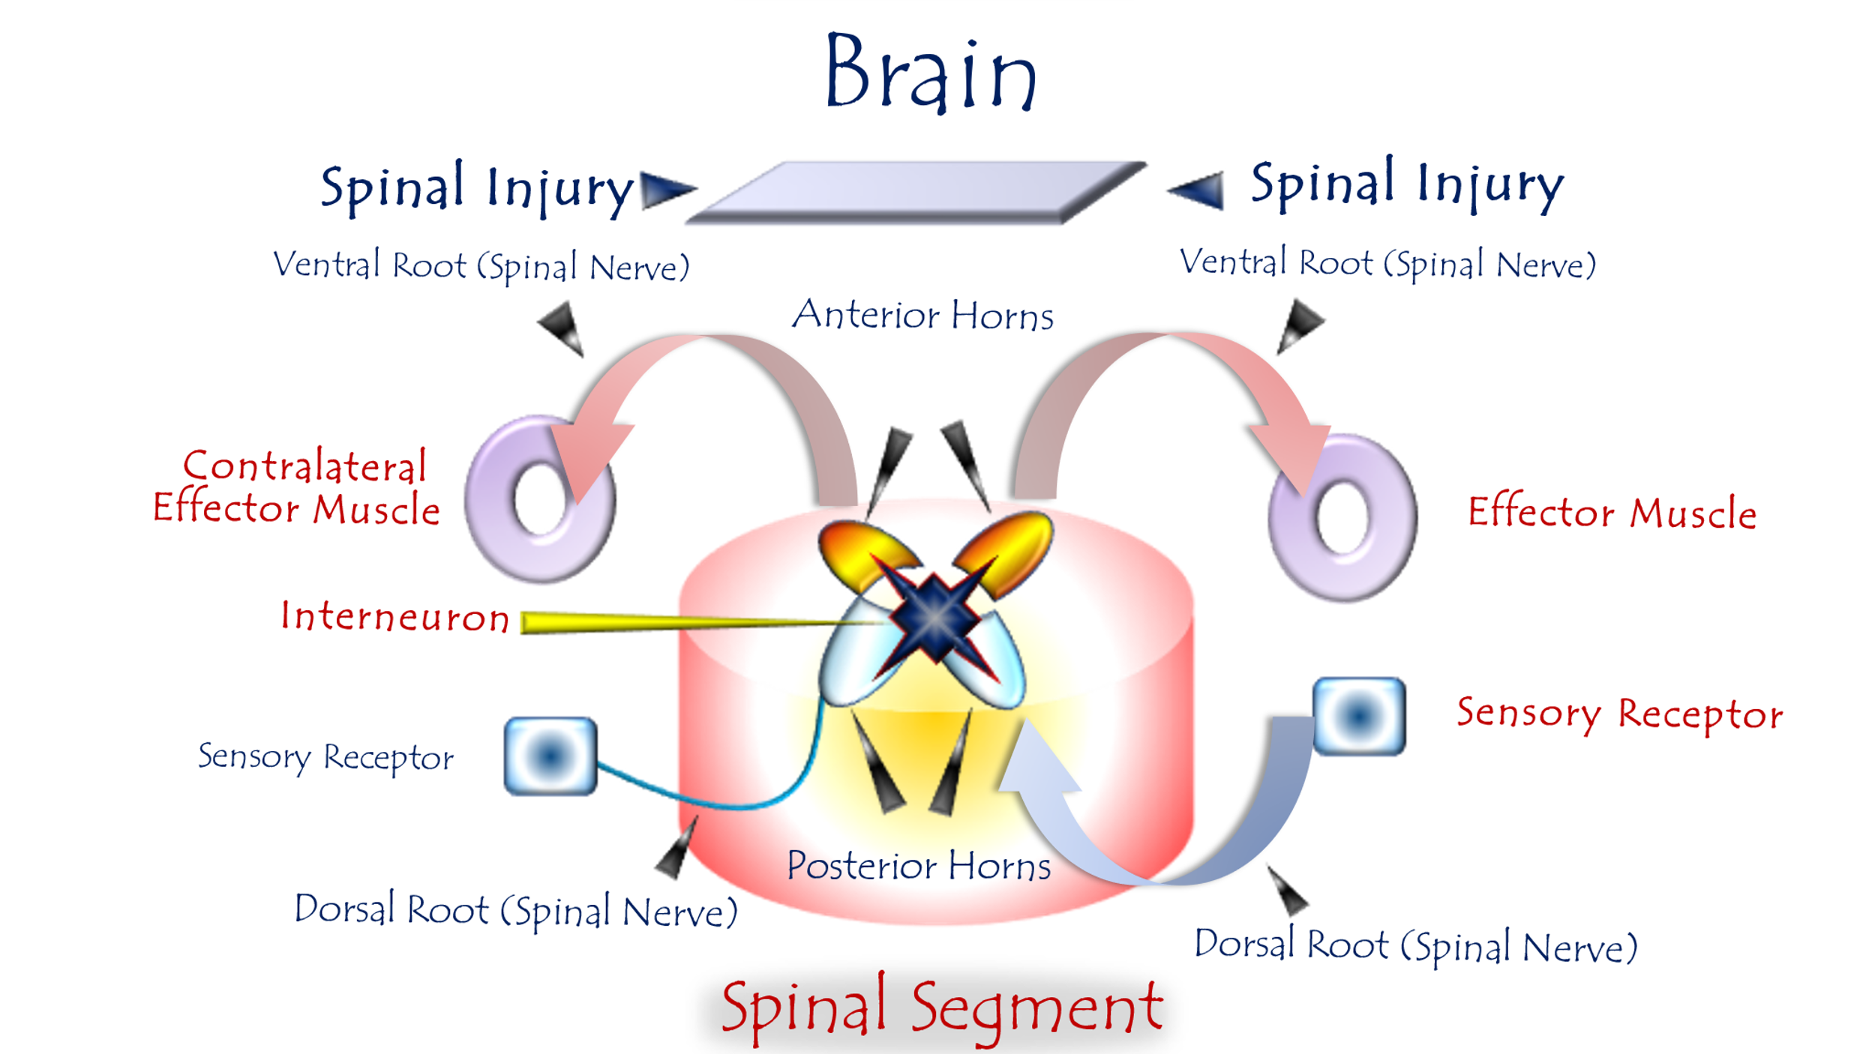
Figure (1)
The Pathophysiology of the Bilateral-Response Hyperreflex
To watch a short video explaining in detail the pathophysiology of the bilateral-response hyperreflex, click on this link:
In an upper motor neuron lesion, after the connection with higher centers is lost,
the neural elements of the spinal cord communicate with each other in an abnormal, aberrant manner. This results in a sensory neuron forming connections with both the ipsilateral (same-side) and the contralateral (opposite-side) lower motor neurons.
Consequently, an abnormal lower motor neuron circuit is formed. Stimulating the receptive field of the concerned sensory neuron can trigger a motor response in both the ipsilateral and contralateral sides simultaneously.
That is, a single sensory input can elicit the spinal reflex motor response in both sides.

………………………………………………………………………………………….
In other contexts, you can also read the following articles:
 | DOI | The Spinal Reflex, New Hypothesis of Physiology
 | - | The Hyperreflexia, Innovated Pathophysiology
 | DOI | The Spinal Shock
 | - | The Spinal Injury, the Pathophysiology of the Spinal Shock, the Pathophysiology of the Hyperreflexia
 | DOI | Upper Motor Neuron Lesions, the Pathophysiology of the Symptomatology
 | - | Hyperreflexia (1): Pathophysiology of Hyperactivity
 | - | Hyperreflexia (2): Pathophysiology of Bilateral Responses
 | DOI | Hyperreflexia (3): Pathophysiology of Extended Hyperreflexia
 | DOI | Hyperreflexia (4): Pathophysiology of Multi-Motor-Response Hyperreflexia
- | - | The pathophysiology of Triple flexion Reflex
 | - | The Clonus, 1st Hypothesis of Pathophysiology
 | - | The Clonus, 2nd Hypothesis of Pathophysiology
 | DOI | The Clonus, Two Hypotheses of Pathophysiology
 | DOI | The Nerve Transmission through Neural Fiber, Personal View vs. International View
 | - | The Nerve Transmission through Neural Fiber (1), The Action Pressure Waves
 | - | The Nerve Transmission through Neural Fiber (2), The Action Potentials
 | - | The Nerve Transmission through Neural Fiber (3), The Action Electrical Currents
 | - | The Function of Standard Action Potentials & Currents
 | - | The Three Phases of Nerve transmission
 | DOI | Neural Conduction in the Synapse (Innovated)
 | DOI | Nodes of Ranvier, the Equalizers
 | - | Nodes of Ranvier, the Functions
 | - | Nodes of Ranvier, First Function
 | - | Nodes of Ranvier, Second Function
 | - | Nodes of Ranvier, Third Function
 | - | Node of Ranvier, The Anatomy
 | DOI | Vesicular Dynamics: A Unifying Theory for Wallerian Degeneration and Neural Regeneration
 | - | The Wallerian Degeneration
 | - | The Neural Regeneration
 | DOI | Wallerian Degeneration: Affects Motor Axons while Sparing Sensory Axons
 | DOI | The Sensory Receptors
 | DOI | Electroneurography vs. Neural Reality: Hidden Fallacies in Nerve Conduction Studies
 | DOI | Piriformis Muscle Injection: Personal Approach
 | DOI | In Philosophy of Nerves: Pain First!
 | DOI | In Neurodoctrines: Form is Necessity!
 | - | Pronator Teres Syndrome, Struthers-Like Ligament (Innovated)
 | DOI | Ulnar Nerve, Congenital Bilateral Dislocation
 | - | Posterior Interosseous Nerve Syndrome
 | DOI | The Multiple Sclerosis: The Causative Relationship Between  The Galvanic Current & Multiple Sclerosis?
 | - | Cauda Equina Injury, New Surgical Approach
 | DOI | Carpal Tunnel Syndrome Ends Its Adherence: Complete Median Nerve Transection
 | DOI | Biceps Femoris' Long Head Syndrome (BFLHS)
 | DOI | Barr Body, The Whole Story (Innovated)
 | - | Adam's Rib and Adam's Apple, Two Faces of one Sin
 | - | Adam's Rib, could be the Original Sin?
 | - | Barr Body, the Second Look
 | DOI | Who Decides the Sex of Coming Baby?
 | - | Boy or Girl, Mother Decides!
 | - | Oocytogenesis
 | - | Spermatogenesis
 | - | This Woman Can Only Give Birth to Female Children
 | - | This Woman Can Only Give Birth to Male Children
 | - | This Woman Can Give Birth to Female Children More Than to Male Children
 | - | This Woman Can Give Birth to Male Children More Than to Female Children
 | - | This Woman Can Equally Give Birth to Male Children & to Female Children
 | - | Eve Saved Human Identity; Adam Ensured Human Adaptation
 | DOI | COVID-19: Beyond the Crisis—Is It Targeting Our Genes?
 | DOI | Fibromyalgia
 | - | Mitosis in Animal Cell
 | - | Meiosis
 | - | Universe Creation, Hypothesis of Continuous Cosmic Nebula
 | - | Circulating Sweepers
 | - | The Black Hole is a (the) Falling Star?
 | - | Pneumatic Petrous, Bilateral Temporal Hyperpneumatization
 | DOI | Congenital Bilateral Thenar Hypoplasia
 | DOI | Ulnar Dimelia, Mirror hand Deformity
 | DOI | Thumb Reconstruction Using Microvascular Second Toe to Thumb Transfer
 | DOI | Surgical Restoration of a Smile by Grafting a Segment of the Gracilis Muscle to the Face
 | DOI | Mandible Reconstruction Using Free Fibula Flap
 | DOI | Presacral Schwannoma
 | DOI | Liver Hemangioma: Urgent Surgery of Giant Liver Hemangioma  Due to Intra-Tumor Bleeding
 | DOI | Free Para Scapular Flap (FPSF) for Skin Reconstruction
 | DOI | Claw Hand Deformity (Brand Operation)
 | DOI | Algodystrophy Syndrome Complicated by Constricting Ring at the Proximal Border of the Edema
 | DOI | Non- Traumatic Non- Embolic Acute Thrombosis of Radial Artery (Buerger’s Disease)
 | DOI | Isolated Axillary Tuberculosis Lymphadenitis
 | DOI | The Iliopsoas Tendonitis... The Snapping Hip
 | To read the article in Arabic, click on
 | DOI | The New Frankenstein Monster
 | DOI | The Lone Wolf
 | DOI | The Delirium of Night and Day
 | DOI | The Delirium of the Economy
 | DOI | Ovaries in a Secure Corner… Testicles in a Humble Sac:  An Inquiry into the Function of Form
 | DOI | Eve Preserves Humanity’s Blueprint; Adam Drives Its Evolution
 | DOI | The Manufacture of the Unconscious
 | DOI | The Ballad of Eternity
 | DOI | Two Truths Woman Would Never Accept
 | DOI | The 'Iddah (Waiting Period) in Islamic Law: A Comparative Analysis of its Rationale for Divorced Women and Widows
 | DOI | The IVF/ICSI-Conceived Child: A Biologically Suboptimal Outcome

23/08/2025

