AMMAR YASEEN MANSOUR
Free Para Scapular Flap (FPSF)*
for Skin Reconstruction
In the hand and the distal third of the forearm, the significant skin loss is of a special importance. Providing skin coverage of high quality is the only guaranty to ensure full recovery of function. This inevitability evokes the free skin flaps as the one and only choice of treatment. Here after, we will present a clinical case of a huge skin loss in the right forearm that ultimately replaced with a free para scapular flap;
Figure (1).

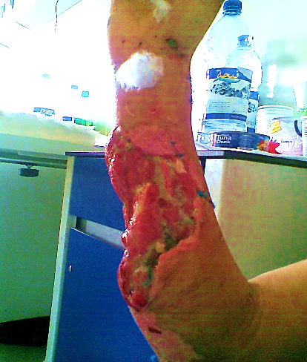
Figure (1)
Pre- Operative View, Right Forearm
A few days after the initial trauma.
A large party of the skin, muscles, tendons, and ulnar nerve and artery were lost.

However, three years early, the skin coverage was simplified with the recruitment of a traditional partial thickness skin graft with, for sure, disappointing outcomes. It was impossible to extend the long fingers despite the fitness of the corresponding system. The right forearm lost the ulnar half of its circumference with a significant psychological impact on the patient; Figure (2).
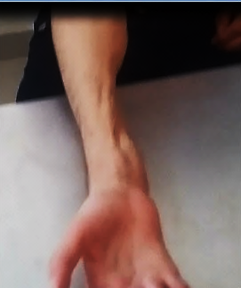
Figure (2)
Pre- Operative View, Right Forearm
The same right forearm three years and a half later.
The traditional partial thickness skin graft survived may on the benefit of the hand's function.
The forearm lost the totality of its ulnar half.

Finally, the Free Para Scapular Flap was used in order to replace the lost and improve the function at the same time; Figures (3) & (4).

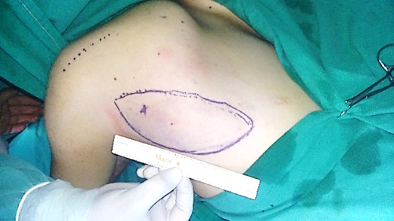
Left Para- Scapular Flap
Triangular Space
Figure (3)
Per- Operative View,
Left Para- Scapular Flap
The patient on his right lateral decubitus, his right forearm on the side table.
The left Para Scapular Flap (PSF) was chosen and was carefully outlined (15X8cm).
In such position and choice, two surgical teams could simultaneously work on;
one to harvest the flap and the other to prepare the recipient field.
The Triangular Space (TS) was preoperatively identified,
and the emerging point of the Scapular Circumflex Artery (SCA) was marked (x).

Three elements form the famous TS; the Teres Major Muscle (TMaM) inferiorly, the Teres Minor Muscle (TMiM) superiorly, and the Triceps Brachii Muscle's long head (TBM' long head) laterally.
Approximately, it is one centimeter below the midpoint of the lateral border of the scapula.
Practically, by the assistance of the intraoperative Echo Doppler we could identify and draw the projection of the nutritional artery (SCA) on the flap's skin.
Such a method greatly helps protecting the nutritional artery (SCA) during the harvesting process.

We started harvesting the flap from distal to proximal.
The anatomical elements to be looked for at first are the Latissimus Dorsi Muscle (LDM),
TMaM, and TMiM respectively.
Great attention should be present while detecting the latest muscle (TMiM).
The nutritional artery (SCA) hides just below it in the areolar tissue of the TS.
The nutritional artery (SCA) of the FPSF should then be precisely identified and carefully followed,
if necessary, to its origin from the Subscapular Artery (SA).

Sometimes, in order to gain much more length of the flap's vascular pedicle,
another surgical approach may be assumed in the axilla.
Thus, we can advance the vascular pedicle's pursuit to the origin on the Axillary Artery.
If so done, we might obtain one artery and one vein of suitable diameter and length for any future vascular anastomosis in the recipient field.

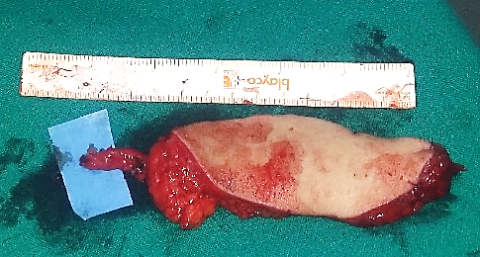
Vascular Pedicle
Para- Scapular Flap
Figure (4)
Per- Operative View,
Para- Scapular Flap
The FPSF was of a suitable thickness and dimensions to fill up the hollow induced by the initial trauma.
The good quality of the skin and the subcutaneous tissues would protect the released tendons and the median nerve in such way an improvement of their mobility was predicted.
Nevertheless, the upcoming adhesions and the consequent restrains to the tendons' mobility
should largely be minimized.

On the recipient field, we peeled the injured forearm of the condemned skin graft. Then, the fixed tendons and median nerve have been released. The stump of the Ulnar Artery (UA) has been identified and been exteriorized for more comfort in performing the soon coming anastomosis with the nutritional artery of the flap. For the venous drainage, one of the superficial veins of the region has also been prepared to receive the venous return from the flap.
The FPSF has been placed in its ultimate situ. Its vascular pedicle was oriented in proximal direction. An arterio-arterial end-to-end anastomosis, as well as, a veno-venous end–to-end anastomosis, between the FPSF's and recipient's vascular pedicles, have been done; Figures (5) & (6).
Figure (5)
Per- Operative View,
Para- Scapular Flap

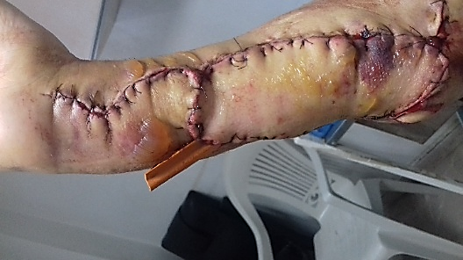
Figure (6)
Post- Operative View,
Para- Scapular Flap
The 4th post-operative day view

………………………………………………………………………………………………..
(*) Another case report of using free parascapular flap in skin reconstruction on the following link:
" Reconstruction of the Leg' Skin Using Parascapular Flap "

In another context, one can also read:
Neural Conduction, Personal View vs. International View (Innovated)
Upper Motor Neuron Lesions, Pathophysiology of Symptomatology
Neural Conduction, Action Pressure Waves (Innovated)
Neural Conduction, Action Potentials (Innovated)
Neural Conduction, Action Electrical Currents (Innovated)
The Function of Action Potentials (Innovated)
The Three Phases of Neural Conduction (Innovated)
Neural Conduction in the Synapse (Innovated)
Sensory Receptors
Nodes of Ranvier, the Equalizers (Innovated)
Nodes of Ranvier, the Functions (Innovated)
Nodes of Ranvier, First Function (Innovated)
Nodes of Ranvier, Second Function (Innovated)
Nodes of Ranvier, Third Function (Innovated)
Node of Ranvier The Anatomy
The Philosophy of Pain, Pain Comes First! (Innovated)
The Philosophy of the Form (Innovated)
Spinal Injury, Pathophysiology of Spinal Shock, Pathophysiology of Hyperreflexia
Who Decides the Sex of Coming Baby?
Spinal Shock (Innovated)
The Clonus (Innovated)
Hyperactivity Hyperreflexia (Innovated)
Hyperreflexia, Extended Sector of Reflex
Hyperreflexia, Bilateral Responses
Hyperreflexia, Multiple Responses
Nerve Conduction Study, Wrong Hypothesis is the Origin of the Misinterpretation (Innovated)
Wallerian Degeneration (Innovated)
Neural Regeneration (Innovated)
Wallerian Degeneration Attacks Motor Axons, While Avoids Sensory Axons
Barr Body, the Whole Story (Innovated)
Boy or Girl, Mother Decides!
Adam's Rib and Adam's Apple, Two Faces of one Sin
The Black Hole is a (the) Falling Star?
Adam's Rib, could be the Original Sin?
Pronator Teres Syndrome, Struthers Like Ligament (Innovated)
Function of Standard Action Potentials & Currents
Posterior Interosseous Nerve Syndrome
Spinal Reflex, New Hypothesis of Physiology
Hyperreflexia, Innovated Pathophysiology
Clonus, 1st Hypothesis of Pathophysiology
Clonus, 2nd Hypothesis of Pathophysiology
Clonus, Two Hypotheses of Pathophysiology
Hyperreflexia (1), Pathophysiology of Hyperactivity
Hyperreflexia (2), Pathophysiology of bilateral Responses
Hyperreflexia (3), Pathophysiology of Extended Hyperreflex
Hyperreflexia (4), Pathophysiology of Multi-Response Hyperreflex
Barr Body, the Second Look
Mitosis in Animal Cell
Meiosis
Universe Creation, Hypothesis of Continuous Cosmic Nebula
Circulating Sweepers
Pneumatic Petrous, Bilateral Temporal Hyperpneumatization
Ulnar Nerve, Congenital Bilateral Dislocation
Oocytogenesis
Spermatogenesis
This Woman Can Only Give Birth to Female Children
This Woman Can Only Give Birth to Male Children
This Woman Can Give Birth to Female Children More Than to Male Children
This Woman Can Give Birth to Male Children More Than to Female Children
This Woman Can Equally Give Birth to Male Children & to Female Children
Piriformis Muscle Injection_ Personal Approach
Eve Saved Human's Identity, Adam Ensured Human's Adaptation
Corona Virus (Covid-19): After Humiliation, Is Targeting Our Genes
Claw Hand Deformity (Brand Operation)
Corona Virus (Covid-19): After Humiliation, Is Targeting Our Genes
Barr Body; Mystery of Origin & Ignorance of Function
The Multiple Sclerosis: The Causative Relationship Between
The Galvanic Current & Multiple Sclerosis?
Liver Hemangioma: Urgent Surgery of Giant Liver Hemangioma
Because of Intra-Tumor Bleeding
Cauda Equina Injury, New Surgical Approach

Ulnar Dimelia, Mirror hand Deformity
Carpal Tunnel Syndrome Complicated by Complete Rupture of Median Nerve
Presacral Schwannoma
Congenital Bilateral Thenar Hypoplasia
Biceps Femoris' Long Head Syndrome (BFLHS)
Algodystrophy Syndrome Complicated by Constricting Ring at the Proximal Border of the Edema
Mandible Reconstruction Using Free Fibula Flap
Non- Traumatic Non- Embolic Acute Thrombosis of Radial Artery
(Buerger’s Disease)
Isolated Axillary Tuberculosis Lymphadenitis
Free Para Scapular Flap (FPSF) for Skin Reconstruction

16/4/2017
Updated 10/1/2022

