Surgical Case
The Claw Hand: Brand Operation
Dr. Ammar Yaseen MANSOUR

Note: For simplified steps of the Brand procedure, see the attached video:
Claw Hand Deformity (Brand Operation)
After more than a year has passed since the motor nerve injury, the primary focus of the rehabilitation process is no longer the original injury site itself, but rather the remaining functional muscle mass. This involves a deliberate process of redistributing the remaining motor forces, aiming to restore a lost function – and potentially multiple functions – that are critical for the limb's overall function.
The necessary and sufficient condition for initiating this repair process is intact sensation in the extremities; specifically, the fingertips when referring to the hand, or the sole of the foot when referring to the foot.
Conversely, and fortunately, lost sensation can be restored through direct intervention targeting the nerve injury itself, even up to ten years after the injury occurred. The key lies in the long lifespan of sensory receptors (10 years) compared to the short lifespan of motor receptors (only 1 year).
We present a clinical case of a young woman who sustained a gunshot wound to her left shoulder. Seven years post-injury, the patient presented to us with clawing of the fingers and complete paralysis of thumb movement on the affected side. The rehabilitation process was conducted in two stages, separated by a five-month interval between the first and second stage.
Clinical Case:
Seven years later, the young woman, 33 years old, recounts with undiminished pain her story of the tragic fate that awaited her first arrival in the capital, Damascus. Seven years—that is the age of her pain. An inept bullet pierced her left shoulder. It shattered her clavicle, severed her artery, destroyed her nerve. And most devastatingly, it severed her lifelong dream of higher education and a sweeter life.
Clinical Examination (Initial Evaluation):
On initial examination, the left hand exhibited a claw deformity (spontaneous hyperextension at the metacarpophalangeal joints of the four long fingers, coupled with spontaneous flexion at the proximal and distal interphalangeal joints); Fig. (1).

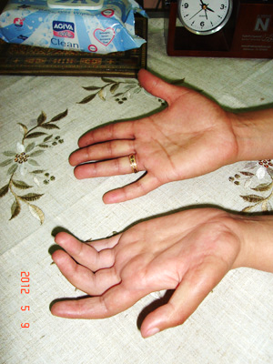
Figure (1): Spontaneous Claw Posture - Left Hand
(Comparative Clinical Presentation)
The left hand assumes a spontaneous claw posture.
Hyperextension at metacarpophalangeal (MCP) joints of the long fingers, coupled with spontaneous flexion at proximal and distal interphalangeal (PIP/DIP) joints.
Note significantly weaker flexion in the index finger compared to other digits.
Compare affected left hand with contralateral healthy right hand.

The thumb demonstrated loss of abduction, adduction, and opposition. Additionally, the left clavicle had a midshaft segmental defect measuring approximately 7 cm in length.
In contrast, the flexor pollicis longus retained its function. The superficialis and profundus finger flexors maintained partial function (muscle strength M3); Fig. (2).
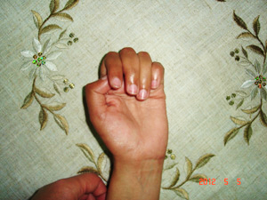 | 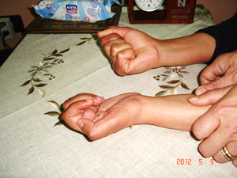
Figure (2): Inability to Form a Fist - Left Hand
(Comparative Clinical Assessment)
Absence of active flexion at metacarpophalangeal (MCP) joints, accompanied by weakened flexion at proximal/distal interphalangeal (PIP/DIP) joints of the four long fingers. Note the thumb positioned coplanar with the palm (loss of palmar abduction and opposition).
Compare left hand with contralateral (right) hand.

No sensorimotor deficits were observed in other critical limb-innervating nerves: the radial nerve, musculocutaneous nerve, or axillary nerve. Protective sensation (pain and temperature perception) remained intact in the hand. The affected hand joints also retained full passive range of motion.
Electrophysiological studies indicated a nerve injury consistent with anterio-medial cord brachial plexus involvement.
Setting aside the significant segmental defect in the left clavicle (approximately 7 cm) and the infraclavicular vascular injury – despite their impact on the functional prognosis of the limb – this study will focus on investigating and managing the clinical manifestations of the neural injury affecting the hand.
Discussion of Neurological Deficits:
The medial cord injury manifests as a complete ulnar nerve lesion and a partial median nerve lesion (specifically involving the medial root of the median nerve).
In complete ulnar nerve injury, paralysis affects the following intrinsic hand muscles:
- Three palmar interossei
- Four dorsal interossei
- Third and fourth lumbricals (first/second lumbricals: median innervation)
- Hypothenar muscles (abductor digiti minimi, flexor digiti minimi)
- Adductor pollicis
- Deep head of flexor pollicis brevis (thenar muscle)
- Flexor carpi ulnaris (major extrinsic muscle)
Medial root median nerve injury causes paralysis of muscles dependent on lower brachial plexus roots (C8-T1):
- Abductor pollicis brevis
- Superficial head of flexor pollicis brevis
- First and second lumbricals
Combined ulnar and medial median root injuries result in:
- Paralysis of ALL intrinsic hand muscles EXCEPT opponens pollicis (C6-C7 innervation).
- Residual thumb movement: Weak adduction (adductor pollicis paralysis) with pseudo-opposition (via FPL/FPL substitution) rather than true opposition (absent abductor pollicis brevis)
Pathophysiological Notes:
- Thumb Function Paradox:
  - Preserved opponens pollicis (C6-C7) enables weak thumb rotation
  - Loss of APB/AdP forces compensatory FPL/FPL activation → Simulated opposition (adduction-flexion) not true opposition (triplanar movement)
- Lumbrical Discrepancy:
  - Ulnar: Controls lateral grip (ring/little fingers)
  - Median: Controls precision grip (index/middle fingers)
- Extrinsic Preservation:
  - Flexor pollicis longus (anterior interosseous) remains functional → Key to residual thumb motion
Pathophysiology of Claw Deformity:
Paralysis of the seven interossei (3 palmar + 4 dorsal) and four lumbrical muscles results in loss of:
i) Active flexion at the metacarpophalangeal (MCP) joints of the four long fingers,
ii) Active extension at the interphalangeal joints (PIP/DIP) of these same fingers.
Consequently, over time, a claw hand deformity develops (spontaneous hyperextension at the MCP joints coupled with spontaneous flexion at the proximal and distal interphalangeal joints); Figure (1). Initially reducible during the early post-injury phase, the deformity becomes fixed and irreducible without timely rehabilitation.
Claw hand constitutes a functionally devastating deformity. Despite preserved function of the extrinsic finger flexors (FDS and FDP), grasp becomes impossible due to:
- MCP hyperextension preventing finger pulp contact
- IP flexion creating object push-away effect; Figure (2).
Key Biomechanical Principles:
- Intrinsic Minus Hand = Loss of MCP flexors + IP extensors
- Extrinsic Dominance = Unopposed:
  - Extensor digitorum → MCP hyperextension
  - FDS/FDP → PIP/DIP flexion
- Grasp Failure Mechanism:
  - MCP hyperextension → fingers "stand up" away from palm
  - IP flexion → fingertips strike objects prematurely
- Progressive Stiffness:
  - Reducible → Capsular contractures → Fixed deformity
Clinical Notes:
Paralysis of the thumb's motors adds profound functional bleakness to the existing clinical picture.
The thumb – essential for precision pinch (thumb-index grasp) and power grip (three-point grip: thumb-index-middle) – endows the human hand with unparalleled dexterity for executing highly refined cognitive commands.
Yet the thumb cannot act alone. It requires synergistic partners – the index and/or middle fingers. In claw hand, dysfunction of these innate partners disrupts thumb biomechanics, rendering it functionally impotent.
Thus, even a functional thumb loses most efficacy in claw hand. Now consider the compounded disability when – as in our patient – the thumb itself is paralyzed. The clinical devastation defies adequate description.
Biomechanical Breakdown:
- Precision Grasp Failure:
  - Clawed index finger cannot stabilize against thumb
  - Thumb paralysis prevents opposition/palmar abduction
→ "Floating thumb" unable to contact index pulp
- Power Grip Collapse:
  - Clawed middle finger loses MCP flexion → cannot form arch with palm
  - Thumb adduction weakness → inability to generate counterforce
→ Objects slip from grasp
- Functional Paradox:
"A functional thumb in claw hand is like a skilled pianist playing a shattered keyboard"
  - Even with intact thumb motors:
    - Clawed partners → no stable platform for opposition
    - MCP hyperextension → thumb-index distance increases by 40-60%
Clinical Implication:
The concluding remark – "imagine the compounded disability" – underscores the catastrophic synergy of:
- Neural Deficit (complete ulnar + partial median injury)
- Biomechanical Failure (claw deformity)
- Functional Isolation (loss of thumb-partner synergy)
Late-Stage Management (7 Years Post-Injury):
Beyond seven years post-neural injury, direct neural repair becomes futile. The sole solution lies in tendon transfer procedures – strategically redistributing remaining functional muscles to restore critical motor functions essential for limb utility.
At this stage, claw deformity becomes fixed and refractory to correction. Pathological changes include:
- Fibrosis of the dorsal capsuloligamentous complex (joint capsule, ligaments, extensor tendons) at MCP joints
- Articular surface remodeling: Dorsal flattening and volar doming
Concurrently, volar soft tissues undergo pathological elongation (volar plate attenuation, collateral ligament stretching), further compromising joint stability. This creates a self-perpetuating imbalance: progressive dorsal contracture versus volar incompetence.
Given this intrinsic muscle paralysis and established clawing, we employed the Brand tendon transfer. This utilizes extensor carpi radialis brevis (ECRB) as a motor to simultaneously:
- Flex the metacarpophalangeal (MCP) joints
- Extend the proximal/distal interphalangeal (PIP/DIP) joints
A tendon grafts bridge the ECRB to the lateral bands of the extensor mechanism (Figure 3).

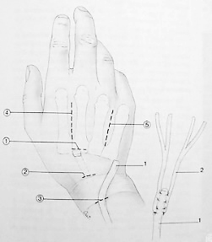

Image A:
- Extensor carpi radialis brevis (ECRB) tendon
- Plantaris tendon graft

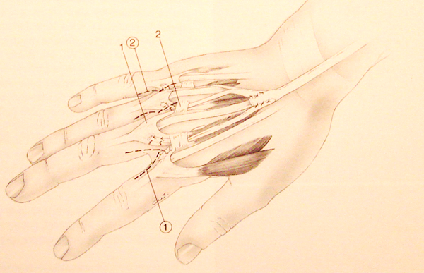

Image B:
- Extensor expansion
- Deep transverse metacarpal ligament
Figure (3):
Brand Tendon Transfer for Claw Hand Correction

This dynamic tendon transfer utilizes extensor carpi radialis brevis (ECRB) (1-A) routed via a tendon graft – preferably plantaris tendon (2-A) over palmaris longus – to simultaneously flex the metacarpophalangeal (MCP) joints and extend the proximal/distal interphalangeal (PIP/DIP) joints.
All surgical approaches are dorsal.
To ensure effective MCP flexion, the tendon graft must pass volar to the deep transverse metacarpal ligament (2-B).
(Dashed lines in both images indicate surgical approaches)

Note: For simplified steps of the Brand procedure, see the attached video:
Claw Hand Deformity (Brand Operation):

Suboptimal Outcomes & Revision Strategy (3 Months Post-Brand Transfer):
At three-month follow-up, outcomes remained suboptimal. Contributing factors included:
- Weakness of flexor digitorum superficialis/profundus (FDS/FDP) secondary to infraclavicular nerve injury and disuse atrophy
- Severe dorsal capsular contracture at metacarpophalangeal (MCP) joints from chronic clawing
- Dominance of extensor digitorum communis (EDC) due to long-standing deformity
This necessitated a dual-strategy revision:
- Enhance mechanical efficiency of extrinsic finger flexors (FDS/FDP)
- Establish permanent mild MCP flexion (15-20°)
For the first objective: We performed A1/A2 pulley release up to the mid-proximal phalanx (P1) to improve flexor tendon excursion and force transmission.
For the second objective: We advanced the volar plate of all four MCP joints and reattached it to the metacarpal neck, securing permanent 15-20° flexion; Figure (4).

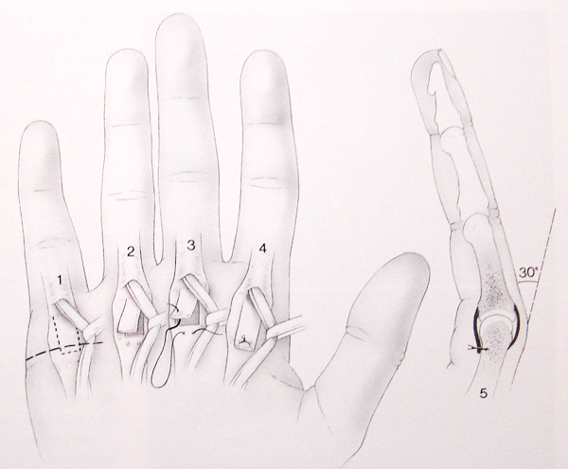
(Figure 4)
Surgical Technique: Zancolli Volar Plate Capsulodesis
1. Surgical incision along the distal palmar crease.
2. Complete A1 pulley release. Radial/ulnar retraction of flexor tendons to expose the volar plate. Elevation of a rectangular capsular flap with distal base.
3-4. Advancement and fixation of the capsular flap to the corresponding metacarpal neck.
5. Fixation must achieve 30° of volar-flexion at the metacarpophalangeal (MCP) joint.

Notably, we deliberately avoided the standard 30° flexion angle due to synergistic effects of both procedures:
- Pulley release → Future progressive flexion contracture
- Volar plate advancement → Immediate 15-20° flexion
Their combined action will achieve the recommended 30° flexion long-term without initial overcorrection risk.

Thumb Rehabilitation: Surgical Technique
- The central challenge in thumb rehabilitation was identifying a viable donor muscle with sufficient power for transfer.
- The sole available donor was the extensor indicis proprius (EIP).
- Given the atrophic, non-functional state of our patient's hand, the EIP tendon was unsurprisingly attenuated and atrophic.
- Nevertheless, we proceeded: The tendon was detached from its insertion, rerouted through a subcutaneous tunnel toward the abductor pollicis brevis (APB) tendon, and ultimately secured to the target tendon using interrupted 2-0 PDS sutures.

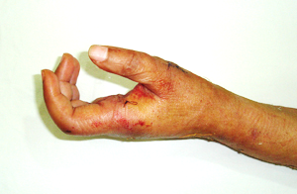
Resolution of spontaneous clawing in the left fingers.
The thumb assumes an automatic abducted position perpendicular to the palmar plane.
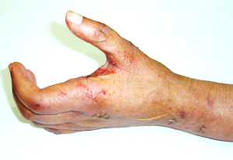
Maximal abduction of the left thumb

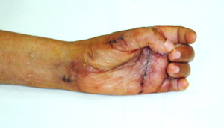
Thumb opposition to the middle finger.
Figure (5): One Month Post-Second Surgery (From Surgeon's Archive)
………………………………………………………………………………………………
In other contexts, you can also read the following articles:
 | DOI | The Spinal Reflex, New Hypothesis of Physiology
 | - | The Hyperreflexia, Innovated Pathophysiology
 | DOI | The Spinal Shock
 | - | The Spinal Injury, the Pathophysiology of the Spinal Shock, the Pathophysiology of the Hyperreflexia
 | DOI | Upper Motor Neuron Lesions, the Pathophysiology of the Symptomatology
 | - | The Hyperreflexia (1), the Pathophysiology of Hyperactivity
 | - | The Hyperreflexia (2), the Pathophysiology of Bilateral Responses
 | - | The Hyperreflexia (3), the Pathophysiology of Extended Hyperreflex
 | - | The Hyperreflexia (4), the Pathophysiology of Multi-Response Hyperreflex
- | - | The pathophysiology of Triple flexion Reflex
 | - | The Clonus, 1st Hypothesis of Pathophysiology
 | - | The Clonus, 2nd Hypothesis of Pathophysiology
 | DOI | The Clonus, Two Hypotheses of Pathophysiology
 | DOI | The Nerve Transmission through Neural Fiber, Personal View vs. International View
 | - | The Nerve Transmission through Neural Fiber (1), The Action Pressure Waves
 | - | The Nerve Transmission through Neural Fiber (2), The Action Potentials
 | - | The Nerve Transmission through Neural Fiber (3), The Action Electrical Currents
 | - | The Function of Standard Action Potentials & Currents
 | - | The Three Phases of Nerve transmission
 | DOI | Neural Conduction in the Synapse (Innovated)
 | DOI | Nodes of Ranvier, the Equalizers
 | - | Nodes of Ranvier, the Functions
 | - | Nodes of Ranvier, First Function
 | - | Nodes of Ranvier, Second Function
 | - | Nodes of Ranvier, Third Function
 | - | Node of Ranvier, The Anatomy
 | - | The Wallerian Degeneration
 | - | The Neural Regeneration
 | - | The Wallerian Degeneration Attacks Motor Axons, While Avoids Sensory Axons
 | DOI | The Sensory Receptors
 | - | Nerve Conduction Study, Wrong Hypothesis is the Origin of the Misinterpretation (Innovated)
 | - | Piriformis Muscle Injection_ Personal Approach
 | - | The Philosophy of Pain, Pain Comes First! (Innovated)
 | - | The Philosophy of the Form (Innovated)
 | - | Pronator Teres Syndrome, Struthers-Like Ligament (Innovated)
 | - | Ulnar Nerve, Congenital Bilateral Dislocation
 | - | Posterior Interosseous Nerve Syndrome
 | - | The Multiple Sclerosis: The Causative Relationship Between  The Galvanic Current & Multiple Sclerosis?
 | - | Cauda Equina Injury, New Surgical Approach
 | - | Carpal Tunnel Syndrome Complicated by Complete Rupture of Median Nerve
 | - | Biceps Femoris' Long Head Syndrome (BFLHS)
 | DOI | Barr Body, The Whole Story (Innovated)
 | - | Adam's Rib and Adam's Apple, Two Faces of one Sin
 | - | Adam's Rib, could be the Original Sin?
 | - | Barr Body, the Second Look
 | DOI | Who Decides the Sex of Coming Baby?
 | - | Boy or Girl, Mother Decides!
 | - | Oocytogenesis
 | - | Spermatogenesis
 | - | This Woman Can Only Give Birth to Female Children
 | - | This Woman Can Only Give Birth to Male Children
 | - | This Woman Can Give Birth to Female Children More Than to Male Children
 | - | This Woman Can Give Birth to Male Children More Than to Female Children
 | - | This Woman Can Equally Give Birth to Male Children & to Female Children
 | - | Eve Saved Human Identity; Adam Ensured Human Adaptation
 | - | Coronavirus (Covid-19): After Humiliation, Is Targeting Our Genes
 | - | Coronavirus (Covid-19): After Humiliation, Is Targeting Our Genes
 | - | The Black Hole is a (the) Falling Star?
 | - | Mitosis in Animal Cell
 | - | Meiosis
 | - | Universe Creation, Hypothesis of Continuous Cosmic Nebula
 | - | Circulating Sweepers
 | - | Pneumatic Petrous, Bilateral Temporal Hyperpneumatization
 | - | Congenital Bilateral Thenar Hypoplasia
 | - | Ulnar Dimelia, Mirror hand Deformity
 | DOI | Thumb Reconstruction Using Microvascular Second Toe to Thumb Transfer
 | DOI | Surgical Restoration of a Smile by Grafting a Segment of the Gracilis Muscle to the Face
 | DOI | Mandible Reconstruction Using Free Fibula Flap
 | DOI | Presacral Schwannoma
 | DOI | Liver Hemangioma: Urgent Surgery of Giant Liver Hemangioma  Due to Intra-Tumor Bleeding
 | DOI | Free Para Scapular Flap (FPSF) for Skin Reconstruction
 | - | Claw Hand Deformity (Brand Operation)
 | - | Algodystrophy Syndrome Complicated by Constricting Ring at the Proximal Border of the Edema
 | - | Non- Traumatic Non- Embolic Acute Thrombosis of Radial Artery (Buerger’s Disease)
 | - | Isolated Axillary Tuberculosis Lymphadenitis
 | DOI | The Iliopsoas Tendonitis... The Snapping Hip
 | To read the article in Arabic, click on
 | DOI | The New Frankenstein Monster
 | DOI | The Lone Wolf
 | DOI | The Delirium of Night and Day
 | DOI | The Delirium of the Economy
 | DOI | Ovaries in a Secure Corner… Testicles in a Humble Sac:  An Inquiry into the Function of Form
 | DOI | Eve Preserves Humanity’s Blueprint; Adam Drives Its Evolution
 | DOI | The Manufacture of the Unconscious
 | DOI | The Ballad of Eternity
 | DOI | Two Truths Woman Would Never Accept
 | DOI | The 'Iddah (Waiting Period) in Islamic Law: A Comparative Analysis of its Rationale for Divorced Women and Widows
 | DOI | The IVF/ICSI-Conceived Child: A Biologically Suboptimal Outcome

27/02/2013

