Traumatic Injuries of the Cauda Equina: A Novel Surgical Approach
Dr. Ammar Yaseen Mansour
To read the original Arabic version of this article, click here: (DOI)
أذيَّاتُ ذيلِ الفرسِ الرَّضِّيَّةُ: مقاربةٌ جراحيَّةٌ جديدةٌ
When interpreting the clinical manifestations of traumatic cauda equina injuries, discussion often centers on the compressive, lacerating action and the subsequent inflammatory cascades of the traumatic force. However, medical understanding does not mandate exclusivity here. All these mechanisms remain insufficient to explain the wide spectrum of clinical presentations of these injuries, as well as the differences in spontaneous progression from one case to another. Occasionally, a rare coincidence brings forth a case that defies your ability, using both your personal knowledge and the entirety of medical literature, to formulate a comprehensive picture of its pathological events. Conventional explanations prove futile. Fortunately, this time, I say, the atypical cases can illuminate uncharted territories and unlock mysteries that have remained sealed puzzles for many decades.
This involves a patient in his third decade of life. His traumatic injury might suggest spastic paraplegia, yet his clinical reality tells a different story. From the moment of encounter to the moment of its delivery, including all the pains of its labor, I present the genesis of this idea, highlighting its strengths, guided by the outcome of this patient's condition after the surgical application of its principles.
Case Presentation:
The patient is a 26-year-old male who sustained a gunshot wound to his back at the level of the 9th and 10th thoracic vertebrae (T9, T10). The patient regained consciousness with complete sensory-motor paralysis below the costal margin. Sensation was absent in the perineal area and external genitalia (Saddle Anesthesia). Voluntary control over defecation and urination was lost. Similarly, sexual function and sexual sensation were absent. A suprapubic catheter was placed for urinary drainage.
The patient weighed the options between a colostomy and repeated personal care, opting for the latter. The condition remained unchanged without improvement from the time of injury until the time of surgery, for approximately one full year.
Radiologically, a Multi-slice Computed Tomography (CT) scan of the spine showed no breach of the spinal canal, nor did it reveal any comminution of the essential bony components forming it: the vertebral bodies, lateral pedicles, or posterior laminae.
The injuries were limited to the destruction of the spinous processes of T9 and T10. The spinal canal remained free of any bony or metallic foreign bodies. Fragments of the projectile were scattered within the paravertebral muscle mass. This scattering hindered the possibility of using Magnetic Resonance Imaging (MRI) for better visualization of the spinal cord.
Consequently, and upon reviewing the sequential slices, a personal conviction was formed regarding the integrity of the spinal cord substance and the sturdiness of its protective bony structure; see Figure (1).

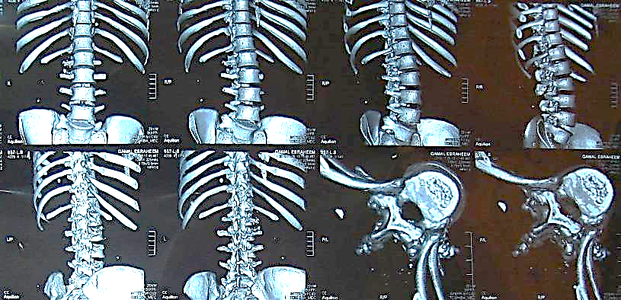
Figure (1): CT Scan of the Vertebral Column

The bottom-left images (yellow star) show an axial view of the spinal canal at the level of the traumatic injury (T9, T10), demonstrating the absence of any foreign body within the spinal canal—the domicile of the spinal cord under investigation.
The remaining images provide a 3D reconstruction of the vertebral column from four angles, clearly showing the integrity of the spine.

One year after the neurological injury, the physical examination revealed a clear contradiction between the implications of the spinal cord injury in terms of type and location, and the findings of the clinical reality. The absence of active movement, along with the absence of tendon reflexes (Patellar reflex, Achilles reflex) and cutaneous reflexes (Cremasteric reflex), constituted a significant difference between the expected and the actual findings. Superficial sensations, pain, and temperature sense were absent below the costal margin. Sexual function and control over other vital functions (urination and defecation) were also absent.
Clinically, we were facing a lower motor neuron lesion. Therefore, surgical intervention on the cauda equina was decided to release it from potential inter- radicular adhesions between its roots within the thecal sac and/or those tethering the nerve root within the intervertebral foramen.
The surgical intervention was performed on 1/2/2014 (time of injury: 25/1/2013). We began the surgical procedure by removing the posterior arch of the spine at the level of the upper three lumbar vertebrae. The thecal sac was opened longitudinally at this level. The nerve roots forming the cauda equina were visualized. The roots appeared free from each other, with normal color and consistency. However, as preoperatively suspected, each root was found fixed within its own canal in the intervertebral foramen. The nerve roots were released at this level, specifically for the first (L1), second (L2), and third (L3) lumbar roots only. The surgical procedure was not completed by releasing all the nerve roots of the cauda equina for technical reasons. The decision was made to halt the procedure and observe the results of what we had accomplished.
Discussion:
Faced with this discrepancy between the location of the spinal cord injury (T9, T10), which suggests an upper motor neuron lesion, and the clinical picture clearly indicating a lower motor neuron lesion, I leaned towards the presence of an injury at the level of the cauda equina and/or the conus medullaris.
A cauda equina injury cannot be of a lacerating nature due to the absence of any breach of the spinal canal at this level. Therefore, the only remaining pathological mechanism explaining the damage to the cauda equina nerve roots is constrictive and/or adhesive fibrosis.
Fibrosis can occur via one of two mechanisms: either through bleeding within the spinal canal (the more likely scenario), or through pathological changes induced by the violent trauma to the cerebrospinal fluid (CSF) structure. The resorption of the hemorrhagic effusion and/or the filtration of the CSF from its turbidity and suspended particles, along with the accompanying reactive inflammatory action, all contribute to planting fibrosis randomly in multiple locations. The random distribution of fibrotic adhesions explains this great diversity in the spectrum of clinical symptoms. The fibrosis may be located within the thecal sac, adhering the nerve roots to each other, or at the exit of each root from its meningeal sheath at the level of the intervertebral foramina; see Figure (2).

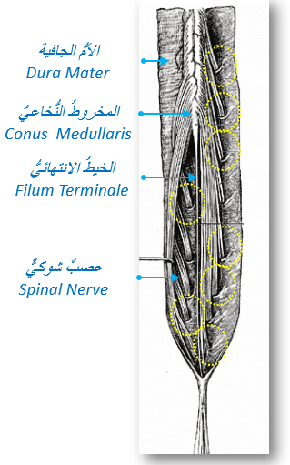
Figure (2): Cauda Equina

Adhesions can constrict the entirety or bundles of the cauda equina roots within the thecal sac, impeding neural transmission therein.
Similarly, fibrosis can strangulate some or all of the nerve roots at their exit from the thecal sac at the level of the intervertebral foramen.
The yellow circles in the drawing indicate the presumed locations of the pathological events without encompassing all of them. We know that the action of fibrosis is random in its distribution. It may affect the exit points of all nerve roots, or it may affect some and spare others.

Relevant Anatomical Details
Each spinal segment gives off a pair of nerve roots: a dorsal root and a ventral root. The two nerve roots of each specific spinal segment converge to form the corresponding spinal nerve. This point of convergence may be within the space of the intervertebral foramen, as in the cervical spinal nerves. Or, the roots may hold their meeting just before that, as in the rest of the spinal nerves.
Each nerve root exits the meningeal sac accompanied by two extensions: one from the dura mater and another from the arachnoid membrane. These two meningeal extensions form a meningeal sleeve that initially envelops the nerve root and then extends to envelop the corresponding spinal nerve.
The entire neural structure—whether two nerve roots or a spinal nerve—along with the meningeal sleeve, passes through the corresponding intervertebral foramen. This obligatory passage is considered the most critical point in the course of the nerve root. There, the slightest fibrosis or compressive action is capable of completely impeding the function of the nerve root. And since the fibrotic process is random, the distribution and degree of fibrosis will differ from one site to another within the thecal sac. This explains the breadth of the spectrum of clinical symptoms and their asymmetry in cauda equina injuries; see Figure (3).

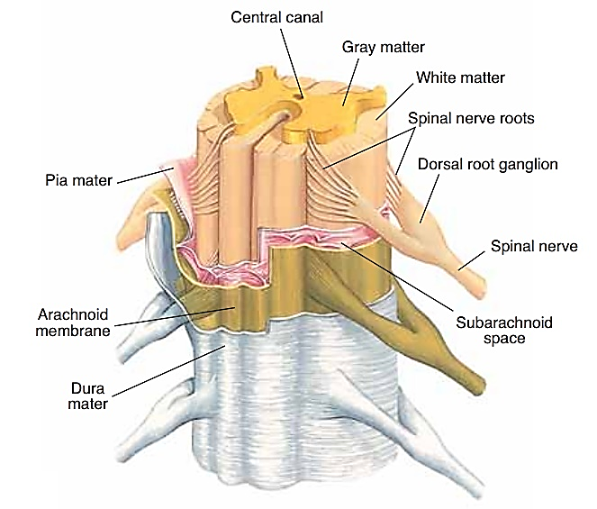 | 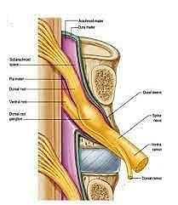
Figure (3): Relevant Anatomical Details, The Meningeal Sleeve

The meninges consist of three layers: the pia mater internally, the arachnoid membrane in the middle, and the dura mater externally.
Each spinal segment gives off a pair of spinal roots. The ventral and dorsal nerve roots of the same spinal segment converge to form the corresponding spinal nerve.
Accompanying each nerve root is a tube from the dura mater and another from the arachnoid membrane. The bi-layer meningeal sleeve surrounds the nerve root and then the spinal nerve, extending with the latter for a short distance.
The entire neural structure, along with the meningeal sleeve, passes through a bony tunnel, the intervertebral foramen. The latter is considered the most critical point in the journey of the spinal nerve. A little fibrosis or a minor compressive factor is capable of completely abolishing the function of the nerve root (red circle).

Surgical Approach and Early Results
Previously, in managing cauda equina injuries, practitioners adhered to a strategy of active monitoring. When surgery was adopted, it was limited to laminectomy, removal of the protruding part of the intervertebral disc (if present), while exercising extreme caution when handling the cauda equina roots. No one had previously attempted to explore the exit points of the nerve roots in search of constrictive fibrosis and/or adhesions compromising the nerve root.
Releasing the nerve roots of the cauda equina requires wide exposure of the thecal sac, at least at the level of the lumbar and first sacral vertebrae. After opening the thecal sac, each nerve root is followed from its origin to its exit via the corresponding intervertebral foramen. We verify the integrity of the nerve root structure (in cases of penetrating traumatic injuries at this level) and its freedom from any adhesions or fixating fibrosis.
The early results of the nerve root release procedure at the level of the first (L1), second (L2), and third (L3) lumbar roots appeared very encouraging. I will not discuss the sensory and psychological gains, despite their richness, as they are subjective signs with emotional dimensions. Instead, I will only discuss the objective, stable, and measurable clinical signs, regardless of the examiner's inclination.
Two months after surgery, movement appeared in the medial (M2) and lateral (M2) thigh rotator muscles. Motor strength also returned to the gluteus maximus (M3), hip flexors (M3), and adductor muscles (M3). Among the reflexes that returned with strength and consistency was the Cremasteric reflex (L2 level).
The patient can now stand spontaneously without assistive devices. Physiotherapy rehabilitation is still ongoing. We will wait for a period of time before proceeding to the second stage of surgery to release the remaining nerve roots of the cauda equina.
Conclusions and Recommendations
Science cannot be reduced, nor can absolute conviction be reached, through a single clinical case. Conversely, a single anomalous case, rich in its elements, can be the detector and guide to many of the body's hidden secrets. I pondered at length over this patient's case, and the clear contradiction between the site of the mechanical action of the projectile (T9, T10) and the location of the resulting functional deficit (below L1) preoccupied me.
Matters only became clear by assuming injury to the cauda equina. Similarly, the injury could only be fibrotic due to the absence of any mechanical breach of the protective vertebral column. Given the frequency of peripheral nerve injuries addressed similarly, the theory of nerve root fixation at its exit from the thecal sac at the level of the intervertebral foramen seemed most probable. And indeed, this was the case. The exposed nerve root exits appeared fibrotic and narrow. A simple release of these exits was sufficient to resolve a devastating problem that had lasted a full year. The rapid clinical improvement specifically in the segments of the released nerve roots (L1, L2, L3), and not others, further strengthens this conviction.
Therefore, based on these findings, a proactive surgical approach is strongly recommended over watchful waiting. Specifically, surgical intervention is indicated in cauda equina injuries under the following circumstances:
1. In every traumatic injury of the spine where the clinical reality contradicts the topographical implications of the mechanical action of the traumatic force (as in our case).
2. Whenever the traumatic force, directly or through one of its products (e.g., a bony or metallic fragment), penetrates the spinal canal at the level of the first lumbar vertebra (L1) or below. Especially since we know the possibility of suturing the cauda equina nerve roots with direct microsurgical suturing or using a nerve graft.
3. In old traumatic injuries of the cauda equina, we should not be content with laminectomy and/or removal of a protruding disc, but must explore the entire course of the cauda equina nerve roots from origin to exit. In this regard, we ensure the freedom of movement of the nerve root within its meningeal sleeve as well as through the intervertebral foramen.
..................................................................................................
Currently Under Study:
1. I am currently studying the possibility of using the 1st Coccygeal Root (Co1) to graft other nerve roots of the cauda equina. If the loss of nerve root substance is greater than the compensatory capacity of the first coccygeal nerve pair (Co1), the fifth lumbar nerve root (L5) can be utilized. The study aims to replace traditional peripheral nerve grafts, which have poor yield due to the predominance of connective tissue in their structure, with the first coccygeal root, due to its richness in neural tissue over connective tissue on one hand, and its low clinical significance on the other, or the fifth lumbar root when necessary, even at the expense of a foot drop.
2. Using an endoscope to release the nerve roots of the cauda equina. The endoscope can access the inside of the thecal sac through a small window. The endoscope has both diagnostic and therapeutic roles simultaneously.
,,,,,,,,,,,,,,,,,,,,,,,,,,,,,,,,,,,,,,,,,,,,,,,,,,,,,,,,,,,,,,,,,,,,,,,,,,,,,,,,,,,,,,,,,,,,,,,,,,,,,,,,,,,,,,,,,,,,,,,,,,,,,,,,,,,,,,,,,,,,,,,,,,,,,,,,,,,,
In other contexts, you can also read the following articles:
 | DOI | The Spinal Reflex, New Hypothesis of Physiology
 | - | The Hyperreflexia, Innovated Pathophysiology
 | DOI | The Spinal Shock
 | - | The Spinal Injury, the Pathophysiology of the Spinal Shock, the Pathophysiology of the Hyperreflexia
 | DOI | Upper Motor Neuron Lesions, the Pathophysiology of the Symptomatology
 | DOI | Hyperreflexia (1): Pathophysiology of Disproportionate Motor Response
 | DOI | Hyperreflexia (2): Pathophysiology of Bilateral-Response Hyperreflexia
 | DOI | Hyperreflexia (3): Pathophysiology of Extended Hyperreflexia
 | DOI | Hyperreflexia (4): Pathophysiology of Multi-Motor-Response Hyperreflexia
- | DOI | The pathophysiology of Triple flexion Reflex
 | DOI | The Clonus, 1st Hypothesis of Pathophysiology
 | DOI | The Clonus, 2nd Hypothesis of Pathophysiology
 | DOI | The Clonus, Two Hypotheses of Pathophysiology
 | DOI | The Nerve Transmission through Neural Fiber, Personal View vs. International View
 | - | The Nerve Transmission through Neural Fiber (1), The Action Pressure Waves
 | - | The Nerve Transmission through Neural Fiber (2), The Action Potentials
 | - | The Nerve Transmission through Neural Fiber (3), The Action Electrical Currents
 | - | The Function of Standard Action Potentials & Currents
 | - | The Three Phases of Nerve transmission
 | DOI | Neural Conduction in the Synapse (Innovated)
 | DOI | Nodes of Ranvier, the Equalizers
 | - | Nodes of Ranvier, the Functions
 | - | Nodes of Ranvier, First Function
 | - | Nodes of Ranvier, Second Function
 | - | Nodes of Ranvier, Third Function
 | - | Node of Ranvier, The Anatomy
 | DOI | Vesicular Dynamics: A Unifying Theory for Wallerian Degeneration and Neural Regeneration
 | - | The Wallerian Degeneration
 | - | The Neural Regeneration
 | DOI | Wallerian Degeneration: Affects Motor Axons while Sparing Sensory Axons
 | DOI | The Sensory Receptors
 | DOI | Electroneurography vs. Neural Reality: Hidden Fallacies in Nerve Conduction Studies
 | DOI | Piriformis Muscle Injection: Personal Approach
 | DOI | In Philosophy of Nerves: Pain First!
 | DOI | In Neurodoctrines: Form is Necessity!
 | DOI | Pronator Teres Syndrome, Struthers-Like Ligament
 | DOI | Ulnar Nerve, Congenital Bilateral Dislocation
 | - | Posterior Interosseous Nerve Syndrome
 | DOI | The Multiple Sclerosis: The Causative Relationship Between  The Galvanic Current & Multiple Sclerosis?
 | - | Cauda Equina Injury, New Surgical Approach
 | DOI | Carpal Tunnel Syndrome Ends Its Adherence: Complete Median Nerve Transection
 | DOI | Biceps Femoris' Long Head Syndrome (BFLHS)
 | DOI | Barr Body, The Whole Story (Innovated)
 | - | Adam's Rib and Adam's Apple, Two Faces of one Sin
 | - | Adam's Rib, could be the Original Sin?
 | - | Barr Body, the Second Look
 | DOI | Who Decides the Sex of Coming Baby?
 | - | Boy or Girl, Mother Decides!
 | - | Oocytogenesis
 | - | Spermatogenesis
 | - | This Woman Can Only Give Birth to Female Children
 | - | This Woman Can Only Give Birth to Male Children
 | - | This Woman Can Give Birth to Female Children More Than to Male Children
 | - | This Woman Can Give Birth to Male Children More Than to Female Children
 | - | This Woman Can Equally Give Birth to Male Children & to Female Children
 | - | Eve Saved Human Identity; Adam Ensured Human Adaptation
 | DOI | COVID-19: Beyond the Crisis—Is It Targeting Our Genes?
 | DOI | Fibromyalgia
 | - | Mitosis in Animal Cell
 | - | Meiosis
 | DOI | The Creation of the Heavens and the Earth: The Connected Nebular Universe Hypothesis
 | DOI | The Sweeping Celestial Bodies (Al-Jawāri Al-Kunnas)
 | DOI | The Black Hole and the Falling Star Hypothesis
- | DOI | Light is a Wave and the Path is Material: A New Vision of the Nature of Light and its Propagation
 | - | Pneumatic Petrous, Bilateral Temporal Hyperpneumatization
 | DOI | Congenital Bilateral Thenar Hypoplasia
 | DOI | Ulnar Dimelia, Mirror hand Deformity
 | DOI | Brachymetacarpia: Bilateral and Symmetrical Shortening of the Three Ulnar Digits
 | DOI | Thumb Reconstruction Using Microvascular Second Toe to Thumb Transfer
 | DOI | Surgical Restoration of a Smile by Grafting a Segment of the Gracilis Muscle to the Face
 | DOI | Mandible Reconstruction Using Free Fibula Flap
- | DOI | Free Fibula Flap for Bone Lost Complicated with Recalcitrant Osteomyelitis
 | DOI | Presacral Schwannoma
 | DOI | Liver Hemangioma: Urgent Surgery of Giant Liver Hemangioma  Due to Intra-Tumor Bleeding
 | DOI | Free Para Scapular Flap (FPSF) for Skin Reconstruction
 | DOI | Claw Hand Deformity (Brand Operation)
 | DOI | Algodystrophy Syndrome Complicated by Constricting Ring at the Proximal Border of the Edema
 | DOI | Non- Traumatic Non- Embolic Acute Thrombosis of Radial Artery (Buerger’s Disease)
 | DOI | Isolated Axillary Tuberculosis Lymphadenitis
 | DOI | The Iliopsoas Tendonitis... The Snapping Hip
- | DOI | Peri- Menopausal Breast Lesions: Towards a More Decisive Approach
 | To read the original Arabic version of the article, click on:
 | DOI | The New Frankenstein Monster
 | DOI | The Lone Wolf
 | DOI | The Delirium of Night and Day
 | DOI | The Delirium of the Economy
 | DOI | Ovaries in a Secure Corner… Testicles in a Humble Sac:  An Inquiry into the Function of Form
 | DOI | Eve Preserves Humanity’s Blueprint; Adam Drives Its Evolution
 | DOI | The Manufacture of the Unconscious
 | DOI | The Ballad of Eternity
 | DOI | Two Truths Woman Would Never Accept
 | DOI | The 'Iddah (Waiting Period) in Islamic Law: A Comparative Analysis of its Rationale for Divorced Women and Widows
 | DOI | The IVF/ICSI-Conceived Child: A Biologically Suboptimal Outcome
 | DOI | Nature's Relentless Couriers
 | DOI | The Triad of Intelligence... A Traveler's Provisions!
 | DOI | Zero-Value Equations: Modernity’s Hidden Costs and False Promises
 | DOI | The Dialectic of Meaning and Meaninglessness
 | DOI | Societal Schizophrenia: The Delirium of Our Time
 | DOI | The Rational Mind and the Abstract Mind
 | DOI | The Electric Lamp: Between Abstraction and Application - A Journey of a Thousand Years!
 | DOI | Thus spoke Abraham, the Friend: The Eternal... and the Ephemeral
 | DOI | The Crisis of an Intellectual Who Lost His Identity Under Piles of the Read and the Heard
 | DOI | Polygamy and Right-Hand Possession
 | DOI | Quranic Revelations
 | DOI | And the Profession... is a Martyr!
 | DOI | After Death and Before the Final Drive: Either Metamorphosis or Liberation!
 | DOI | The Junction of the Two Seas: An Isthmus Between Two Lives... The Story of Moses Who Lost His Fish
 | DOI | Absurd Wars: The Dualities of Existential Anxiety... Eternal Torment or a Sustained Test?
 | DOI | The Myth, The Aged Truth: Samson the Tale, and Sisyphus the Human
 | DOI | The Black Hole and The Falling Star Hypothesis
 | DOI | Adam's Apple and Adam's Rib: Two Facets of the Human Form
 | DOI | Eve (Hawwā): The Containing Woman.. A Philosophical Study of Name, Nature, and the Feminine Psyche
 | DOI | The Spirit and The Psyche: The First is a Gift from the Creator, The Second is a Craft of the Created
 | DOI | Noah's Ark: A Reprieve from Annihilation, Not from the Ordeal
 | DOI | The Final Deluge: A Great Flood... and No Ark
 | DOI | Unveiling the Veiled: It begins with the Name… and ends with Identity.
 | DOI | Human Society: A Gathering of Necessity or a Gathering of Innate Nature?
 | DOI | The Eternal Dialectic: Thought and Power in the Rise and Fall of Civilizations
 | DOI | She Almost Bore Her Brother: How Genetics Vindicates an Ancient Arabic Saying
 | DOI | The Imam Said: On Solitude and the Cure for a Troubled Time
 | DOI | Vitamin D: Youth For Ever
 | DOI | The Creation of Adam and the Creation of Eve: And from His Rib, Eve Was
 | DOI | Adam's Apple and Adam's Rib: Two Facets of a Single Sin

14/04/2019

