Surgical Case
Biceps Femoris Long Head Syndrome (BFLHS)
Dr. Ammar Yaseen Mansour
Biceps Femoris Long Head Syndrome is a compressive neuropathy (Nerve Compression Syndrome) affecting the sciatic nerve. This compression occurs due to the nerve's proximity, both in the gluteal region and the posterior thigh, to the long tendon of the biceps femoris muscle. It is a relatively uncommon syndrome compared to other causes of sciatic nerve pain.
Its incidence rate ranks significantly lower than that of disc herniation and piriformis syndrome. It is typically encountered in a young, athletic individual with a muscular build. The most prominent symptom in this neuropathy is pain in the posterior thigh accompanied by difficulty walking. Sensory disturbances in the distribution area of the sciatic nerve are inconsistent and may possibly appear in the advanced stages of the syndrome.
Initially, the clinical symptoms are mild and tolerable, associated with exertion of the lower limb muscles, such as climbing numerous stairs or frequent repetitions of squatting and standing – activities required by certain sports and some manual professions. The pain resolves spontaneously with rest. Patients often describe their complaint as a muscle cramp. These mild, fluctuating symptoms persist for some time before taking a darker turn.
The pain then becomes severe and constant, persisting even at rest, preventing the patient from rising and walking. Often, the patient reports a history of minor trauma to the posterior thigh that precipitated the syndrome. It is as if the neuropathy was in a state of latency, awaiting an ominous triggering factor provided by the trauma to that area. The trauma induces severe contraction in the already sensitized biceps femoris muscle, which in turn intensifies its compressive effect on the sciatic nerve.
Consequently, the sciatic nerve becomes trapped between the hammer of the rigid long head of the biceps femoris muscle posteriorly and the anvil of the hard femur bone anteriorly. This constitutes a vicious circle, whose components are muscle contraction and neuropathic pain, each alternately causing and exacerbating the other.
Trauma to the posterior thigh region is frequent and often significant, yet it does not correlate with the low incidence rate of this neuropathy. The occurrence of the syndrome in only a small subset of individuals, while sparing many others, suggests the existence of anatomical variations in the structure and/or shape of the biceps femoris long head tendon and/or differences in the course of the sciatic nerve between the affected few and the unaffected majority.
Medical literature describes some cases where the sciatic nerve deviated medially and came very close to the proximal insertion of the biceps femoris long head tendon on the ischial tuberosity. This adverse adjacency between the nerve and the tendon apparently causes irritation and subsequent inflammation of the sciatic nerve; see Figure (1).

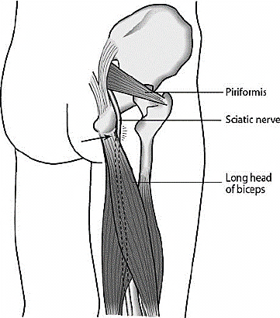
Figure (1):
The Condemned Neighborhood
The sciatic nerve gravely errs should it approach the long head of the biceps femoris. For the sciatic nerve may trespass and infringe upon the integrity of the long tendon of the biceps femoris muscle. Yet the tendon is rigid and unyielding, showing no mercy to this intruder.
The tendon compresses the nerve, causing it pain. The repetitive motion of flexion and extension at the hip joint and knee joint respectively serves to enhance the tendon's irritative effect on the nerve. Thus, over time, the full-fledged compressive neuropathy becomes established in all its elements.

In the posterior thigh, the sciatic nerve embraces the anterior surface of the long head of the biceps femoris muscle as the latter transitions obliquely from superior-medial to inferior-lateral relative to the sciatic nerve. Typically, the muscle's anterior surface remains pliable and arched protectively over the nerve, with perfect harmony between them allowing smooth, graceful gliding of one upon the other. Consequently, hip extension and knee flexion occur with the imposed logical smoothness; see Figure (2).

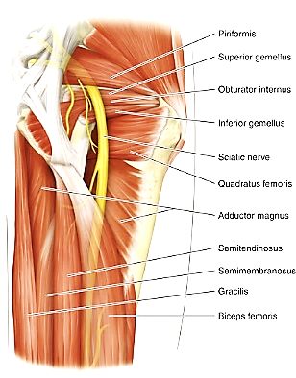
Figure (2):
The Second Etiology of Biceps Femoris Long Head Syndrome
Sciatic Nerve, Gluteal Region & Posterior Femoral Region
(Theatre of action highlighted in Yellow Circle)
The sciatic nerve (SN) courses alongside the long head of the biceps femoris muscle (LHBFM) over an extended distance.
Normally, the muscle tenderly embraces the nerve from behind.
However, in pathological cases, the LHBFM becomes rigid and nearly fibrous, compressing the SN.
The femur bone anteriorly and the rigid muscle posteriorly form the classic hammer-anvil duo, trapping the sciatic nerve between them.

Conversely, and rarely, fibrous extensions of the long head of the biceps femoris muscle may occasionally stretch distally for a variable distance—potentially reaching the mid-thigh. At this point, harmony turns to dissonance, and what was once pliable and yielding becomes rigid and injurious to the nerve. Here, these "migrating fibrous tongues" within the tendon substance exert a chronic, cutting action on the enveloped sciatic nerve.
This compressive effect intensifies during each hip flexion and/or knee extension movement, precisely as the damage inflicted by a thread sawing back-and-forth through soap or butter; see Figure (3).

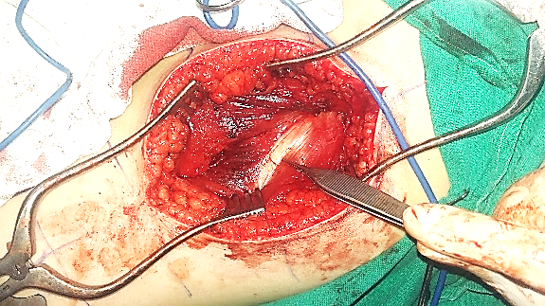
Long Head of Biceps Femoris
Fibrous Bands invade
the Muscle Body
Figure (3):
Peri-Operative View, Right Posterior Femoral Region
(From Private Archive)
The patient is positioned prone.
The surgical incision follows the midline of the middle third of the posterior thigh.
Note the fibrous extension of the long head of the biceps femoris muscle (LHBFM) distally to the mid-thigh (indicated by surgeon's forceps).
Fibrous tissue is not limited to the muscle surface but extends into multiple deep fibrous bands permeating the muscle body and directly adjoining the sciatic nerve (SN).
These longitudinal fibrous bands exerted compressive force on the SN, constituting the second pathogenic mechanism of this compressive neuropathy.

Summary:
Biceps Femoris Long Head Syndrome (BFLHS) is a compressive neuropathy in which the sciatic nerve experiences chronic irritation in the lower gluteal region and/or posterior thigh. Over time, this establishes sciatica – yet with distinct characteristics and localization. Initially, pain is exertional and tolerable, localized to the posterior thigh. It progressively evolves into constant, severe pain that immobilizes the patient. Patients describe it as muscle cramp-like pain. Sensory symptoms are absent except in advanced stages of neural injury.
Two distinct etiological factors are recognized:
- Medial deviation of the sciatic nerve near the proximal insertion of the biceps femoris long head tendon (i.e., a subtle nerve pathway aberration).
- Abnormal distal extension of the tendon's fibrous structure at the expense of muscle belly tissue (i.e., a structural aberration in tendon anatomy).
The medical literature documents rare clinical cases involving medial deviation of the sciatic nerve near the biceps femoris long head tendon. Conversely, I have found no published descriptions – not even a single clinical case – of abnormally extended fibrous tissue from this tendon (either directly or via multiple thick fibrous bands) establishing direct anterior contact with the sciatic nerve. Over time, with repetitive motion of the adjacent hip and knee joints, these fibrous bands carve deep pathological tracks into the nerve, resulting in intractable pain and functional impairment.
Ultimately, a single occurrence logically implies potential recurrence elsewhere and in other individuals. The distal extension of the tendon's fibrous component to the mid-thigh – accompanied by varying thicknesses of fibrous bands within the muscle belly, some in direct posterior contact with the sciatic nerve – was observed by the surgeon's eye and documented here; see Figure (3).
The patient is an 18-year-old male with exceptionally developed musculature. He complained of severe, stabbing pain in the mid-posterior thigh, described as muscle cramp-like. The pain was not associated with sensory disturbances and did not radiate proximally or distally. The patient reported a history of moderate blunt trauma to the posterior thigh region. Following this, the clinical picture rapidly progressed along the dark spectrum described previously, refractory to all attempted therapies despite extensive efforts.
Key Clinical Findings:
- Localized Sciatic Nerve Involvement:
  - All findings indicated sciatic nerve pathology in the middle third of the posterior thigh.
- Provocative Signs:
  - Violent gripping of the mid-posterior thigh during walking or minimal attempts to lift the extended leg (Severely positive Straight Leg Raise Test/Lasegue's Sign, approaching 0°).
  - Positive Tinel's Sign over the mid-posterior thigh.
- Diagnostic Challenges:
  - All investigative modalities failed to identify the underlying cause.
  - Only exploratory surgical exposure resolved the diagnostic ambiguity.
Surgical Report:
Intraoperatively, fibrous tissue predominated extensively over muscular tissue within the long head of the biceps femoris muscle. At its proximal insertion, the tissue appeared purely white without red hue. At the mid-thigh level, white coloration similarly dominated over redness.
In the middle third of the tendon, multiple thick fibrous bands were observed, with some in direct, strangulating contact with the sciatic nerve. All fibrous tissues were surgically transected at two distinct levels separated by 4 cm – excised wherever identified (superficial/deep, intramuscular).
Surgical objectives:
- Primary nerve liberation from compressive bands.
- Muscle lengthening to minimize recurrence risk; see Figure (4).

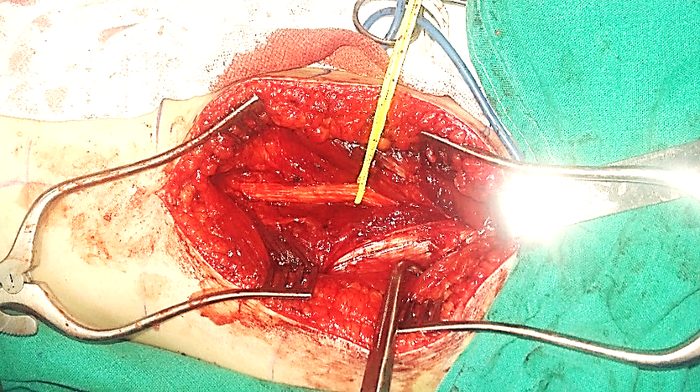
Biceps Femoris (Long Head)
Sciatic Nerve
Abnormal Fibrous Bands
Semitendinosus Muscle
Figure (4): Peri-Operative View
Liberated Right Sciatic Nerve (Yellow Loops)
(From Private Archive)

In the middle and distal thirds of the thigh, the sciatic nerve courses between the long head of the biceps femoris muscle (laterally) and the semitendinosus muscle (medially).
Superficial fibrous bands (white tissue, top left of image) and deep bands (not visualized) of the biceps femoris long head were surgically transected. This reduces muscular tension and, consequently, diminishes its compressive force on the nerve.
Transection was performed at two distinct levels to minimize recurrence risk following neurolysis.

…………………………………………………………………
In other contexts, you can also read the following articles:
 | DOI | The Spinal Reflex, New Hypothesis of Physiology
 | - | The Hyperreflexia, Innovated Pathophysiology
 | DOI | The Spinal Shock
 | - | The Spinal Injury, the Pathophysiology of the Spinal Shock, the Pathophysiology of the Hyperreflexia
 | DOI | Upper Motor Neuron Lesions, the Pathophysiology of the Symptomatology
 | DOI | The Hyperreflexia (1), the Pathophysiology of Hyperactivity
 | DOI | The Hyperreflexia (2), the Pathophysiology of Bilateral Responses
 | DOI | The Hyperreflexia (3), the Pathophysiology of Extended Hyperreflex
 | DOI | The Hyperreflexia (4), the Pathophysiology of Multi-Response Hyperreflex
- | - | The pathophysiology of Triple flexion Reflex
 | DOI | The Clonus, 1st Hypothesis of Pathophysiology
 | DOI | The Clonus, 2nd Hypothesis of Pathophysiology
 | DOI | The Clonus, Two Hypotheses of Pathophysiology
 | DOI | The Nerve Transmission through Neural Fiber, Personal View vs. International View
 | DOI | The Nerve Transmission through Neural Fiber (1), The Action Pressure Waves
 | DOI | The Nerve Transmission through Neural Fiber (2), The Action Potentials
 | DOI | The Nerve Transmission through Neural Fiber (3), The Action Electrical Currents
 | DOI | The Function of Standard Action Potentials & Currents
 | DOI | The Three Phases of Nerve transmission
 | DOI | Neural Conduction in the Synapse (Innovated)
 | DOI | Nodes of Ranvier, the Equalizers
 | DOI | Nodes of Ranvier, the Functions
 | DOI | Nodes of Ranvier, First Function
 | DOI | Nodes of Ranvier, Second Function
 | DOI | Nodes of Ranvier, Third Function
 | DOI | Node of Ranvier, The Anatomy
 | - | The Wallerian Degeneration
 | - | The Neural Regeneration
 | - | The Wallerian Degeneration Attacks Motor Axons, While Avoids Sensory Axons
 | DOI | The Sensory Receptors
 | - | Nerve Conduction Study, Wrong Hypothesis is the Origin of the Misinterpretation (Innovated)
 | DOI | Piriformis Muscle Injection: Personal Approach
 | - | The Philosophy of Pain, Pain Comes First! (Innovated)
 | - | The Philosophy of the Form (Innovated)
 | - | Pronator Teres Syndrome, Struthers-Like Ligament (Innovated)
 | - | Ulnar Nerve, Congenital Bilateral Dislocation
 | - | Posterior Interosseous Nerve Syndrome
 | - | The Multiple Sclerosis: The Causative Relationship Between  The Galvanic Current & Multiple Sclerosis?
 | - | Cauda Equina Injury, New Surgical Approach
 | - | Carpal Tunnel Syndrome Complicated by Complete Rupture of Median Nerve
 | - | Biceps Femoris' Long Head Syndrome (BFLHS)
 | DOI | Barr Body, The Whole Story (Innovated)
 | - | Adam's Rib and Adam's Apple, Two Faces of one Sin
 | - | Adam's Rib, could be the Original Sin?
 | - | Barr Body, the Second Look
 | DOI | Who Decides the Sex of Coming Baby?
 | - | Boy or Girl, Mother Decides!
 | - | Oocytogenesis
 | - | Spermatogenesis
 | - | This Woman Can Only Give Birth to Female Children
 | - | This Woman Can Only Give Birth to Male Children
 | - | This Woman Can Give Birth to Female Children More Than to Male Children
 | - | This Woman Can Give Birth to Male Children More Than to Female Children
 | - | This Woman Can Equally Give Birth to Male Children & to Female Children
 | - | Eve Saved Human Identity; Adam Ensured Human Adaptation
 | DOI | COVID-19: Beyond the Crisis—Is It Targeting Our Genes?
 | DOI | Fibromyalgia
 | - | The Black Hole is a (the) Falling Star?
 | - | Mitosis in Animal Cell
 | - | Meiosis
 | - | Universe Creation, Hypothesis of Continuous Cosmic Nebula
 | - | Circulating Sweepers
 | - | Pneumatic Petrous, Bilateral Temporal Hyperpneumatization
 | DOI | Congenital Bilateral Thenar Hypoplasia
 | DOI | Ulnar Dimelia, Mirror hand Deformity
 | DOI | Thumb Reconstruction Using Microvascular Second Toe to Thumb Transfer
 | DOI | Surgical Restoration of a Smile by Grafting a Segment of the Gracilis Muscle to the Face
 | DOI | Mandible Reconstruction Using Free Fibula Flap
 | DOI | Presacral Schwannoma
 | DOI | Liver Hemangioma: Urgent Surgery of Giant Liver Hemangioma  Due to Intra-Tumor Bleeding
 | DOI | Free Para Scapular Flap (FPSF) for Skin Reconstruction
 | DOI | Claw Hand Deformity (Brand Operation)
 | DOI | Algodystrophy Syndrome Complicated by Constricting Ring at the Proximal Border of the Edema
 | DOI | Non- Traumatic Non- Embolic Acute Thrombosis of Radial Artery (Buerger’s Disease)
 | DOI | Isolated Axillary Tuberculosis Lymphadenitis
 | DOI | The Iliopsoas Tendonitis... The Snapping Hip
 | To read the article in Arabic, click on
 | DOI | The New Frankenstein Monster
 | DOI | The Lone Wolf
 | DOI | The Delirium of Night and Day
 | DOI | The Delirium of the Economy
 | DOI | Ovaries in a Secure Corner… Testicles in a Humble Sac:  An Inquiry into the Function of Form
 | DOI | Eve Preserves Humanity’s Blueprint; Adam Drives Its Evolution
 | DOI | The Manufacture of the Unconscious
 | DOI | The Ballad of Eternity
 | DOI | Two Truths Woman Would Never Accept
 | DOI | The 'Iddah (Waiting Period) in Islamic Law: A Comparative Analysis of its Rationale for Divorced Women and Widows
 | DOI | The IVF/ICSI-Conceived Child: A Biologically Suboptimal Outcome

26/05/2017

